Integrated brain–body physiological monitoring from a smart earbud
Wenjian Li^{1†}, Sijie Ji^{1†}, Ruixiao Liu¹, Jin Qu¹, Kexin Fan¹, Songhua Zheng¹, Jihong Min¹, Seokjoo Cho¹, Kaiyu Zhao¹, Shukun Yin¹, Yadong Xu¹, Gwangmook Kim¹, Peng Jin¹, Tammy Wong^{2,3}, Richard Castriotta², Wei Gao¹*
¹Andrew and Peggy Cherng Department of Medical Engineering, Division of Engineering and Applied Science, California Institute of Technology, Pasadena, CA 91125, USA.
²Division of Pulmonary, Critical Care and Sleep Medicine, Department of Medicine, University of Southern California Keck School of Medicine, Los Angeles CA 90033, USA
³Division of Pulmonary and Critical Care, Department of Medicine, University of California, Irvine School of Medicine, Irvine, CA 92697, USA
†These authors contribute equally to this work.
*Corresponding author. weigao@caltech.edu
Abstract: Continuous monitoring of interacting physiological systems is central to digital health but remains challenging because wearable devices typically capture isolated signals from distributed body locations. The human ear provides a unique anatomical site where neural, cardiovascular, respiratory, and thermoregulatory signals converge, enabling integrated physiological monitoring from a single interface. Here we present EarSense, a smart earbud that integrates adaptive deep ear-canal electrophysiology enabled by shape-memory actuators and hydrogel electrodes with optical, thermal, electrodermal, and inertial sensing modalities. EarSense enables simultaneous acquisition of neural activity, reconstructed cardiac electrophysiology, vascular dynamics, respiration patterns, core body temperature, electrodermal activity, and body motion from a single ear-worn device. In human studies, EarSense supports continuous monitoring during daily activities and sleep, enabling quantitative assessment of affective states, automated sleep staging with 89.9% agreement with polysomnography, and prediction of next-day cognitive performance. These results establish the ear as a practical interface for integrated brain–body physiological monitoring in real-world settings.
Main Text
Continuous physiological monitoring in daily life is a central goal of digital health and personalized medicine (1-5). Wearable technologies have advanced this vision by enabling continuous measurement of vital signs outside clinical environments (6-10). However, human physiology arises from tightly coupling among neural, cardiovascular, respiratory, thermoregulatory, and sympathetic systems (11). Most wearable devices monitor only a limited subset of these signals from isolated body locations—for example, wrist-based photoplethysmography (PPG) for heart rate, chest patches for electrocardiography (ECG), or scalp electrodes for electroencephalography (EEG). As a result, current systems provide fragmented physiological information and fail to capture coordinated brain–body dynamics underlying health, behavior, and cognitive performance.
Achieving integrated monitoring of multiple physiological systems with wearables remains challenging. Key physiological signals originate from spatially distributed organs and tissues and are traditionally measured at different anatomical locations. Although combining multiple devices can in principle provide a more complete picture of physiological state (12), distributed sensing increases system complexity, introduces synchronization and calibration challenges, and burdens users. Moreover, neural monitoring—essential for understanding brain–body regulation—remains difficult to achieve at high fidelity in wearable systems. Conventional EEG requires bulky hardware or extensive preparation, whereas wearable EEG often relies on dry or shallow electrodes with unstable interfaces, causing high impedance, motion artifacts, and reduced signal fidelity during long-term monitoring (13-15). The limited availability of near-brain sensing sites further complicates compact integration of EEG with other physiological sensors, so most systems operate in isolation and fail to capture integrated brain–body physiology (16, 17).
The human ear offers a promising anatomical site for addressing these challenges. Several physiological pathways converge within the auricular region, enabling access to signals originating from multiple organ systems (Fig. 1A and text S1). The ear canal lies in close proximity to the temporal cortex, allowing detection of neural activity using in-ear electrophysiology (18). Cardiac electrical signals propagate throughout the body via volume conduction and can also be detected near the ear (19, 20). The auricular vasculature preserves pulsatile and respiration-modulated blood flow signatures that can be measured optically (21), while the tympanic membrane provides a well-established proxy for core body temperature (CBT) (22). In addition, the postauricular skin contains eccrine sweat glands that enable electrodermal monitoring of sympathetic activity. Together, these features make the ear a compact and protected site where neural, cardiovascular, respiratory, thermal, and sympathetic signals intersect, enabling integrated physiological monitoring from a single wearable interface.
Here we present EarSense, a smart earbud that enables multimodal monitoring of brain and peripheral physiology (Fig. 1A). EarSense integrates adaptive deep ear-canal electrophysiology enabled by shape-memory actuators and hydrogel electrodes with optical, thermal, electrodermal, and inertial sensing modalities (Fig. 1, B and C). The actuator–hydrogel interface establishes stable, low-impedance contact within the ear canal while maintaining gentle mechanical coupling, enabling high-fidelity electrophysiological recording during long-term wear. This configuration enables simultaneous acquisition of neural activity via EEG, machine-learning (ML)–reconstructed ECG, vascular and respiration dynamics via PPG, CBT, electrodermal activity via galvanic skin response (GSR), and body motion from a single ear-worn device.
Using this integrated sensing approach, we demonstrate continuous multimodal physiological monitoring during daily activities and sleep (Fig. 1, D and E, and fig. S1). In human studies, EarSense captures coordinated brain–body signals that enable affective state assessment and automated sleep staging. Leveraging ML algorithms, EarSense achieves quantitative assessment of affective state levels (R² > 0.9), 89.9% agreement with polysomnography (PSG) for sleep staging, and accurate prediction of next-day cognitive performance (R² = 0.88) (Fig. 1F). Together, these results establish the ear as a practical interface for integrated brain–body monitoring and highlight ear-worn devices as a scalable approach for real-world assessment of complex physiological states.
Ear-worn multimodal sensing architecture
To realize such integrated sensing, we designed an anatomically adaptive ear-worn system that combines deep ear-canal electrophysiology with multimodal physiological sensing. EarSense comprises three primary components: a compact tip assembly for electrophysiology and tympanic CBT sensing; a central flexible printed circuit board (FPCB) for signal acquisition and wireless communication; and an adaptive enclosure with a soft hook for device stabilization, peripheral sensing, and power supply housing (Fig. 1, A to C).
The tip assembly contains a four-actuator hydrogel array forming deep ear-canal electrophysiological interface and protrudes from a soft elastic ear tip. This multi-actuator architecture and compliant substrate enable stable and conformal electrode–skin contact inside the ear canal (Fig. 1C and fig. S2). The actuators surround a central holder containing an infrared (IR) sensor for noncontact tympanic CBT measurement.
All sensing and system components are distributed across the main enclosure and ear hook, interfacing with the FPCB through flexible interconnects or compact wiring (Fig. 1B). A PPG sensor is oriented toward the vascular-rich concha to capture pulsatile and respiration-modulated vascular signals. GSR electrodes positioned on the postauricular skin enable electrodermal sensing while minimizing electrical crosstalk between electrophysiological recordings. Biopotential reference (Ref) and ground (GND) electrodes are placed near the mastoid to minimize neural and muscular interference. Rechargeable lithium-ion batteries are housed in the distal hook and support docking-based charging. The complete system weighs less than 23 g, supporting comfortable long-term wear (Fig. 1, D and E).
Adaptive actuator-hydrogel interface for deep ear-canal electrophysiology
Ear EEG is a promising approach for wearable neural monitoring because of the ear’s proximity to brain, reduced hair-related impedance variability, and socially acceptable form factor. However, existing ear-EEG systems typically use shallow ear-canal (15, 17) or postauricular locations (23), and rely on dry (24) or short-lived electrodes (16), resulting in unstable contact, elevated impedance, motion sensitivity, and degraded signal fidelity.
To address these challenges, EarSense uses an actuator-hydrogel interface that establishes stable low-impedance contact at deep ear-canal locations (Fig. 2A). This actuator features a bilayer of prestretched elastic polydimethylsiloxane (PDMS) and nickel–titanium (NiTi) shape memory alloy (SMA), enabling reversible actuation (Fig. 2B). At low temperatures, the compliant martensitic SMA permits elastomer-driven bending, whereas heating induces transformation toward the stiffer austenitic phase and drives recovery toward a straighter configuration (text S2 and fig. S3).
To optimize in-ear operation and skin-safe heating, the SMA was thermally aged to tune its transformation behavior. Aging increases martensitic-related character and reduces stiffness at room temperature and sharpens thermal recovery through Ni₄Ti₃ precipitation and associated coherency strains (figs. S4 to S6 and text S3) (25, 26). With aged SMA and optimized PDMS thickness and pre-stretch, the actuator showed nearly doubled bending curvature and recovery rates exceeding 96% (figs. S7 and S8). Although the free-state transformation temperatures exceed skin-safe threshold (~45 °C), the bilayer architecture induced stress-assisted reverse transformation (27) (text S4), enabling full recovery at ~45 °C within 1 min (Fig. 2B, fig. S9, and movie S1).
The actuator showed no measurable degradation over 800 heating–cooling cycles (Fig. 2C and fig. S10), supported a 0.2-g load without curvature loss (fig. S11 and movie S2), and fully recovered after rolling, folding, and twisting (fig. S12 and movie S3). A four-actuator array was constructed to provide stable multipoint contact and multichannel recording in the ear canal (Fig. 2D). At physiological temperature (~37 °C), the array remains in its default open configuration, minimizing power consumption. Brief heating to 45 °C induces transition to a closed state for insertion or retraction, followed by reopening after cooling (fig. S9), with synchronized actuation across all units (fig. S13 and movie S4). The array spans an equivalent diameter from ~4 mm (closed) to ~10 mm (open), encompassing the average human ear-canal diameter (~7 mm) and enabling easy insertion and reliable post-insertion contact (Fig. 2, D and E and movie S5). Contact pressure in the open state remained below the skin perception threshold (~20 kPa) (16), supporting comfortable long-term wear (Fig. 2F).
To ensure low-impedance coupling, a water-retentive ionically conductive acrylamide-based hydrogel (WR-IC-PAAm) was integrated onto the actuator tips by in situ interfacial bonding (Fig. 2, A and G and figs. S14 and S15) (28-31). Lithium chloride in the glycerol–water cosolvent enhances hydration (32, 33) and ionic conductivity (34) without compromising softness (figs. S16 to S18). This interface yielded a contact impedance of ~35 kΩ at 50 Hz, comparable to commercial Ag/AgCl semi-dry and saline wet electrodes and substantially lower than bare Au dry electrodes (Fig. 2H and fig. S19).
This stabilized interface markedly improves deep ear-canal recording quality. Under alpha modulation (AM), steady-state visually evoked potentials (SSVEP), and auditory steady-state responses (ASSR) paradigms, hydrogel-enabled recordings exhibit clear neural oscillations together with discernible cardiac signatures within the same biopotential traces (fig. S20). Neural recording quality is reflected by an AM ratio of 3.75 and signal-to-noise ratio (SNR) values of 2.94 dB (AM), 9.13 dB (SSVEP), and 6.72 dB (ASSR), all substantially higher than those obtained using bare Au electrodes (fig. S21). Distinct cardiac signatures were preserved in hydrogel-enabled recordings but were largely absent with dry electrodes (fig. S20).
The hydrogel also maintains long-term stability. It remained fully hydrated at 25 °C and retained ~60% of its initial water content at 37 °C after one week (fig. S22), resulting in only a modest increase to ~50 kΩ at 37 °C (Fig. S23). Week-long daily recordings using the same hydrogel electrodes exhibited stable alpha peaks, AM ratios, SNRs (Fig. 2I and fig. S24), and preserved cardiac signatures (fig. S25). By contrast, commercial gels rapidly dehydrated and showed pronounced impedance increases and signal degradation within one day (Fig. 2H and figs. S26 to S39).
Deep ear-canal recordings further enhance artifact tolerance and biopotential fidelity. Compared with shallow ear-tip recordings, actuator-enabled deep ear-canal recordings largely suppressed Electrooculogram (EOG) transients (fig. S30) and remained resilient to facial and head motions, under which shallow placements degraded markedly (Fig. 2J and fig. S31). Even at low contact pressure (1.5 kPa), electrode–skin impedance remained low (~40 kΩ) and high-quality neural recordings were preserved (fig. S33). Alpha-modulation recordings demonstrate consistent oscillatory and cardiac signatures across 1.5 –10 kPa (figs. S34 and S35), indicating robustness to inter-individual anatomical variability. Power spectral density (PSD) spectrograms show clear alpha peaks with low baseline noise at all pressures, whereas shallow ear-tip electrodes produce noisy spectra (Fig. 2K). Histological analysis in rats revealed no detectable tissue damage or inflammation after 2 weeks of actuator contact (fig. S36), supporting long-term wear suitability. Finally, recordings from the array exhibit excellent inter-channel uniformity (fig. S37).
Reconstruction of full ECG waveforms from ear-canal composite biopotentials
Cardiac electrical activity propagates throughout the body via volume conduction and can therefore be detected near the ear. However, in conventional ear-EEG systems, cardiac signals are typically attenuated and obscured by low SNR and unstable interfaces. By contrast, the high-fidelity deep ear-canal recordings enabled by the actuator–hydrogel interface preserve distinct cardiac signatures, particularly R peaks (fig. S20).
Leveraging these preserved cardiac components, we developed an attention-augmented autoencoder network (ECGnet) to reconstruct full ECG waveforms from deep ear-canal signals (Fig. 2L and fig. S38). ECGnet extracts local morphological features and integrates long-range temporal dependencies across cardiac cycles, with ECG-aware training constraints in both the time and frequency domains, to recover coherent, physiologically meaningful P–QRS–T morphology.
The reconstructed ECG showed high agreement with reference arm ECG (Fig. 2M), with cosine similarity and Pearson correlation coefficients (r) of 0.92 (fig. S39A), a mean absolute error (MAE) of 0.03 mV, and a mean squared error (MSE) of 0.003 mV² (fig. S39B). Cardiac-related spectral components were clearly recovered but were largely absent in the original composite biopotential (fig. S40). R-to-R intervals (RRI) and heart rate (HR) trajectories derived from reconstructed ECG showed near-perfect agreement with reference ECG (R² = 0.998) (Fig. 2N and fig. S41).
Clinically relevant ECG metrics could also be extracted reliably from the reconstructed signals. Bland–Altman analyses demonstrated strong agreement across multiple parameters, including JT interval, diastolic interval, and QT-to-RRI ratio (Fig. 2, O and P; fig. S42). Compared with prior approaches that rely on contralateral electrodes or provide only limited R-peak detection, this method enables reconstruction of complete, clinically meaningful cardiac waveforms from a single ear-canal recording (table S1). These results show that a single ear-canal biopotential measurement can support simultaneous neural monitoring and full ECG reconstruction.
System integration and multimodal physiological sensing
EarSense integrates electrophysiological, optical, thermal, electrodermal, and inertial sensing within a compact earbud through a space-efficient FPCB design, optimized layout, and integrated electronics (Fig. 3A). The central FPCB incorporates the biopotential front-end, PPG, IR thermometer, inertial measurement unit (IMU), GSR interface, and microcontroller with Bluetooth Low Energy (BLE) communication (Fig. 3, B and C; fig. S43). Dedicated power management coordinates actuator heating, GSR operation, and system regulation for reliable multimodal operation. Actuator heating requires ~3 W of power but is only needed before wearing and completes within 1 min. Multimodal sensing with BLE transmission consumes less than 0.24 W, enabling over 9 h of continuous operation and up to 24 h under optimized interval streaming using two 300 mAh batteries (fig. S44).
From ear PPG, pulse waveforms, respiration patterns, and oxygen saturation (SpO₂) were extracted using tailored signal processing (Fig. 3D and fig. S45), with high SNRs for pulse (15.66 dB) and respiration signals (23.74 dB) (fig. S46), enabling accurate measurement of HR, respiration rate (RR), and SpO₂ with strong agreement to an FDA-cleared pulse oximeter (fig. S47). Tympanic temperature closely reflects CBT (Fig. 3E) and is less sensitive to environmental fluctuations than skin temperature. A noncontact IR sensor enables stable CBT measurement without the baseline drift common to contact-based thermistors (fig. S48). GSR electrodes positioned along the ear hook measure postauricular skin conductance (Fig. 3F) while minimizing crosstalk during concurrent electrophysiology recording (fig. S49).
To evaluate real-world performance, we conducted a continuous monitoring study in a healthy participant across 24-hour daily activities and sleep (Fig. 3G). During exercise, HR, RR, respiration amplitude (RA), GSR, and CBT increased markedly and returned to baseline after activity cessation. Sleep states were identifiable from EEG spectral transitions and stage-specific oscillations. Across sleep, HR decreased with parasympathetic dominance and reduced metabolic demand, while CBT followed its circadian trajectory, reaching an early-morning nadir before rising toward wakefulness. These results demonstrate that EarSense enables stable continuous multimodal monitoring in naturalistic settings, supporting integrated assessment of physiological, cognitive, and behavioral states.
Affective state evaluation using EarSense
EarSense was applied to monitor human affective states that arise from coordinated brain–body physiological responses (Fig. 4A) (35). Controlled experiments were conducted in 15 healthy participants under four affective conditions: relaxation, cold pressor test (CPT), virtual reality (VR) challenge, and recovery (table S2). Multimodal physiological signals were continuously recorded using EarSense (Fig. 4B and 4C), while subjective affective states were assessed using the Positive and Negative Affect Schedule (PANAS) (36) and the State-Trait Anxiety Inventory Form Y (STAI-Y) (37), administered after each condition (table S3).
During CPT, participants immersed one hand in ice water for 5 min, inducing nociceptive stress and sympathetic activation, with increased negative affect (NA) and state anxiety levels (fig. S50, A to C). This condition produced rapid cardiorespiratory and electrodermal responses, including changes in HR, heart rate variability (HRV), SpO₂, RA, and GSR (Fig. 4B). During the VR challenge, participants underwent a 10-min immersive roller-coaster simulation that elicited heightened emotional arousal and anticipatory engagement, resulting in increased positive affect (PA), NA and STAI scores (fig. S50, D to E), accompanied by neural spectral redistribution and cardiorespiratory modulation (Fig. 4C). Relaxation and recovery periods (10 min each) were defined immediately before and after CPT or VR exposure.
To quantify affective states, we implemented a supervised ML pipeline that maps physiological features to both discrete affective conditions and questionnaire-derived scores (Fig. 4D). EarSense captures characteristic brain–body dynamics across affective states, exemplified by increased EEG beta-band power (Fig. 4E) and decreased ECG-derived root mean square of successive differences (RMSSD) (Fig. 4F) during CPT and VR exposure, consistent with elevated cortical arousal and reduced vagal tone.
Using multimodal physiological features, the Light Gradient Boosting Machine (LGBM) classifier achieved the best performance, distinguishing the four affective states with 99.2% cross-validated accuracy (Fig. 4G and fig. S51) and a macro-F1 score of 0.992 (fig. S52). The multimodal data further enabled quantitative prediction of continuous affective scores. An LGBM regression model accurately predicted PA, NA, and STAI scores, with R² ≈ 0.91 and MAE ≈ 1–2 across targets (Fig. 4H to 4J; figs. S53 to S55). These results indicate that EarSense captures graded affective dynamics rather than merely distinguishing experimental conditions.
Shapley additive explanations (SHAP) revealed that the most influential predictors span complementary neural, autonomic cardiovascular–respiratory, and motion domains, (Fig. 4K and fig. S56). reflecting coordinated brain–body responses to stress. The decision plot further illustrates how these multimodal signals collectively determine affective state predictions (Fig. 4L). Together, these results demonstrate that accurate affect inference arises from integrated physiological dynamics.
Sleep monitoring and functional and cognitive performance evaluation using EarSense
Sleep involves coordinated neural and peripheral regulation, making integrated brain–body monitoring essential for comprehensive sleep assessment. However, gold-standard PSG requires complex laboratory instrumentation, whereas most wearables rely on limited peripheral proxies.
EarSense’s multimodal brain–body sensing enables naturalistic sleep monitoring and facilitates linking overnight physiological dynamics to next-day functional and cognitive performance (Fig. 5A). Overnight studies were conducted in 27 participants (20 healthy and 7 patients with sleep disorders) wearing EarSense, including 6 patients who also underwent simultaneous PSG monitoring (Fig. 5B and table S4). Subjective outcomes—including daytime sleepiness, sleep quality, and functional status—were assessed using Epworth Sleepiness Scale (ESS), Pittsburgh Sleep Quality Index (PSQI) and Functional Outcomes of Sleep Questionnaire (FOSQ), administered before and after sleep. Objective vigilance was further evaluated using a 10-min psychomotor vigilance task (PVT) (table S5).
EarSense continuously captured coordinated physiological dynamics across PSG-defined sleep stages (Fig. 5C). Consistent with canonical sleep physiology, HR and CBT declined overnight to an early-morning nadir, while respiratory stabilized and HRV remained relatively elevated during non–rapid eye movement (NREM) sleep. GSR stayed generally low with transient arousal-associated fluctuations, and body motion was minimal except during brief awakenings. EEG patterns recorded by EarSense exhibited strong agreement with PSG across sleep stages, with spectrograms recapitulated PSG-derived stage transitions and oscillatory dynamics, yielding an overall similarity of Pearson r = 0.83 and strong concordance across canonical bands (delta–beta; r ≈ 0.8–0.9) (Fig. 5, D and E and fig. S57). Sleep spindle events detected by EarSense also aligned closely with PSG detections, achieving an F1 score of 0.54, comparable to inter-expert agreement in spindle scoring (38, 39) (Fig. 5F and table S6).
To quantify sleep stages, we developed a temporal-context deep convolutional neural network integrating multimodal inputs across neighboring epochs to capture sleep dynamics. A cascade classifier with probabilistic refinement of the ambiguous N1 transition stage further improves stage discrimination (fig. S58). Accordingly, EarSense achieved automated sleep staging with 89.9% agreement and a Cohen’s κ of 0.88 with PSG-based ground truth across five stages (Fig. 5G). The predicted hypnogram of a representative patient with sleep disorders closely tracked PSG-derived overnight stage transitions, reaching 91.7% agreement with a Cohen’s κ of 0.88 (Fig. 5H). This performance places EarSense among the highest-performing wearable sleep monitoring systems, surpassing most commercial and laboratory-developed systems that rely on limited modalities or peripheral proxies (table S7).
Beyond sleep staging, EarSense enables prediction of next-day functional and cognitive outcomes from overnight physiological dynamics. Multinomial logistic regression models trained on EarSense-derived sleep features accurately predicted subjective outcome levels assessed via questionnaires, including ESS (40, 41), PSQI (42, 43), and FOSQ (44), achieving agreements of 85.2%, 96.3%, and 96.3%, respectively (Fig. 5, I to K), with misclassifications predominantly confined to adjacent severity levels and remaining within ±1 level of the ground truth in 96.3–100% of cases (fig. S59). A multilayer perceptron regressor further quantitatively predicted the slowest 10% reaction time on the PVT, a sleep-sensitive index of cognitive performance, with R² = 0.88 and MAE = 22.9 ms (Fig. 5L). Bland–Altman and residual analyses confirming strong agreement and minimal systematic bias (fig. S60).
User surveys indicated minimal side effects during overnight use, with a mean wearing comfort score of 7.93/10 and a willingness-to-replace PSG score of 9.18/10 (table S8). Together, these results demonstrate that EarSense enables accurate, continuous sleep monitoring and links physiological dynamics to next-day functional and cognitive outcomes, highlighting its potential as a scalable platform for real-world assessment of sleep and cognitive performance.
Conclusions
We present a smart earbud that enables integrated multimodal sensing of coordinated physiological systems, including neural, cardiovascular, respiratory, thermoregulatory, sympathetic, and motion dynamics. By leveraging the ear as a physiological convergence site, EarSense captures brain–body dynamics through electrophysiological, optical, thermal, electrodermal, and inertial sensing. A deep ear-canal electrophysiology interface, enabled by adaptive shape-memory actuators and water-retentive ionically conductive hydrogel electrodes, establishes stable low-impedance contact for high-fidelity composite biopotential acquisition, enabling simultaneous EEG monitoring and reconstruction of clinically meaningful ECG waveforms.
Human studies show that EarSense supports continuous multimodal monitoring during daily activities and sleep, enabling quantitative assessment of affective states, automated sleep staging, and prediction of next-day functional and cognitive performance. Together, these results establish the ear as a practical interface for integrated physiological monitoring and highlight the potential of ear-worn devices for unobtrusive assessment of complex physiological states in real-world environments.

References and Notes
1. E. J. Topol, A decade of digital medicine innovation. Sci. Transl. Med. 11, eaaw7610 (2019).
2. C. Xu, Y. Yang, W. Gao, Skin-Interfaced Sensors in Digital Medicine: from Materials to Applications. Matter 2, 1414-1445 (2020).
3. M. Reis, F. Reis, W. Kunde, Influence of believed AI involvement on the perception of digital medical advice. Nat. Med. 30, 3098-3100 (2024).
4. P. C. Ng, S. S. Murray, S. Levy, J. C. Venter, An agenda for personalized medicine. Nature 461, 724-726 (2009).
5. L. Evangelista, S. R. Steinhubl, E. J. Topol, Digital health care for older adults. The Lancet 393, 1493 (2019).
6. W. Heng et al., A smart mask for exhaled breath condensate harvesting and analysis. Science 385, 954-961 (2024).
7. K. Bayoumy et al., Smart wearable devices in cardiovascular care: where we are and how to move forward. Nat. Rev. Cardiol. 18, 581-599 (2021).
8. D. Zhong et al., High-speed and large-scale intrinsically stretchable integrated circuits. Nature 627, 313-320 (2024).
9. J. Shin et al., A non-contact wearable device for monitoring epidermal molecular flux. Nature 640, 375-383 (2025).
10. X. Gao et al., A wearable echomyography system based on a single transducer. Nat. Electron. 7, 1035-1046 (2024).
11. K. Mahato et al., Hybrid multimodal wearable sensors for comprehensive health monitoring. Nat. Electron. 7, 735-750 (2024).
12. R. Lin et al., Wireless battery-free body sensor networks using near-field-enabled clothing. Nat. Commun. 11, 444 (2020).
13. N. Kaongoen et al., The future of wearable EEG: a review of ear-EEG technology and its applications. J. Neural. Eng. 20, 051002 (2023).
14. K. T. Johnson, R. W. Picard, Advancing Neuroscience through Wearable Devices. Neuron 108, 8-12 (2020).
15. Y. Xu et al., In-ear integrated sensor array for the continuous monitoring of brain activity and of lactate in sweat. Nat. Biomed. Eng. 7, 1307-1320 (2023).
16. Z. Wang et al., Conformal in-ear bioelectronics for visual and auditory brain-computer interfaces. Nat. Commun. 14, 4213 (2023).
17. R. Kaveh, C. Schwendeman, L. Pu, A. C. Arias, R. Muller, Wireless ear EEG to monitor drowsiness. Nat. Commun. 15, 6520 (2024).
18. J. Y. Juez et al., Ear-EEG Devices for the Assessment of Brain Activity: A Review. IEEE Sens. J. 24, 31606-31623 (2024).
19. M. Yarici et al., Hearables: feasibility of recording cardiac rhythms from single in-ear locations. R. Soc. Open Sci. 11, 221620 (2024).
20. R. De Lucia et al., The in-ear region as a novel anatomical site for ECG signal detection: validation study on healthy volunteers. J Interv Card Electrophysiol 60, 93-100 (2021).
21. H. J. Davies et al., Wearable In-Ear PPG: Detailed Respiratory Variations Enable Classification of COPD. IEEE Trans. Biomed. Eng. 69, 2390-2400 (2022).
22. H. Ota et al., 3D Printed "Earable" Smart Devices for Real-Time Detection of Core Body Temperature. ACS Sens. 2, 990-997 (2017).
23. M. Guermandi, S. Benatti, V. J. Kartsch Morinigo, L. Bertini, paper presented at the 2018 IEEE Biomedical Circuits and Systems Conference (BioCAS), Cleveland, Ohio, 2018.
24. S. L. Kappel, M. L. Rank, H. O. Toft, M. Andersen, P. Kidmose, Dry-Contact Electrode Ear-EEG. IEEE Trans Biomed Eng 66, 150-158 (2019).
25. J. Frenzel et al., Influence of Ni on martensitic phase transformations in NiTi shape memory alloys. Acta Mater. 58, 3444-3458 (2010).
26. J. Khalil-Allafi, A. Dlouhy, G. Eggeler, Ni4Ti3-precipitation during aging of NiTi shape memory alloys and its influence on martensitic phase transformations. Acta Mater. 50, 4255-4274 (2002).
27. M. Kök, F. Dağdelen, A. Aydoğdu, Y. Aydoğdu, The change of transformation temperature on NiTi shape memory alloy by pressure and thermal ageing. J. Phys. Conf. Ser. 667, 012011 (2016).
28. F. Chen et al., Rational Fabrication of Anti-Freezing, Non-Drying Tough Organohydrogels by One-Pot Solvent Displacement. Angew. Chem. Int. Ed. 57, 6568-6571 (2018).
29. H. Yuk, T. Zhang, S. Lin, G. A. Parada, X. Zhao, Tough bonding of hydrogels to diverse non-porous surfaces. Nat. Mater. 15, 190-196 (2016).
30. J. Y. Sun et al., Highly stretchable and tough hydrogels. Nature 489, 133-136 (2012).
31. W. Ge, S. Cao, Y. Yang, O. J. Rojas, X. Wang, Nanocellulose/LiCl systems enable conductive and stretchable electrolyte hydrogels with tolerance to dehydration and extreme cold conditions. Chem. Eng. J. 408, (2021).
32. X. Fu et al., Self-healing actuatable electroluminescent fibres. Nat. Commun. 15, 10498 (2024).
33. C. Guo et al., Radiative cooling assisted self-sustaining and highly efficient moisture energy harvesting. Nat. Commun. 15, 6100 (2024).
34. L. Scalco de Vasconcelos et al., On-scalp printing of personalized electroencephalography e-tattoos. Cell Biomater. 1, 100004 (2025).
35. W. Lovallo, The Cold Pressor Test and Autonomic Function: A Review and Integration. Psychophysiol. 12, 268-282 (1975).
36. D. Watson, L. A. Clark, A. Tellegen, Development and validation of brief measures of positive and negative affect: The PANAS scales. J. Pers. Soc. Psychol. 54, 1063-1070 (1988).
37. C. D. Spielberger, F. Gonzalez-Reigosa, A. Martinez-Urrutia, L. F. S. Natalicio, D. S. Natalicio, Manual for the State-Trait Anxiety Inventory., (Consulting Psychologists Press, Palo Alto, CA, 1983).
38. S. L. Wendt et al., Inter-expert and intra-expert reliability in sleep spindle scoring. Clin. Neurophysiol. 126, 1548-1556 (2015).
39. L. Ray et al., Expert and crowd-sourced validation of an individualized sleep spindle detection method employing complex demodulation and individualized normalization. Front. Hum. Neurosci. 9, 507 (2015).
40. L. Yared, K. Rodrigues, R. Mangal, T. S. Stead, L. Ganti, Sleep Hygiene, Daytime Sleepiness, and Coping Mechanisms Amongst US Adults. Cureus 15, e45608 (2023).
41. E. Kazemeini et al., Scoring of Hypersomnolence and Fatigue in Patients With Obstructive Sleep Apnea Treated With a Titratable Custom-Made Mandibular Advancement Device. J. Clin. Sleep Med. 15, 623-628 (2019).
42. Y. Zheng et al., Sleep quality and mental health of medical workers during the coronavirus disease 2019 pandemic. Sleep Biol. Rhythms 19, 173-180 (2021).
43. K. Yu, S. Song, L. Wu, Z. Chen, Investigation and analysis of sleep and mental health status among MEFCs. Front. Psychiatry 16, 1458291 (2025).
44. M. Veje et al., Sleep architecture, obstructive sleep apnea and functional outcomes in adults with a history of Tick-borne encephalitis. PLoS One 16, e0246767 (2021).
45. M. W. Johns, A New Method for Measuring Daytime Sleepiness: The Epworth Sleepiness Scale. Sleep 14, 540-545 (1991).
46. D. J. Buysse;, C. F. Reynolds;, T. H. Monk;, S. R. Berman;, D. J. Kupfer, The Pittsburgh sleep quality index: A new instrument for psychiatric practice and research. Psychiatry Res. 28, 193-213 (1989).
47. T. Mollayeva et al., The Pittsburgh sleep quality index as a screening tool for sleep dysfunction in clinical and non-clinical samples: A systematic review and meta-analysis. Sleep Med. Rev. 25, 52-73 (2016).
48. T. E. Weaver et al., An Instrument to Measure Functional Status Outcomes for Disorders of Excessive Sleepiness. Sleep 20, 835-843 (1997).
49. J. Lim, D. F. Dinges, Sleep Deprivation and Vigilant Attention. Ann. N. Y. Acad. Sci. 1129, 305-322 (2008).
50. M. Basner, D. F. Dinges, Maximizing Sensitivity of the Psychomotor Vigilance Test (PVT) to Sleep Loss. Sleep 34, 581-591 (2011).
51. K. B. Mikkelsen, S. L. Kappel, D. P. Mandic, P. Kidmose, EEG Recorded from the Ear: Characterizing the Ear-EEG Method. Front. Neurosci. 9, 438 (2015).
52. D. Looney et al., The in-the-ear recording concept: user-centered and wearable brain monitoring. IEEE Pulse 3, 32-42 (2012).
53. D. Seok, S. Lee, M. Kim, J. Cho, C. Kim, Motion Artifact Removal Techniques for Wearable EEG and PPG Sensor Systems. Front. Electron. 2, 685513 (2021).
54. D. B. Geselowitz, On the theory of the electrocardiogram. Proc. IEEE 77, 857-876 (1989).
55. G. Dirlich, L. Vogl, M. Plaschke, F. Strian, Cardiac field effects on the EEG. Electroencephalography and Clinical Neurophysiology 102, 307-315 (1997).
56. G. G. BERNTSON et al., Heart rate variability: Origins, methods, and interpretive caveats. Psychophysiol. 34, 623-648 (1997).
57. K. H. Shelley, Photoplethysmography: Beyond the Calculation of Arterial Oxygen Saturation and Heart Rate. Anesth. Analg. 105, S31-S36 (2007).
58. M. Elstad, K. Toska, K. H. Chon, E. A. Raeder, R. J. Cohen, Respiratory sinus arrhythmia: opposite effects on systolic and mean arterial pressure in supine humans. J. Physiol. 536, 251-259 (2001).
59. S. Standring, Gray's Anatomy: The Anatomical Basis of Clinical Practice. (Churchill Livingstone, ed. 39th, 2005).
60. M. Shibasaki, C. G. Crandall, Mechanisms and controllers of eccrine sweating in humans. Front. Biosci. (Schol Ed) 2, 685-696 (2010).
61. E. N. D. Grassi, G. Chagnon, H. M. R. de Oliveira, D. Favier, Anisotropy and Clausius-Clapeyron relation for forward and reverse stress-induced martensitic transformations in polycrystalline NiTi thin walled tubes. Mech. Mater. 146, 103392 (2020).
62. Y. Liu, H. Yang, Strain dependence of the Clausius–Clapeyron relation for thermoelastic martensitic transformations in NiTi. Smart Mater. Struct. 16, S22 (2007).
63. A. L. McKelvey, R. O. Ritchie, On the temperature dependence of the superelastic strength and the prediction of the theoretical uniaxial transformation strain in Nitinol. Philos. Mag. A 80, 1759-1768 (2000).
64. P. Agarwal, Y. Guo, N. V. Thakor, paper presented at the 2023 IEEE Biomedical Circuits and Systems Conference (BioCAS), 2023.
65. N. Celik;, N. Manivannan;, W. Balachandran, Evaluation of a Behind-the-Ear ECG Device for Smartphone based Integrated Multiple Smart Sensor System in Health Applications. Int. J. Adv. Comput. Sci. Appl. 7, 409-418 (2016).
66. H. J. Davies et al., The Deep-Match Framework: R-Peak Detection in Ear-ECG. IEEE Trans. Biomed. Eng. 71, 2014-2021 (2024).
67. R. De Lucia et al., The in-ear region as a novel anatomical site for ECG signal detection: validation study on healthy volunteers. J. Interv. Card. Electrophysiol. 60, 93-100 (2021).
68. S. Guler, A. Golparvar, O. Ozturk, M. K. Yapici, Ear Electrocardiography With Soft Graphene Textiles for Hearable Applications. IEEE Sens. Lett. 6, 1-4 (2022).
69. G. Hammour;, M. Yarici;, W. v. R. D. P. Mandic, paper presented at the 2019 41st Annual International Conference of the IEEE Engineering in Medicine and Biology Society (EMBC), Berlin, Germany, 2019.
70. N. K. Jacob; et al., paper presented at the 2018 40th Annual International Conference of the IEEE Engineering in Medicine and Biology Society (EMBC), Honolulu, HI, USA, 18-21 July 2018 2018.
71. D. Mandic et al., In Your Ear: A Multimodal Hearables Device for the Assessment of the State of Body and Mind. IEEE Pulse 14, 17-23 (2023).
72. E. Occhipinti et al., In-ear ECG Signal Enhancement with Denoising Convolutional Autoencoders. 2024 (10.48550/arXiv.2409.05891).
73. A. C. Palmisciano et al., Eyewear-Based ECG Recording: A Novel Head-Electrode Approach for Reliable Cardiac Signal Acquisition. IEEE Access 13, 45488-45499 (2025).
74. H. Tian, E. Occhipinti, A. Nassibi, D. P. Mandic, Hearables: Heart Rate Variability from Ear Electrocardiogram and Ear Photoplethysmogram (Ear-ECG and Ear-PPG). Annu. Int. Conf. IEEE Eng. Med. Biol. Soc. 2023, 1-5 (2023).
75. W. von Rosenberg et al., Hearables: feasibility of recording cardiac rhythms from head and in-ear locations. R. Soc. Open Sci. 4, 171214 (2017).
76. Q. Zhang, X. Zeng, W. Hu, D. Zhou, A Machine Learning-Empowered System for Long-Term Motion-Tolerant Wearable Monitoring of Blood Pressure and Heart Rate With Ear-ECG/PPG. IEEE Access 5, 10547-10561 (2017).
77. S. E. Lim, H. S. Kim, S. W. Lee, K. H. Bae, Y. H. Baek, Validation of Fitbit Inspire 2(TM) Against Polysomnography in Adults Considering Adaptation for Use. Nat. Sci. Sleep 15, 59-67 (2023).
78. F. B. Silva et al., Sleep staging algorithm based on smartwatch sensors for healthy and sleep apnea populations. Sleep Med. 119, 535-548 (2024).
79. J. Guo, J. Luo, Y. Xiao, R. Huang, Validity and clinical utility of a wrist-worn device against polysomnography. PLoS One 20, e0330774 (2025).
80. T. Lee et al., Accuracy of 11 Wearable, Nearable, and Airable Consumer Sleep Trackers: Prospective Multicenter Validation Study. JMIR mHealth uHealth 11, e50983 (2023).
81. R. Robbins et al., Accuracy of Three Commercial Wearable Devices for Sleep Tracking in Healthy Adults. Sensors 24, (2024).
82. T. A. Song et al., AI-Driven sleep staging from actigraphy and heart rate. PLoS One 18, e0285703 (2023).
83. X. Zhang et al., Sleep stage classification based on multi-level feature learning and recurrent neural networks via wearable device. Comput. Biol. Med. 103, 71-81 (2018).
84. Y. Du et al., A skin-interfaced wireless wearable device and data analytics approach for sleep-stage and disorder detection. Proc. Natl. Acad. Sci. U.S.A. 122, e2501220122 (2025).
85. A. H. Zhang et al., Mamba-based Deep Learning Approach for Sleep Staging on a Wireless Multimodal Wearable System Without Electroencephalography. Sleep, zsag022 (2026).
86. H. S. K. Shinjae Kwon, Kangkyu Kwon, Hodam Kim, Yun Soung Kim,, Y.-T. K. Sung Hoon Lee, Jae-Woong Jeong, Lynn Marie Trotti, Audrey Duarte,, W.-H. Yeo, At-home wireless sleep monitoring patches for the clinical assessment of sleep quality and sleep apnea. Sci. Adv. 9, eadg9671 (2023).
87. P. J. Arnal et al., The Dreem Headband compared to polysomnography for electroencephalographic signal acquisition and sleep staging. Sleep 43, (2020).
88. S.-W. Kim et al., Wearable Multi-Biosignal Analysis Integrated Interface With Direct Sleep-Stage Classification. IEEE Access 8, 46131-46140 (2020).
89. D. J. Levendowski et al., The Accuracy, Night-to-Night Variability, and Stability of Frontopolar Sleep Electroencephalography Biomarkers. J. Clin. Sleep Med. 13, 791-803 (2017).
90. C.-T. Lin et al., Forehead EEG in Support of Future Feasible Personal Healthcare Solutions: Sleep Management, Headache Prevention, and Depression Treatment. IEEE Access 5, 10612-10621 (2017).
91. M. A. Jaoude et al., paper presented at the 2023 11th International IEEE/EMBS Conference on Neural Engineering (NER), 2023.
92. S. Shustak et al., Home monitoring of sleep with a temporary-tattoo EEG, EOG and EMG electrode array: a feasibility study. J. Neural. Eng. 16, 026024 (2019).
93. K. B. Mikkelsen et al., Accurate whole-night sleep monitoring with dry-contact ear-EEG. Sci Rep 9, 16824 (2019).
94. T. Nakamura, Y. D. Alqurashi, M. J. Morrell, D. P. Mandic, Hearables: Automatic Overnight Sleep Monitoring With Standardized In-Ear EEG Sensor. IEEE Trans Biomed Eng 67, 203-212 (2020).

Acknowledgements
We gratefully acknowledge the critical support and infrastructure provided for this work by the Kavli Nanoscience Institute at Caltech. W. L. thanks the financial support of the Rubicon Fellowship (019.232EN.012) from the Dutch Research Council (NWO).
Funding:
National Institutes of Health grant R01DC021461 (W.G.)
National Institutes of Health grant R01HL155815 (W.G.)
National Science Foundation grant 2145802 (W.G.)
National Science Foundation grant 2444815 (W.G.)
Army Research Office grant W911NF-23-1-0041 (W.G.)
Office of Naval Research grant N00014-25-1-2258 (W.G.)
US Army Medical Research Acquisition Activity grant HT9425-24-1-0249 (W.G.)
Heritage Medical Research Institute (W.G.)
Author contributions:
Conceptualization: W.L. and W.G.
Methodology: W.L. S.J. and W.G.
Investigation: W.L., S.J., R.L., J.Q., K.F., S.Z., J.M., S.C., K.Z., S.Y., Y.X., G.K. P.J., T. W., R.C.
Funding acquisition: W.G.
Supervision: W.G.
Writing-original draft: W.L. S.J. and W.G.
Writing-review & editing: All authors.
Competing interests: The authors have no competing interests.
Data and materials availability: All data are available in the main text or the supplementary materials.
Supplementary Materials
Materials and Methods
Text S1 to S4
Figs. S1 to S60
Table S1 to S8
References (45 to 94)
Movie S1 to S5
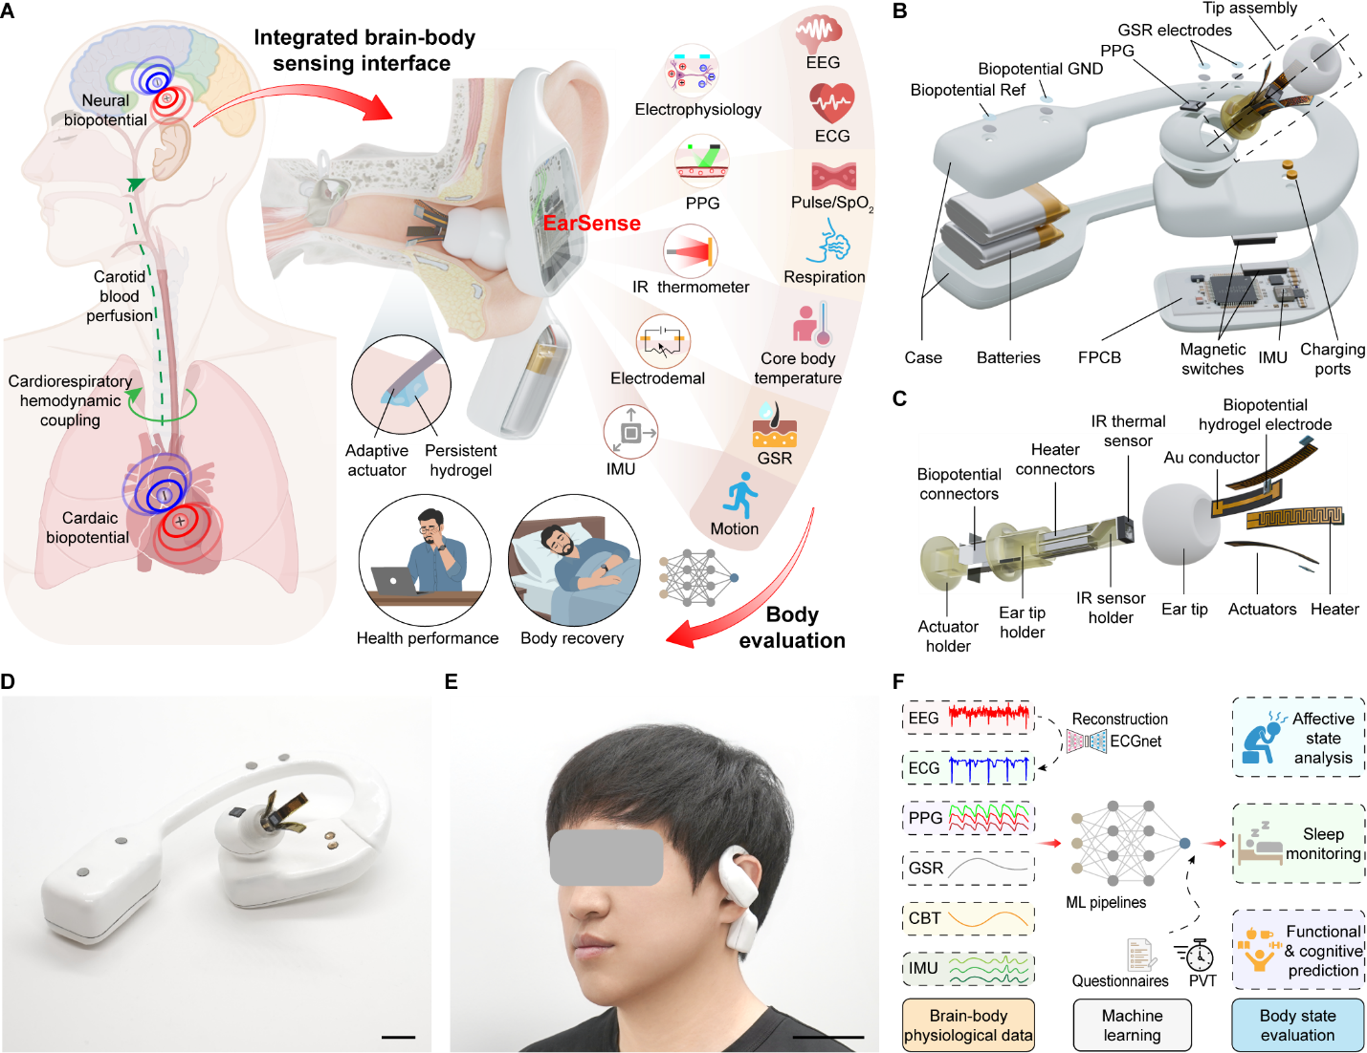
Fig. 1. EarSense, a smart earbud for integrated brain–body physiological sensing. (A) Schematic of EarSense. The device enables deep ear-canal recording of composite neural–cardiac electrophysiology together with vascular-respiratory dynamics, core body temperature (CBT), galvanic skin response (GSR), and body motion, providing multimodal physiological information from a single ear-worn interface. EEG, electroencephalogram; ECG, electrocardiogram; PPG, photoplethysmography; IR, infrared; IMU, inertial measurement unit; SpO₂, peripheral oxygen saturation. (B) Exploded-view schematic of EarSense showing the tip assembly, sensor modules, electronics, batteries, and mechanical enclosure. Ref, reference electrode; GND, ground electrode; FPCB, flexible printed circuit board. (C) Detailed structure of the tip assembly, including the actuator array with hydrogel electrodes for deep ear-canal electrophysiology, the IR temperature sensor, and electrical interconnects. (D and E) Photographs of EarSense showing the compact earbud form factor (D) and in-ear wearing during daily use (E). Scale bars, 1 cm and 5 cm, respectively. (F) Multimodal physiological data acquired by EarSense, combined with machine learning (ML) analysis, enable body-state evaluation, including affective state analysis, sleep monitoring, and prediction of next-day functional and cognitive performance.
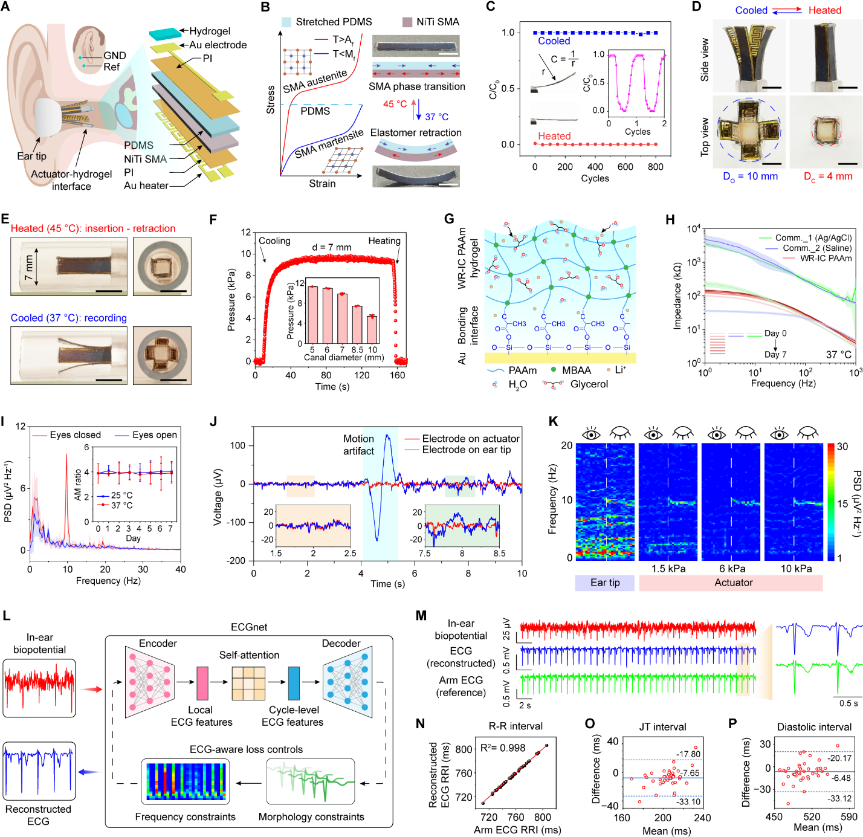
Fig. 2. Actuator–hydrogel interface enabling stable deep ear-canal composite electrophysiology (EEG–ECG) recording. (A) Schematic of deep ear-canal electrophysiology enabled by the actuator-hydrogel interface, composed of an adaptive bilayer PDMS-SMA actuator, hydrogel electrode, and integrated thin-film heater. PI, polymide; PDMS, polydimethylsiloxane; SMA, shape memory alloy. (B) Operating mechanism of the PDMS–SMA actuator based on stress balance between elastomer retraction and temperature-controlled SMA phase transition, producing a bent configuration at physiological temperature (37 °C) and a straightened state upon heating (45 °C). Scale bar, 5 mm. A_{s}, austenite start temperature; A_{f}, austenite finish temperature. (C) Cyclic stability of the actuator over 800 heating-cooling cycles. C₀, initial curvature; C, real-time curvature; r, bending radius. (D) Photographs of the four-actuator array in open (cooled) and closed (heated) states from side and top views. Scale bar, 3 mm. D_{o}, open-state diameter; D_{c}, close-state diameter. (E) Demonstration of insertion and conformal contact within a simulated ear canal. Scale bar, 5 mm. (F) Contact pressure as a function of canal diameter, demonstrating adaptive sub-perceptual contact. Error bars represent the standard deviation (s.d.) of the mean from 3 samples. (G) Structure of the water-retentive ionically conductive acrylamide-based hydrogel (WR-IC-PAAm) and its bonding with the Au substrate. PAAm, polyacrylamide; MBAA, N,N′-methylenebisacrylamide. (H) Electrode–skin impedance and stability comparison between WR-IC-PAAm hydrogel and commercial electrodes. Comm._1, Ag/AgCl-based semi-dry electrode (3M Reddot 2560); Comm._2, saline-based wet gel (Parker Signa gel). (I) Week-long stability of neural alpha modulation (AM, eyes-open/eyes-closed) recorded using a WR-IC-PAAm electrode. Error bars represent the s.d. of the mean from 8 samples. (J) Artifact tolerance comparison between actuator-enabled deep ear-canal recordings and shallow ear-tip recordings. (K) Power spectral density (PSD) spectrograms of AM signals under varying actuator contact pressures and from shallow ear-tip recordings. (L) Schematic of ECGnet for reconstructing ECG from composite deep ear-canal biopotential. (M) Comparison of composite ear-canal signals, reconstructed ECG, and reference arm ECG. (N) Correlation of R-to-R interval (RRI) derived from reconstructed ECG and reference ECG. (O and P) Bland–Altman analysis of ECG metrics, JT interval (O) and diastolic interval (P). Solid lines indicate the mean bias; dashed lines denote the limits of agreement (mean ±1.96 s.d.).

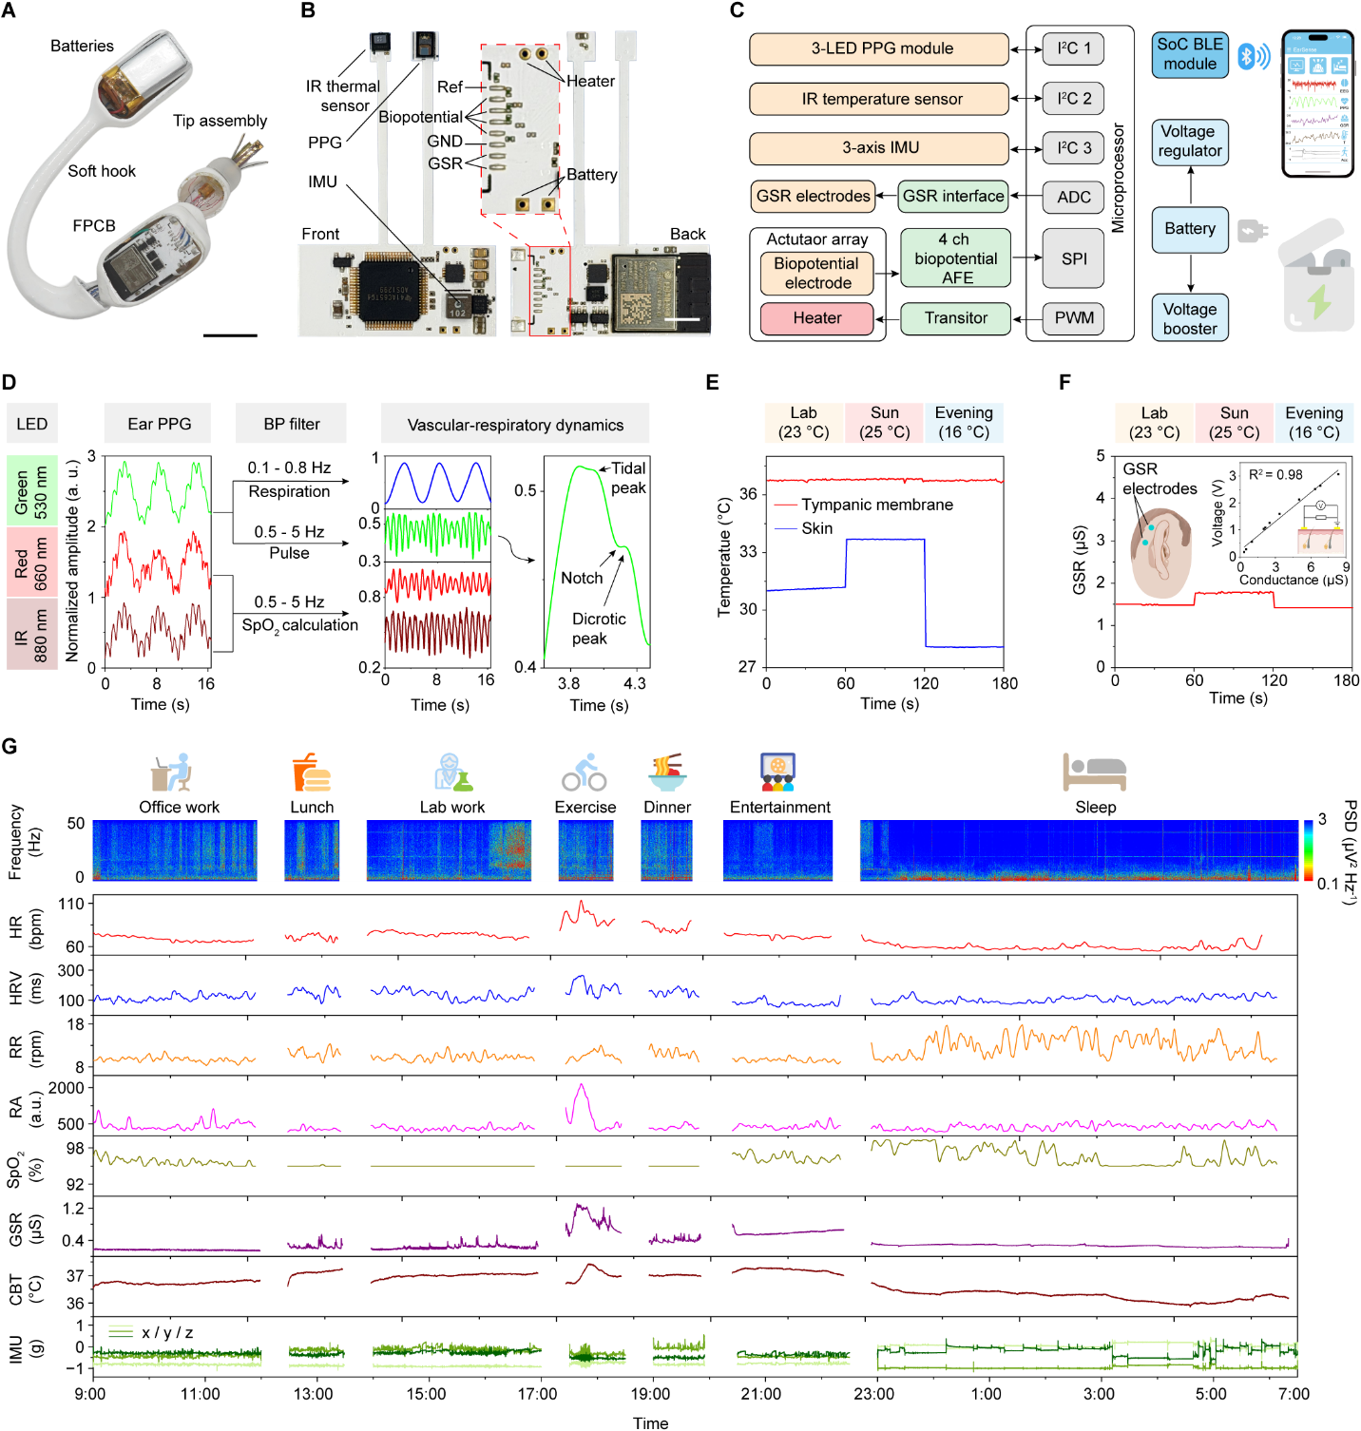
Fig. 3. System integration and multimodal physiological sensing with EarSense during daily activities. (A and B) Photographs of EarSense before encapsulation (A) and the layout of the FPCB (B). Scale bars, 2 cm and 5 mm, respectively. (C) System-level block diagram illustrating integration of multimodal physiological sensors, power management circuits, and wireless communication modules. AFE, analog front-end; I²C, inter-integrated circuit bus; ADC, analog-to-digital converter; SPI, serial peripheral interface; PWM, pulse-width modulation; SoC, system-on-chip; BLE, Bluetooth Low Energy. (D) Signal-processing pipeline for three-channel ear PPG, enabling extraction of vascular–respiratory dynamics, including pulse waveform, respiration, and SpO₂. BP, bandpass. (E) Tympanic membrane temperature demonstrating reduced sensitivity to ambient temperature fluctuations compared with skin temperature under changing ambient conditions. (F) GSR measurements under varying ambient conditions. (G) Continuous multimodal physiological monitoring over a full day, capturing brain–body dynamics across daily activities. HR, heart rate; HRV, heart rate variability; RR, respiration rate; RA, respiration amplitude.

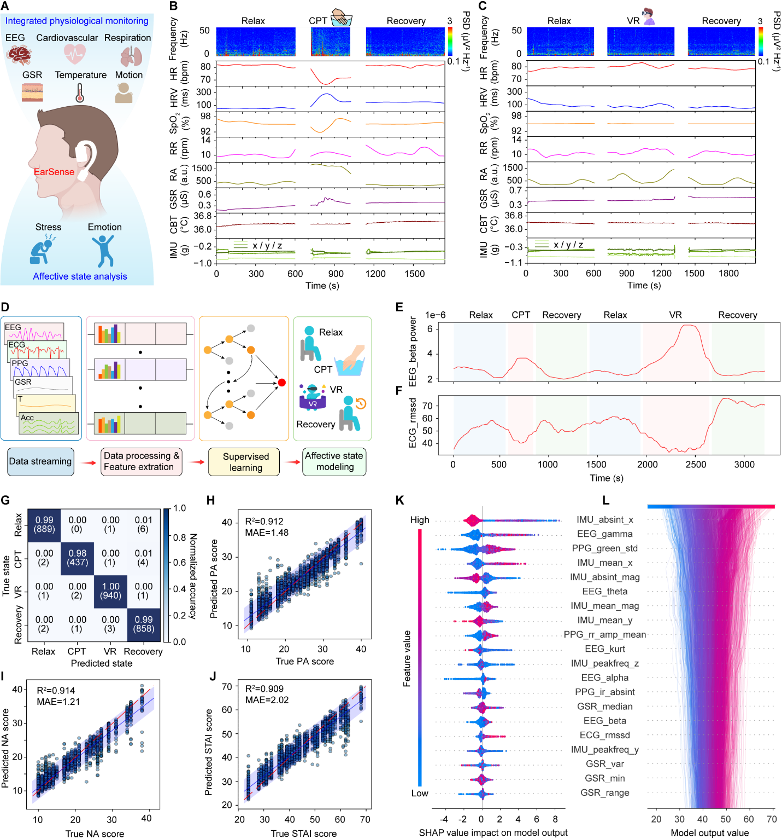
Fig. 4. Affective state analysis using multimodal physiological signals with EarSense. (A) Schematic of multimodal physiological sensing with EarSense for affective state analysis. (B and C) Representative multimodal recordings during different affective stimuli: cold pressor test (CPT), in which the participant immersed one hand in ice water (B), and a virtual reality (VR) challenge involving a rhythm game (C). (D) Overview of the ML pipeline, including data preprocessing, feature extraction, supervised learning, and affective state modeling. (E and F) Representative feature changes across affective states, including EEG_beta power (E) and ECG_rmssd (F) across different affective states. ECG_rmssd, root mean square of successive differences of R-to-R intervals. (G) Confusion matrix for classification of four affect states: Relaxation, CPT, VR, and Recovery. (H to J) Predicted versus true questionnaire scores for positive affect (PA) (H), negative affect (NA) (I) and state anxiety (STAI) (J) scores. The dashed line denotes the ideal identity line; the solid line and shaded region represent the fitted regression and 95% confidence interval. (K and L) SHAP-based model interpretation. Summary plot shows feature contributions across all predictions (K), whereas decision plot illustrates how multimodal features combine to determine the affective state predictions (L). Feature abbreviations: Acc_absint_x, accelerometer absolute integral (X-axis); EEG_gamma, gamma-band EEG power; PPG_green_std, standard deviation of green-channel PPG; Acc_mean_x, mean acceleration (X-axis); Acc_absint_mag, accelerometer absolute integral magnitude; EEG_theta, theta-band EEG power; Acc_mean_mag, mean acceleration magnitude; Acc_mean_y, mean acceleration (y-axis); PPG_rr_amp_mean, mean respiratory-related PPG amplitude modulation; EEG_kurt, EEG signal kurtosis; Acc_peakfreq_z, peak frequency of acceleration (Z-axis); EEG_alpha, alpha-band EEG power; PPG_ir_absint, infrared PPG absolute integral; GSR_median, median galvanic skin response; EEG_beta, beta-band EEG power; ECG_rmssd, root mean square of successive differences of ECG; Acc_peakfreq_y, peak frequency of acceleration (Y-axis); GSR_var, variance of galvanic skin response; GSR_min, minimum galvanic skin response; GSR_range, range of galvanic skin response.

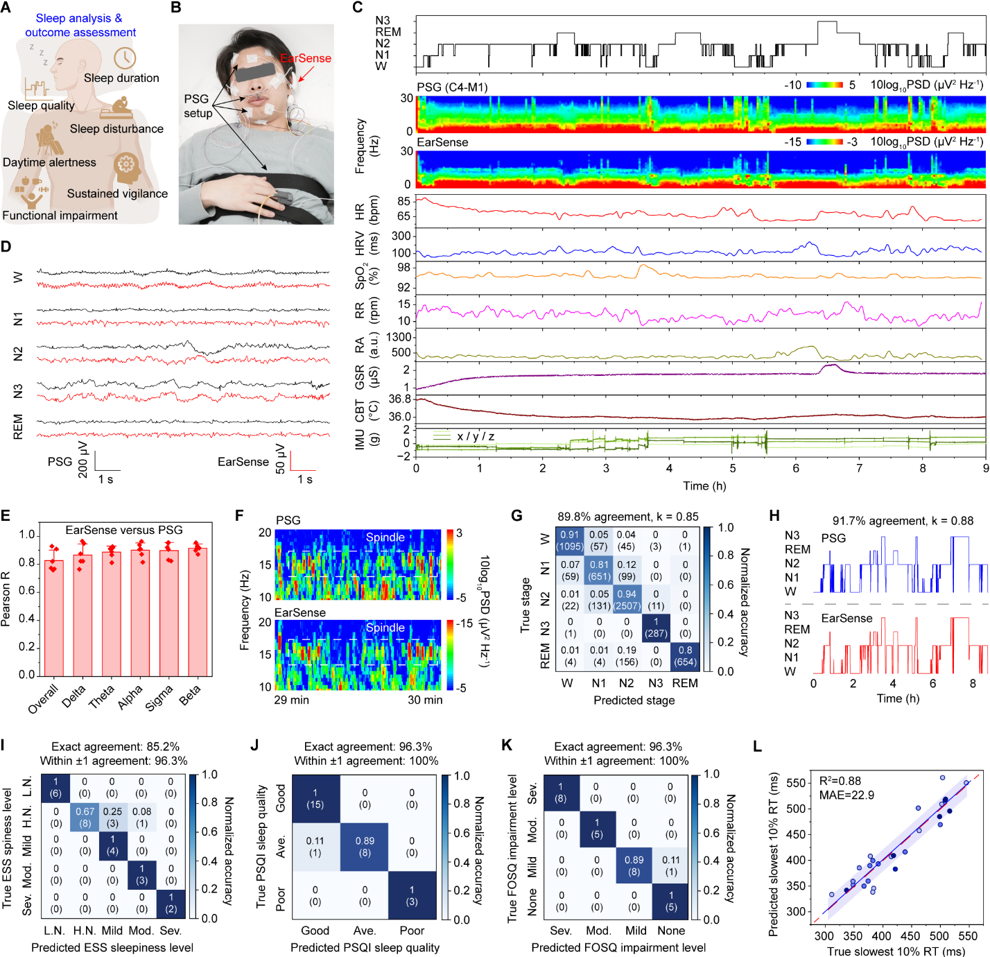
Fig. 5. Overnight sleep monitoring and sleep-informed functional and cognitive performance prediction with EarSense. (A) Conceptual overview of EarSense-enabled sleep monitoring and cognitive assessment, capturing sleep duration, quality, and disturbances, and enabling prediction of next-day sleepiness, functional impairment, and vigilance. (B) Photograph of a participant wearing standard polysomnography (PSG) equipment alongside EarSense during overnight monitoring. (C) Multimodal physiological dynamics recorded throughout sleep, including comparison of EEG spectrograms from EarSense and PSG. W, wake; REM, rapid eye movement; N1–N3, non–rapid eye movement stages 1–3. (D) Representative EEG waveforms across sleep stages (W, N1, N2, N3, REM), showing stage–specific neural rhythms consistent with PSG. (E) Spectrogram similarity between EarSense and PSG, quantified by Pearson correlation across global time–frequency structure and canonical frequency bands. Delta: 0.5–4 Hz; Theta, 4–8 Hz; Alpha, 8–12 Hz; Sigma: 12–16 Hz; Beta, 16–30 Hz. (F) Representative sleep spindle events detected by PSG and EarSense, demonstrating temporal and spectral alignment. (G) Confusion matrix for five-class sleep stage classification (W, N1, N2, N3, REM) using EarSense-derived multimodal data. (H) Comparison of hypnograms from EarSense and PSG, showing 91.7% agreement (Cohen κ of 0.88). (I to K) Classification of next-day subjective outcomes-based on EarSense-derived sleep features: daytime sleepiness (ESS) (I), sleep quality (PSQI) (J), and functional impairment (FOSQ) (K). L.N., lower normal; H.N., higher normal; Mod., moderate; Sev., severe; Ave., average. (L) Predicted versus measured psychomotor vigilance task (PVT) slowest 10% reaction time (RT), demonstrating sleep-informed prediction of next-day vigilance. The dashed line denotes the identity line; the solid line and shaded region represent the regression fit and 95% confidence interval.



Supplementary Materials for

Integrated brain–body physiological monitoring from a smart earbud
Wenjian Li et al.
*Corresponding author. weigao@caltech.edu

The PDF file includes:
Materials and Methods
Text S1 to S4
Figs. S1 to S60
Table S1 to S8
References and Notes

Other Supplementary Material for this manuscript includes the following:
Movie S1 to S5
Materials and Methods
Materials
Polydimethylsiloxane (PDMS; Sylgard 184) was purchased from Dow Inc. Nickel–titanium (NiTi) shape memory alloy was obtained from Luoyang Shengsheng Metal Materials Co., Ltd. Polyimide (PI) films (12.5 μm thick) were purchased from American Durafilm Co., Inc. Rigid and soft 3D-printing resins were purchased from Anycubic Technology Co., Ltd (Standard Resin, clear) and 3DMaterials Co., Ltd (Superflex, clear), respectively. Acrylamide, N,N′-methylenebisacrylamide, ammonium persulfate, N,N,N′,N′-tetramethylethylenediamine, and 3-(trimethoxysilyl)propyl methacrylate were purchased from Sigma-Aldrich. Acetic acid, acetone, ethanol, and isopropanol were purchased from Thermo Fisher Scientific.
Methods
Fabrication and assembly of EarSense
Fabrication of the Au heater and Au electrode. Au heater and biopotential electrodes were fabricated on 12.5-μm-thick PI substrates using photolithography and lift-off processes. After substrate cleaning with acetone and isopropanol, photoresist patterns were defined, followed by electron-beam evaporation of Ti/Au (5/100 nm) at 0.5 and 1.0 Å s⁻¹, respectively. Lift-off was performed in Remover PG (Kayaku Advanced Materials), followed by rinsing with IPA and drying under nitrogen.
Thermal aging of the NiTi SMA. NiTi SMA sheets were clamped between glass slides and thermally aged at 450 °C for 8 h under external loading to maintain a straight geometry, followed by quenching in room-temperature water.
Synthesis of the WR-IC-PAAm hydrogel. WR-IC-PAAm hydrogel was prepared from a degassed precursor containing AAm (23 wt%), MBAA (0.051 wt%), and APS (0.043 wt%), followed by addition of TEMED (0.0575 wt%) to initiate polymerization. The precursor was cast in a PDMS mold and cured at 60 °C for 15 min. To strengthen hydrogel–Au adhesion, Au substrates were solvent-cleaned, oxygen-plasma treated for 10 min, and functionalized with 2 wt% TMSPMA in aqueous solution (pH 3.5) for 2 h before in situ hydrogel curing. The resulting hydeogel was then equilibrated for 6 h in 3 M LiCl solution containing glycerol/water (66.6/33.3 vol%) (figs. S15 and S16).
Fabrication of the actuator-hydrogel interface. As shown in fig. S14, uncured PDMS (10:1 prepolymer:crosslinker) was spin-coated on glass, cured at 80 °C for 2 h, peeled off, and laser-cut into 5 × 30 mm strips. The strips were prestretched and fixed on a second glass substrate. After oxygen-plasma treatment of the prestretched PDMS and NiTi SMA, an ultrathin layer of uncured PDMS was applied as an adhesive, and the SMA strip was laminated onto the PDMS and cured at 80 °C for 2 h. A thin-film Au/PI heater was attached to the SMA side, and a thin-film Au/PI biopotential electrode was bonded to the PDMS side. After laser release, the hydrogel electrode was formed in situ on the Au electrode using a 3D-printed mold.
Assembly of EarSense. The enclosure was designed in SolidWorks and fabricated by stereolithography (Mars 3 Pro, Elegoo) using rigid and soft resins. A PDMS ear tip was molded using 3D-printed molds. Circular stainless-steel electrodes serving as GSR, reference, and ground contacts, together with two parallel-connected lithium-ion batteries, were integrated into the ear hook and connected to the central FPCB. Within the main enclosure, charging electrodes, metal plates, and magnetic switches were integrated for aligned charging and power control, after which the central FPCB was installed. For the tip module, a two-part 3D-printed holder was used to mount the IR thermometer and its FPCB extension. Stainless-steel electrodes on the inner surfaces of the ear-tip holder served as biopotential conduction pathways, whereas electrodes on the outer surfaces of the temperature holder provided electrical interconnects to heaters. All leads were routed to the main circuit, and the temperature holder, actuator support, and ear-tip holder were assembled into an integrated tip module. The device was then wired, enclosed, and sealed to complete EarSense (Fig. 1C, Fig. 3A, and fig. S2).
Mechanical and materials characterization
Mechanical characterization. Tensile tests of WR-IC-PAAm hydrogels with varying LiCl contents were characterized with a force gauge (M5-50, Mark-10) using dog-bone samples (fig. S18). Interfacial adhesion between the hydrogel and Au substrate was evaluated by a standard 180° peel test (ASTM F2256) (fig. S15). The elastic modulus of the SMA was measured by a cantilever probing test using a strain gauge–based force sensor (HBTLM619BL, Haibo Sensor) coupled to an HX711 ADC module (SparkFun), with displacement controlled by a tensile testing machine (fig. S6A). Actuator contact pressure was characterized using the same force sensor in a cantilever configuration with a 2.5 V DC bias applied to the integrated Au heater; restoring force during cooling-driven recovery was recorded at adjustable vertical gaps to emulate ear canals of different diameters.
SMA phase and crystalline structure characterization. Differential scanning calorimetry (DSC) of original and thermally aged NiTi SMA samples was performed on a DSC 25 (TA Instruments). Samples were cooled from room temperature to 0 °C at 1 °C min⁻¹, heated to 80 °C at the same rate, and cooled back to 0 °C; the cycle was repeated three times while heat flow was recorded (fig. S4). X-ray diffraction (XRD) patterns were collected on a Rigaku SmartLab diffractometer with Cu Kα₁ radiation (50 kV, 40 mA) (fig. S5).
Hydrogel water retention characterization. Water retention abilities of WR-IC-PAAm hydrogel and commercial electrodes, including a saline wet gel (Parker Signa Gel) and an Ag/AgCl semi-dry electrode (3M Red DotTM 2560), were tested in parallel and stored at 25 or 37 °C and 50% relative humidity. For mass measurements, the saline gel was placed on weighing paper, and the Ag/AgCl gel was removed from the patch backing and metal connector. Remaining mass was recorded over 24 h and over 7 days to evaluate water retention (figs. S16 and S22).
In vivo tissue damage under long-term actuator contact
An in vivo rat model was used under protocols approved by the California Institute of Technology Institutional Animal Care and Use Committee (protocol no. IA23-1800). Twelve-week-old male Long–Evans rats wore a custom jacket-mounted 3D-printed holder that maintained continuous actuator tip contact with the dorsal skin. After 7 or 14 days, skin tissues were collected, fixed in 4% paraformaldehyde overnight, dehydrated, paraffin-embedded, sectioned, and stained with hematoxylin and eosin for histological analysis.
Electronic system design and characterization
The EarSense electronic system was implemented on a four-layer FPCB (34.3 mm × 15.15 mm × 1 mm) designed in Eagle CAD and powered by two lithium-ion batteries (Lanzhd 801525, 300 mAh each), providing 3.7 V and a total capacity of 600 mAh. Charging was enabled through exposed contact pads interfacing with a custom dock, while magnetic reed switches (MK24-B-3-OE, Standex-Meder Electronics) disconnected the main PCB during charging. Power management used a boost converter (TPS63070RNMR, Texas Instruments) followed by low-dropout regulators (ADM7172CP, Analog Devices) to generate stabilized 5 V and 3.3 V rails. Electrophysiological signals were acquired using an eight-channel analog front-end (ADS1299IPAG, Texas Instruments). PPG, inertial motion, and tympanic temperature were measured using a MAXM86161 optical sensor (Analog Devices), a BMI270 accelerometer (Bosch Sensortec), and an MLX90632SLD infrared sensor (Melexis Technologies), respectively. All sensing modules interfaced with an ESP32-PICO-MINI microcontroller (Espressif Systems) through I²C or SPI, with on-board Bluetooth Low Energy for wireless transmission. GSR was measured using the on-chip ADC with discrete analog front-end circuitry, and actuator heating was controlled by an N-channel MOSFET (DMN3731U-13, Diodes Incorporated). The full circuit schematic is shown in fig. S43. Power consumption was characterized using a Nordic PPK2 power profiler, with subsystem-level breakdowns shown in fig. S44.
On-body sensing performance characterization
On-body characterization of the electrodes, actuator, and integrated sensors was performed on healthy participants with no history of any ear-related infection and disorders under protocols approved by the California Institute of Technology Institutional Review Board (IRB no. 25-1537). Before testing, ear canals were cleaned using non-mechanical over-the-counter ear-cleaning solutions under investigator supervision.
Electrode-ear impedance characterization. Electrode–ear impedance was measured using a CHI760e electrochemical workstation in a three-electrode configuration. The same electrode material was used for the working, reference, and counter electrodes to enable direct comparison among WR-IC-PAAm and commercial electrodes. The working electrode was placed on the actuator in contact with the ear canal, whereas the reference and counter electrodes were positioned around the mastoid region (Fig. 2A). Electrochemical impedance spectroscopy was performed with a 5 mV excitation and 2 s quiet time over 1 Hz–1 kHz; for frequencies above 100 Hz, single-frequency mode was used.
Alpha modulation measurement and analysis. Alpha modulation was evaluated using a standard eyes-open/eyes-closed paradigm. Participants remained relaxed with eyes open for 30 s, followed by 30 s with eyes closed. EEG was recorded at 1 kHz, band-pass filtered from 1 to 50 Hz, and analyzed in LabChart 8 using time–frequency spectrograms and power spectral density (PSD) with a 4k FFT, Welch windowing, 50% overlap, and removal of the zero-frequency component. The AM ratio was defined as the mean alpha-band power (8–12 Hz) during eyes closed ($P_{eyes closed}$) relative to that during eyes open ($P_{eyes open}$):
$AM ratio= \frac{P_{eyes closed}}{P_{eyes open}}= \frac{\frac{1}{N}\sum_{f_{i} ∈[8, 12 Hz]}{P_{eyes closed} (f_{i})}}{\frac{1}{N}\sum_{f_{i} ∈[8, 12 Hz]}{P_{eyes open} (f_{i})}}$ (1)
where P(𝑓_{𝑖}) denotes the EEG power at frequency 𝑓_{𝑖}, and 𝑁 is the number of frequency bins.
The AM SNR was defined as the ratio of mean alpha-band power during eyes closed to the mean surrounding-band power ($P_{noise}$) from 5 to 15 Hz excluding the alpha range:
$P_{noise}=\frac{1}{N} \sum_{f_{i}∈\left[5,15 Hz\right], { f}_{i}∉[8,12 Hz]}{P_{eyes closed}(f_{i})}$ (2.1)
$AM SNR= \frac{P_{eyes closed }}{P_{noise}}$ (2.2)
ASSR measurement and analysis. ASSR were elicited using a 1 kHz pure tone amplitude-modulated at 45 Hz with 100% modulation depth. Stimuli were sampled at 44.1 kHz, and presented binaurally through Bluetooth headphones at 75 dB for 2 min while participants remained relaxed and stationary. ASSR signal processing was identical to that used for AM, except for a 1–55 Hz band-pass filter and processed a 32k FFT. The ASSR SNR was calculated as the ratio of the PSD at the stimulation frequency ($P(f_{ASSR})$) to the mean surrounding-band PSD within $±5$Hz excluding the target frequency bin:
$ASSR SNR= \frac{P(f_{ASSR})}{\frac{1}{N}\sum_{f_{i} ∈\left[f_{ASSR}-5, { f}_{ASSR}+5 Hz\right], { f}_{i}≠ f_{ASSR}}{P(f_{i})}}$ (3)
SSVEP measurement and analysis. Steady-state visual evoked potentials were elicited using a 10 Hz full-screen black–white flicker generated on a 1920 × 1080 display. The stimulus was presented continuously for 30 s while participants fixated on the screen at a distance of 60 cm. SSVEP signal processing was identical to that used for AM, except for a 16k FFT. The SSVEP SNR was defined as the ratio of the PSD at the stimulation frequency ($P(f_{SSVEP})$) to the mean PSD within the surrounding $±5$Hz band excluding the target bin:
$SSVEP SNR= \frac{P(f_{SSVEP})}{\frac{1}{N}\sum_{f_{i} ∈\left[f_{SSVEP}-5, { f}_{SSVEP}+5 Hz\right], { f}_{i}≠ f_{SSVEP}}{P(f_{i})}}$ (4)
EEG resistance to EOG, facial and motion artifact. Artifact tolerance of ear EEG was assessed by intentionally introducing ocular, facial, and motion artifacts during continuous recording. Ocular artifacts included gentle and heavy blinking and directional gaze shifts (fig. S30). Facial artifacts included a closed-jaw grin showing the upper teeth and a mouth-open task standardized to a two-finger width, with photo examples provided (fig. S31, A to D). Motion artifacts were evaluated during slow head rotation to the left and right (fig. S31E).
PPG signal processing. Green-light PPG (530 nm) was used for HR and RR estimation, whereas red (660 nm) and IR (880 nm) PPG were used for SpO₂ estimation. For HR and RR analysis, the green-channel signal was band-pass filtered at 0.5–5 Hz and 0.1–0.8 Hz, respectively (Fig. 3D). The SNRs of pulse and respiration signals were calculated from the RMS ratio between the bandpass filtered green-light PPG signal and high-frequency noise estimated by high-pass filtering above 5 Hz (fig. S46):
$SNR=20*\log_{10}\frac{{RMS}_{PPG}}{{RMS}_{noise}}$ (5)
For SpO₂ estimation, red and IR PPG signals were band-pass filtered between 0.5 and 5 Hz. SpO₂ was derived from ratio of AC-to-DC ratios, R = (AC_{red} ​/ DC_{red}​) / (AC_{IR} ​/ DC_{IR}​), using SpO₂ = 110 − 22R.
Monitoring of daily activities using EarSense
The fully assembled EarSense was evaluated in on-body applications including daily activity monitoring, affective-state assessment, and overnight sleep monitoring. In the integrated wireless system, EEG, PPG, core body temperature, GSR, and IMU were sampled at 200, 100, 1, 1, and 20 Hz, respectively. All subjects wore EarSense in the left ear to maintain recording from the same hemisphere. Continuous multimodal physiological signals were recorded over 24 h during typical daily activities, including office work, meals, laboratory work, exercise, entertainment, and sleep (Fig. 3G). Data were acquired continuously, with battery recharging performed as needed to maintain uninterrupted recording.
Affective state monitoring using EarSense
Subject recruitment. Affective-state monitoring was conducted on healthy human participants under protocols approved by the California Institute of Technology Institutional Review Board (IRB No. 25-1537). 15 participants (11 males and 4 females; age 25–32 years) were recruited from the Caltech campus and surrounding communities. All participants reported no history of ear infection or other ear-related disorders, no diagnosed anxiety or depression, and no susceptibility to visually induced motion sickness. Written informed consent was obtained from all participants.
Affective state monitoring protocol. Before testing, ear canals were cleaned using over-the-counter non-mechanical ear-cleaning solution, and the postauricular and mastoid regions were cleaned with alcohol wipes to improve electrode contact. Participants were instructed to avoid food, alcohol, caffeine, and exercise for at least 3 h before the experiment. During testing, multimodal physiological signals were recorded continuously with EarSense, and questionnaires were administered after each task. Affective states were assessed using the Positive and Negative Affect Schedule (PANAS) and the State–Trait Anxiety Inventory–Y1 (STAI-Y1).
Cold pressor test (CPT). Participants first rested for 5 min after wearing EarSense, followed by continuous recording during relaxation, CPT, and recovery. The relaxation phase lasted 10 min, followed by a 5-min CPT by immersing one hand up to the forearm in ice water, and finally an additional 10 min recovery phase. PANAS and STAI-Y1 assessments were administrated after each session withn 1 min, during which data acquisition was paused to minimize motion artifacts.
VR challenge. The VR protocol followed the same structure as the CPT except that the induction phase consisted of a 10-min VR task performed with an Oculus Quest 2 headset (Meta). Participants played Epic Roller Coaster, controlled by two finger. To induce psychophysiological stress, participants were instructed to compete against the best score created.
Sleep monitoring using the EarSense
Subject recruitment. Sleep monitoring was conducted in healthy participants and patients with sleep disorders under protocols approved by the Institutional Review Boards of the California Institute of Technology (IRB no. 25-1537) and the University of Southern California (IRB no. HS-25-00143). Healthy participants were recruited from the Caltech campus and surrounding communities, while patients were recruited at the USC Sleep Disorders Center following clinical diagnosis by polysomnography (PSG) during their initial evaluation. In total, 20 healthy participants (15 males and 5 females; age 23–34 years) and 7 patients (4 males and 3 females; age 30–47 years) were enrolled. 6 patients underwent simultaneous PSG and EarSense monitoring at the USC Sleep Disorders Center, whereas the remaining participants were studied at the Caltech sleep laboratory using EarSense alone. All participants reported no history of ear-related infection and disorders. Written informed consent was obtained from all participants, who received a stipend of $200.
Sleep monitoring protocol. Participants were instructed to shower at least 2 h before the study and arrived at the laboratory at least 1 h before their habitual sleep time. Before EarSense placement, participants completed the Stanford Sleepiness Scale (SSS) and Epworth Sleepiness Scale (ESS). EarSense and, when applicable, PSG electrodes were then applied following ear-canal and skin preparation. Continuous overnight recording began when participants were ready to sleep, without a fixed sleep duration. Upon awakening, devices were removed and participants completed the SSS, ESS, Functional Outcomes of Sleep Questionnaire (FOSQ), and Pittsburgh Sleep Quality Index (PSQI), followed by a 10-min psychomotor vigilance task (PVT).
Questionnaires for sleep quality evaluation. Subjective sleep outcomes were assessed using the SSS, ESS, FOSQ-30, and PSQI. ESS total scores ranged from 0 to 24 and were categorized into lower normal (0–5), higher normal (6–10), mild excessive (11–12), moderate excessive (13–15), and severe excessive (16–24) daytime sleepiness (45). Global PSQI scores ranged from 0 to 21 and were categorized as good (0–5), average (6–10), poor (11–15), and very poor (16–21) sleep quality (46, 47). FOSQ-30 global scores ranged from 5 to 20, with scores ≤17.9 indicating functional impairment (48). For analysis, scores were categorized into severe (5–12.9), moderate (13–15.9) and mild functional impairment (16–17.9), as well as normal (18–20) functional status.
PVT test. During the 10-min PVT, participants pressed the spacebar as quickly as possible when a visual stimulus appeared at the center of the screen. Each trial began with a fixation cross followed by the response cue after a randomized delay. Anticipatory responses (RT < 100 ms) and time-out responses (>3000 ms) were excluded. Lapses were defined as RT ≥ 500 ms, and lapse rate was normalized by valid trial count (49, 50). The primary metric used for subsequent analysis was the mean slowest 10% reaction time, which captures the tail of the reaction-time distribution and is sensitive to vigilance lapses.
Sleep stage scoring. For participants undergoing PSG, sleep stages (W, N1, N2, N3, and REM) were scored by a trained sleep technician according to American Academy of Sleep Medicine criteria using Natus SleepWorks software. For EarSense-only recordings, sleep stages were manually scored by a trained technician following standardized home-PSG scoring guidelines.
Sleep EEG correlation and spindle analysis. Sleep EEG correlation between EarSense and PSG (C4–M1), including the overall spectrogram and canonical band-specific spectral profiles (delta to beta), was assessed using multi-taper–processed EEG signals. Sleep spindles were detected during N2 sleep after band-pass filtering within slow (11–13.5 Hz), fast (13.5–16 Hz), and combined (12–16 Hz) spindle bands. Candidate events were identified from the Hilbert-envelope amplitude using thresholds derived from the N2 distribution, with durations constrained to 0.5–2.0 s and gaps <0.2 s merged.
ML for ECG reconstruction (ECGnet)
Data preprocessing and augmentation. Continuous in-ear composite biopotentials and reference arm ECG were temporally aligned and segmented into overlapping 2-s windows (50% overlap). During training, stochastic augmentation was applied with 50% probability, including random amplitude scaling $\left(U(0.8,1.2)\right)$and time warping by linear interpolation $\left(U(0.9,1.1)\right)$, followed by random cropping.
ECGnet architecture. ECGnet is a one-dimensional convolutional encoder–attention–decoder network (Fig. 2L; fig. S38). The encoder consisted of two convolutional layers (kernel sizes 15 and 11), each followed by instance normalization, ReLU activation, and max pooling (stride = 2). A self-attention block was introduced at the bottleneck to capture long-range dependencies across cardiac cycles. Encoded features were projected into query, key, and value representations using $1×1$convolutions, and the resulting attention-enhanced features were fused with the original features through a residual connection with a learnable scaling factor $γ$. The decoder used two transposed convolution layers (kernel sizes 11 and 15, stride = 2) to reconstruct a single-channel ECG waveform.
Model training, signal reconstruction and post-processing. To preserve spectral and morphological fidelity, ECGnet was trained using a focal frequency loss together with a multi-scale peak loss computed at the original, 2× downsampled, and 4× downsampled resolutions, weighted by 0.5, 0.3, and 0.2, respectively. Spatial weighting based on the normalized absolute temporal gradient of the reference ECG was further applied to emphasize sharp waveform features such as R-peaks.
Continuous ECG signals were reconstructed using a weighted overlap-add strategy with a Hann window and subsequently smoothed using a one-dimensional Gaussian filter ($k=31$, $σ=5.0$). Reconstruction performance relative to the reference arm ECG was evaluated using MSE, MAE, Pearson correlation coefficient ($r$), cosine similarity, SNR, and percentage root mean square difference (PRD), reported as mean ± s.d. with 95% confidence intervals.
ML for affective state analysis
Signal processing and feature extraction. Raw signals were cleaned by removing missing or non-finite samples and identifying recording gaps. EEG and ECG were band-pass filtered from 1 to 50 Hz, and PPG was separated into pulse-related (0.5–5 Hz) and respiration-related (0.1–0.8 Hz) components. GSR, CBT, and IMU were used without additional filtering. Signals were segmented into synchronized non-overlapping windows across modalities, using 30 s epochs for EEG, ECG, PPG, GSR, and CBT, and 5 s windows for IMU. Feature sequences were truncated to the minimum window count across modalities to preserve alignment.
Modality-specific features were extracted from each epoch. EEG features included Hjorth parameters, band powers, band ratios, spectral entropy, mean and peak frequencies, and time-domain statistics. ECG features included heart rate, RR interval statistics, and time- and frequency-domain HRV metrics. PPG features included pulse rate, beat-interval statistics, respiration features, channel-wise statistics, and cross-channel ratios. GSR, CBT, and IMU features included descriptive statistics together with slope, derivative, motion-intensity, and dominant-frequency measures as appropriate.
Model training and interpretation. Labels were derived from session-level PANAS and STAI-Y1 scores and assigned to all epochs within the corresponding session. Constant features were removed using a variance threshold. Features were normalized within each subject using baseline recordings and then z-score standardized using parameters estimated from the training folds only. Models were trained and evaluated by cross-validation, with performance assessed exclusively on held-out folds.
Model interpretability was assessed using SHAP (Fig4. K and L). Tree-based, linear, and other nonlinear models were analyzed using TreeExplainer, LinearExplainer, and KernelExplainer, respectively. SHAP values were computed on held-out test samples and aggregated across folds to generate global attribution and decision plots.
ML for sleep staging and functional and cognitive performance prediction
Signal processing and contextual input construction. EarSense overnight multimodal recordings in European Data Format were paired with technician-scored hypnograms (Wake, N1, N2, N3, REM), and their timestamps were aligned. Data were segmented into 30s epochs with a sleep-stage label. All signals were resampled to 100 Hz and band-pass filtered (EEG: 0.5–45 Hz; ECG: 0.5–40 Hz; PPG: 0.5–8 Hz; IMU: 0.1–15 Hz). Each epoch was independently z-score normalized, and adjacent epochs were concatenated such that the input for target epoch $t$was $\left[t-1,t,t+1\right]$. During training, data augmentation was applied with 70% probability, including random temporal shifts (≤80 samples), amplitude scaling (0.9–1.1), Gaussian jitter ($σ=0.01$), and random masking of up to two temporal segments (maximum length 250 samples).
Sleep stage classification. Sleep staging was performed using a one-dimensional convolutional neural network with residual connections, squeeze-and-excitation blocks, and dilated convolutions. The network consisted of a stem convolution layer (kernel size 11, stride 2) followed by four stages of residual blocks containing parallel convolutional paths (kernel sizes 5 and 7), dropout (0.15), and squeeze-and-excitation recalibration ($r=8$). Dilation rates increased from 1 to 8, while channel dimensions increased from 32 to 128. Intermediate stages used stride-2 convolutions for temporal downsampling, and final features were aggregated by adaptive average pooling and passed to a two-layer multilayer perceptron classifier.
To address class imbalance and the ambiguity of N1 sleep, a two-stage cascade strategy was used. Stage 1 was trained as a binary classifier to distinguish N1 from all other stages using inverse-square-root weighted sampling. Stage 2 classified non-N1 epochs into Wake, N2, N3, and REM using inverse-frequency sampling. Both stages were optimized with AdamW (learning rate $1×{10}^{-3}$, weight decay $1×{10}^{-4}$) and cosine-annealing scheduling. The loss combined focal loss ($γ=2.0$) with label smoothing (0.03 for Stage 1; 0.05 for Stage 2). During inference, the Stage 1 N1 probability was nonlinearly down-weighted ($α=1.4$), and the remaining probability mass was redistributed across the Stage 2 outputs to reconstruct the final five-class probability distribution.
Sleep-derived functional and cognitive performance prediction.
Each epoch was converted into a multimodal feature vector containing time- and frequency-domain descriptors. EEG features included summary statistics and canonical band powers. ECG and PPG features included amplitude and variability descriptors together with peak-rate proxies, whereas IMU features were derived from the magnitude of the three-axis acceleration. Epoch-level features were aggregated into subject-level representations using mean, standard deviation, selected quantiles ($q_{10},q_{50},q_{90}$), temporal-instability measures, and coarse sleep-architecture surrogates, and concatenated into the final feature vector $z_{i}$.
ESS, FOSQ-30, and PSQI outcomes were grouped into discrete categories and predicted using multinomial logistic regression with $L_{2}$regularization, inverse-frequency class weights, and leave-one-subject-out validation. Next-day vigilance was predicted from $z_{i}$using a multilayer perceptron regressor with fully connected layers and ReLU activations, with the mean slowest 10% reaction time as the target. Regression performance was evaluated using MAE, RMSE, and $R^{2}$.
Text S1 Physiological and anatomical basis of integrated brain-body sensing from the ear
The human ear provides a unique anatomical and physiological site for integrated multimodal sensing. Conventional physiological monitoring distributes sensors across multiple body locations, such as the scalp for electroencephalography (EEG), the chest for electrocardiography (ECG), peripheral sites for photoplethysmography (PPG), respiration, and temperature. In contrast, the ear’s compact structure and vascular connectivity enable simultaneous access to neural, cardiac, respiratory, thermal, and autonomic signals from a single location. This capability arises from the proximity of the auditory canal to cortical structures, the propagation of cardiac electrical fields through conductive tissues, the rich vascularization of the auricular region, and the thermal coupling between the tympanic membrane and central circulation (Fig. 1A).
The ear canal lies in close proximity to cortical regions that generate prominent EEG rhythms. Compared with scalp recordings, which are affected by hair, skin, and cranial musculature, the ear canal provides a near-hairless conductive pathway that reduces signal attenuation. The temporal and temporoparietal cortices, involved in sensory processing, attention, and sleep regulation, are located adjacent to the auditory canal, allowing neural activity to be detected using in-ear or peri-auricular electrodes (51). The semi-enclosed geometry of the ear canal further reduces environmental interference and mechanical artifacts from facial and jaw movements. (52, 53), enabling reliable detection of canonical EEG features, including alpha and theta rhythms, slow-wave activity, and transient events such as sleep spindles.
Cardiac activity is also detectable at the ear through volume conduction. Electrical activity generated by the heart propagates throughout the body as a time-varying dipole field (54). Blood, as a highly conductive medium, facilitates transmission of these signals along vascular pathways supplying the head. The carotid arteries pass near the ear and branch into vessels supplying the auricular and temporal regions, while the internal carotid artery traverses the temporal bone near the middle and inner ear. These pathways enable cardiac potentials to reach the ear, allowing detection of R-peaks and beat-to-beat timing (55). Although signal amplitudes are smaller than at the chest, they remain sufficient for extracting heart rate and heart-rate variability.
Respiratory dynamics can be inferred from cardiovascular modulation preserved in the auricular vasculature (56). The ear is highly vascularized, providing strong pulsatile signals suitable for PPG (57). Respiratory cycles modulate intrathoracic pressure, influencing venous return, stroke volume, and arterial pressure, which manifest as periodic amplitude variations in PPG signals. Compared with peripheral sites prone to vasoconstriction and motion artifacts, the ear canal maintains relatively stable perfusion, enabling reliable extraction of respiration rate and respiratory-coupled cardiovascular dynamics (58).
The tympanic membrane provides a robust proxy for core body temperature (CBT). It is thin, highly vascularized, and supplied by branches of both the external and internal carotid arteries (59), carrying blood representative of the central circulation. Its direct thermal coupling to cerebral blood flow allows tympanic temperature to closely track brain temperature. The semi-enclosed ear canal minimizes heat exchange with the environment, improving measurement stability compared with skin temperature. These properties underpin the widespread clinical use of tympanic thermometry as a noninvasive indicator of CBT.
The peri-auricular region also enables monitoring of autonomic activity through electrodermal signals. The postauricular skin contains eccrine sweat glands innervated by sympathetic cholinergic fibers (59, 60), allowing changes in autonomic arousal to manifest as measurable variations in skin conductance. This region is relatively protected from airflow and mechanical disturbance, providing a stable site for electrodermal sensing.
Together, these anatomical and physiological features establish the ear as a compact and integrated sensing site where neural, cardiovascular, respiratory, thermal, and autonomic signals converge. This co-localization enables synchronized monitoring of multiple physiological systems from a single wearable interface and supports integrated analysis of brain–body dynamics in applications such as sleep, stress, and cognitive performance.

Text S2 Mechanism of the bilayer PDMS-SMA actuator
The actuation and recovery of a PDMS–SMA bilayer can be described as the temperature-dependent equilibrium of a perfectly bonded composite beam driven by mismatched eigenstrains. Consider a slender bilayer of width b consisting of a PDMS layer of thickness t_{p} bonded to an NiTi SMA sheet of thickness t_{s}. Let z denote the through-thickness coordinate with z=0 at the interface, z>0 within PDMS, and z<0 within SMA.
Under Euler–Bernoulli kinematics, the axial strain field is assumed linear through thickness,
ε(z)=ε0​+κz (6.1)
where ε0 is the uniform axial strain of the composite midline and k is the curvature of the bilayer. The mechanical strain that generates stress in each layer is the deviation of εz from that layer’s eigenstrain $ε_{i}^{\text{\backslash *}}(T)$, which represents the strain the layer would adopt if unconstrained at temperature $T$.
For PDMS, the dominant eigenstrain comes from the pre-stretch during bonding. Assume the PDMS have original free length $L_{0}$ and is stretched to $λL_{0}$ during bonding, the pre-stretch eigenstrain can be approximated as $ε_{\text{pre}}≈λ-1$. Including thermal expansion of PDMS, the PDMS eigenstrain can be written as
$ε_{p}^{\text{\backslash *}}(T)=ε_{\text{pre}}+α_{p} (T-T_{\text{bond}})$ (6.2)
where $α_{p}$ is the coefficient of thermal expansion (CTE) of PDMS and $T_{\text{bond}}$ is the bonding temperature.
For SMA, the eigenstrain contains a transformation component and thermal expansion,
$ε_{s}^{\text{\backslash *}}(T)=ε_{\text{tr}}(T)+α_{s} (T-T_{\text{bond}})$ (6.3)
where $ε_{\text{tr}}(T)$ is the temperature-dependent transformation eigenstrain associated with the martensite–austenite transition and $α_{s}$ is the SMA CTE. The SMA elastic modulus is also temperature dependent, $E_{s}(T)$, transitioning from a lower martensitic modulus $E_{M}$ to a higher austenitic modulus $E_{A}$. The PDMS modulus $E_{p}$ is treated as an effective tangent modulus about the operating strain.
With these definitions, the axial stresses in the two layers can be expressed as,
$σ_{p}\left(z,T\right)=E_{p}\left(ε_{0}+κz-ε_{p}^{\text{\backslash *}}\left(T\right)\right),0≤z≤t_{p}$ (6.4)
$σ_{s}(z,T)=E_{s}(T)(ε_{0}+κz-ε_{s}^{\text{\backslash *}}(T)),-t_{s}≤z≤0$ (6.5)
Because the actuator is free-standing, the cross-sectional resultants must satisfy net axial force $N=0$ and net bending moment $M=0$:
$N=b\left(\int_{0}^{t_{p}}{σ_{p}dz}+\int_{-t_{s}}^{0}{σ_{s}dz}\right)=0$ (6.6)
$M=b(\int_{0}^{t_{p}}{σ_{p}zdz}+\int_{-t_{s}}^{0}{σ_{s}zdz}σ_{s}z)=0$ (6.7)
Carrying out these integrations yields two coupled linear conditions for $ε_{0}$ and $κ$:
$E_{p}[(ε_{0}-ε_{p}^{\text{\backslash *}})t_{p}+\frac{1}{2}κt_{p}^{2}]+E_{s}(T)[(ε_{0}-ε_{s}^{\text{\backslash *}})t_{s}-\frac{1}{2}κt_{s}^{2}]=0$ (6.8)
$E_{p}[(ε_{0}-ε_{p}^{\text{\backslash *}})\frac{t_{p}^{2}}{2}+κ\frac{t_{p}^{3}}{3}]+E_{s}(T)[-(ε_{0}-ε_{s}^{\text{\backslash *}})\frac{t_{s}^{2}}{2}-κ\frac{t_{s}^{3}}{3}]=0$ (6.9)
Solving these equations gives the temperature-dependent equilibrium curvature $κ(T)$ and average axial strain $ε_{0}(T)$. It shows that bending is not controlled by the stress level of one layer alone but by how the eigenstrain mismatch and stiffness contrast shape the self-equilibrated force and moment resultants.
In the room-temperature state, the SMA is predominantly martensitic, so $E_{s}(T)≈E_{M}$, and $ε_{\text{tr}}(T)$ is small relative to the large PDMS pre-stretch eigenstrain. The effective mismatch $ε_{p}^{\text{\backslash *}}-ε_{s}^{\text{\backslash *}}$ is therefore large, and the equilibrium solution typically yields a substantial curvature. Physically, the structure lowers elastic energy by redistributing the large PDMS pre-stretch through thickness via bending rather than attempting a uniform contraction that would require larger incompatible axial forces. The PDMS is globally still longer than its original $L_{0}$, so it remains predominantly in tensile stress relative to the $L_{0}$ reference, while the SMA carries the complementary stress required by $N=0$ and $M=0$.
Upon heating, two concurrent SMA effects drive straightening. First, $E_{s}(T)$ increases significantly toward $E_{A}$, giving the SMA stronger leverage in both force and moment balance. Second, $ε_{\text{tr}}(T)$ evolves toward the trained austenitic state, and its preferred austenitic length is close to the bonding length, the effective eigenstrain mismatch decreases with temperature. In the equilibrium equations, these changes shift the solution toward smaller $∣κ∣$. The hot-state actuator is therefore nearly straight, because the through-thickness stress distribution rearranges to make the net bending moment small while maintaining zero net axial force. Because $E_{A}≫E_{p}$, only a very small additional mechanical strain in the SMA is required to balance substantial PDMS-driven internal forces, so the actuator realizes a “near-complete straightening” state with only a small residual curvature. On cooling, $E_{s}(T)$ decreases back toward $E_{M}$ and $ε_{\text{tr}}(T)$ reverses along a hysteretic path, rebuilding the mismatch and restoring the cold-state curvature. Within this eigenstrain–equilibrium framework, the reversible sequence of bent at low temperature, nearly straight at high temperature, and bent again on cooling emerges naturally from compatibility, temperature-programmable SMA eigenstrain, and the strong modulus contrast between soft PDMS and phase-transforming SMA.

Text S3 Thermal aging of NiTi SMA
Thermal aging of near-equiatomic NiTi SMA at 400 °C for ~8 h induces coupled changes in thermodynamics, microstructure, and functional response that link precipitation chemistry to calorimetric kinetics and lattice geometry. Differential scanning calorimetry (DSC) shows that before aging the NiTi alloy features austenite start (A_{s}) and finish (A_{f}) temperatures on heating of 31 °C and 42.5 °C, and martensite start (M_{s}) and finish (M_{f}) temperatures on cooling of 22.9 °C and 8.5 °C. Room-temperature X-ray diffraction (XRD) further indicates that the untreated alloy is dominated by the B2 austenite phase, with a sharp B2(110) reflection at 2𝜃 ≈ 42.4°, and weaker B2(211) and B2(220) peaks at 77.6°and 92.7°, confirming that the alloy remains largely austenitic across the sub-physiological temperature range (< 37 °C).
After aging, the reverse (heating) transformation shifts upward and sharper, with A_{s} ≈ 52.8 °C and A_{f} ≈ 54.4 °C. On cooling, the transformation resolves into two steps: a B2 austenite to R intermediate phase transition at R_{s} ≈ 43.6 °C and R_{f} ≈ 39.6 °C, followed by an R phase to B19′ martensite transition at M_{s} ≈18 °C and M_{f} ≈ 9.7 °C. Notably, the austenitic peak on heating becomes taller and narrower, indicating a more abrupt transformation. Defining the transformed fraction by a scan-rate-corrected DSC signal,
$ξ \left(T\right)= \frac{1}{∆H} \int_{T_{0}}^{T}{\dot{q}}\left(T^{'}\right)dT^{'}$ (7.1)
$∆H= \frac{1}{β}\int_{T_{start}}^{T_{finish}}{\dot{q}(T)dT}$ (7.2)
with $\dot{q}(T)$ is the baseline-corrected heat flow (power per mass), β=dT/dt is the scan rate, T₀ is a reference temperature below onset, and T_{start} ,T_{finish} bound the transformation peaks. A reduced peak width corresponds to a steeper dξ/Dt, i.e., a faster and more temperature-precise phase evolution. If the integrated peak area increases after aging, this would also imply a larger ΔH, consistent with a strengthened or more cooperative transformation. Such sharpening is expected to translate into more rapid and better-defined curvature or recovery-stress changes during thermally driven actuation.
The upward shift and sharpening of the austenitic transformation after thermal aging are attributed to coherent Ni₄Ti₃ precipitation during aging, which sequesters Ni and leaves a slightly Ti-richer B2 matrix (26). This compositional change raises transformation temperatures and, together with precipitate coherency strains, stabilizes the R-phase and sharpens the transformation front. Consistently, room-temperature XRD after aging shows a slight left-shift of B2(110) and additional features in the 38–45° window, indicative of R/B19′ signatures superposed on B2, including peaks near 37.77° and 39.22° [B19′(110)], 41.28° [B19′(011)], 42.59° [B19′(020) shoulder on B2(110)], and 43.72° [R(112)], and 44.75° [B19′(111)]. These diffraction changes suggest that, at room temperature, the aged alloy exhibits increased R/B19′ character relative to the predominantly B2 austenitic untreated alloy, implying a lower effective stiffness in the aged state. Mechanical probing tests on the NiTi cantilevers corroborate this interpretation, showing a reduction in bending modulus from 36.5 GPa before aging to 18.2 GPa after aging.

Text S4 Stress-assisted early straightening below the free-strip A_{S}
Although the aged NiTi SMA shows elevated reverse transformation temperatures in the free state (As ≈ 52.8 °C and Af ≈ 54.4 °C), the bilayer actuator can straighten from its bent stage with a high recovery rate at ~45 °C, a temperature generally considered skin-safe. This seemingly premature recovery arises from the strong stress sensitivity of the reverse transformation when the SMA is mechanically biased by the PDMS layer. In the low-temperature state, the SMA strip sustains a through-thickness stress gradient: the PDMS-adjacent (inner) face is under compression, while the outer face is under tension. Such stress asymmetry is intrinsic to a curved laminate and can be substantial even when the global temperature remains below the nominal free-strip As. The reverse transformation in NiTi follows a Clausius–Clapeyron-type relationship (61, 62), and to first order,
$\frac{dσ}{dT}=C,ΔT≈\frac{σ}{C}$ (8)
where $C$ is a material constant typically on the order of ~6–10 MPa/°C. Under compressive stress ($σ<0$), the local austenite onset is effectively reduced by $∣σ∣/C$, such that an austenitic band can nucleate at the inner face several degrees below the free-strip As measured by DSC (63). This early nucleation is not merely a local phase change; it has system-level mechanical consequences because it increases the local SMA modulus $E_{s}(T)$ as the material shifts toward austenite and simultaneously activates recovery eigenstrain $ε_{s}^{*}(T)$. Both effects enhance the SMA’s ability to counteract the PDMS-driven bending moment, thereby reducing the curvature $κ$. As $κ$ decreases, the tensile bias at the outer NiTi face is relaxed, narrowing the stress asymmetry and lowering the energetic barrier for transformation there. The transformation front can then sweep across the thickness in a cooperative manner, converting a localized, stress-favored nucleation event into rapid macroscopic straightening.
This stress-assisted pathway is further amplified by the aged alloy’s sharpened reverse transformation. A taller, narrower DSC peak implies a steeper transformed-fraction slope $dξ/dT$over the reverse transition, indicating that once the transformation is triggered, the phase fraction evolves more abruptly with temperature. Consequently, the actuator can exhibit a high recovery rate within a narrow effective temperature interval, enabling near-complete straightening around ~45 °C despite the higher free-strip As. In this sense, the bilayer architecture leverages internal bending stresses to “advance” the functional onset of recovery relative to standard DSC-derived values for an unconstrained NiTi strip.

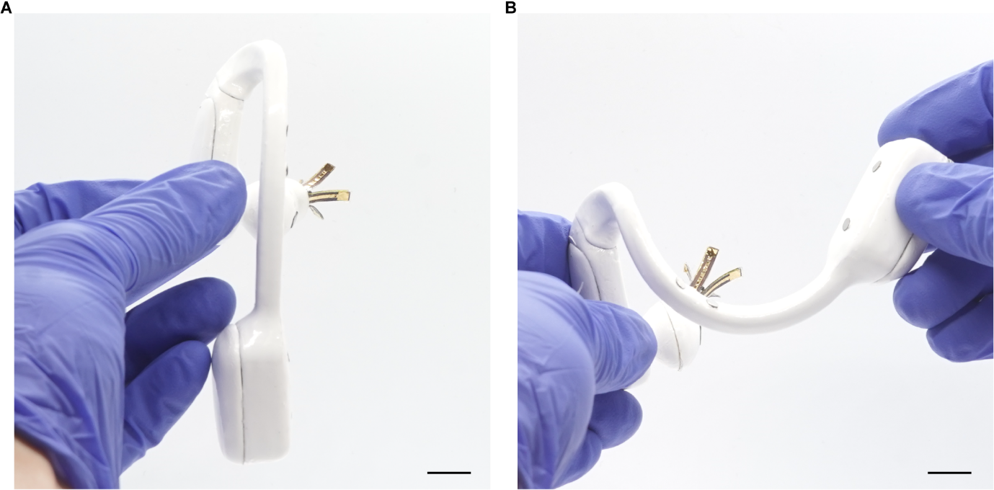
Fig. S1. Mechanical design and flexibility of the EarSense enclosure. (A) Side view of the EarSense showing the compact ear-specific enclosure and soft hook designed for conformal auricular fit. (B) Manual deformation of the enclosure and hook, demonstrating mechanical flexibility for stable and conformal attachment. Scale bars, 1 cm.

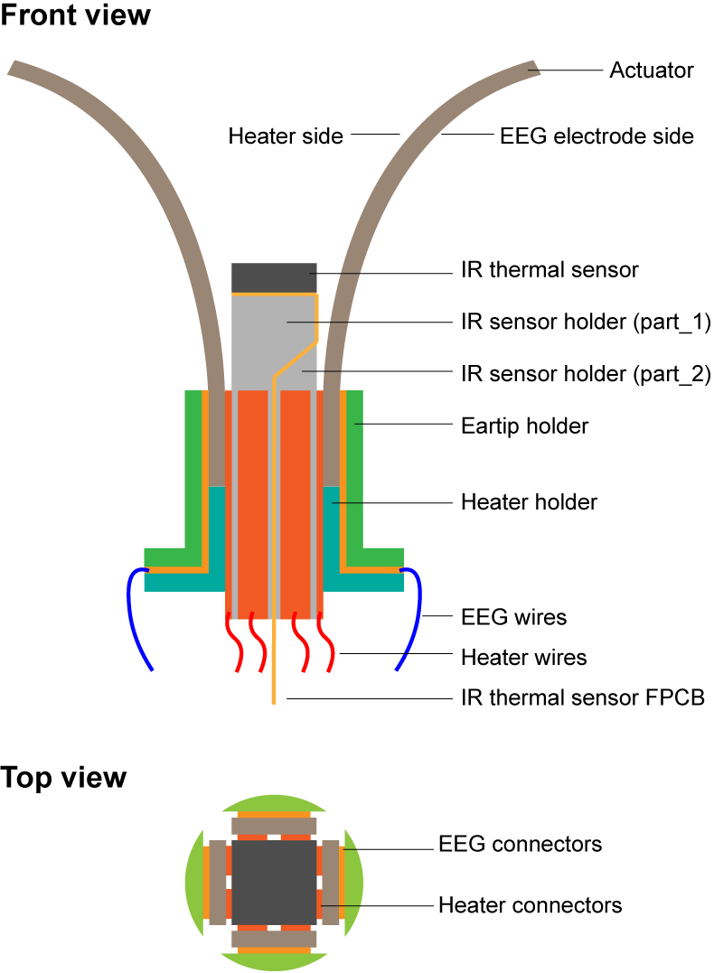
Fig. S2. Structure and electrical interconnects of the tip assembly.

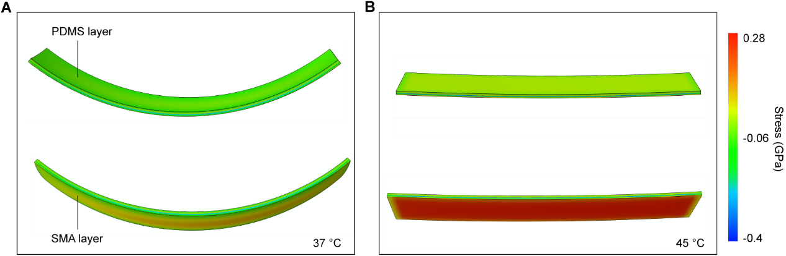
Fig. S3. Finite element analysis (FEA) of actuator deformation and recovery. (A and B) Simulated bending (cooled state, A) and straightening (heated state, B) of the PDMS–SMA bilayer actuator. At low temperature, the SMA layer experiences compression near the PDMS interface and tension at the outer surface, while the pre-stretched PDMS stores elastic strain energy. Upon heating, reverse phase transformation in the SMA generates recovery stress that counteracts PDMS-induced bending and drives the bilayer toward a straight configuration, accompanied by stress redistribution and partial relaxation.

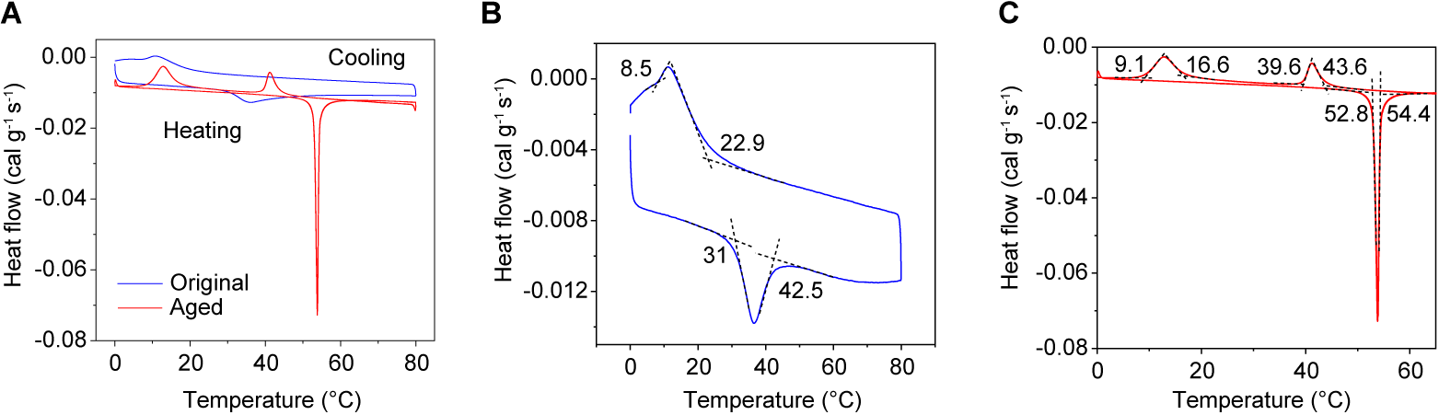
Fig. S4. Differential scanning calorimetry (DSC) characterizations of original and thermally aged SMA. (A) DSC heat-flow curves of original and thermally aged SMA during heating and cooling cycles. (B) Enlarged DSC curve of the original SMA, showing martensitic transformation during cooling occurs with a martensite start temperature (M_{s}) ≈ 22.9 °C and martensite finish temperature (M_{f}) ≈ 8.5 °C and the reverse transformation upon heating with an austenite start temperature (A_{s}) ≈ 31 °C and austenite finish temperature (A_{f}) ≈ 42.5 °C. (C) Enlarged DSC curve of the thermally aged SMA, showing a pronounced upward shift and narrowing of the reverse transformation (As ≈ 52.8 °C; Af ≈ 54.4 °C).

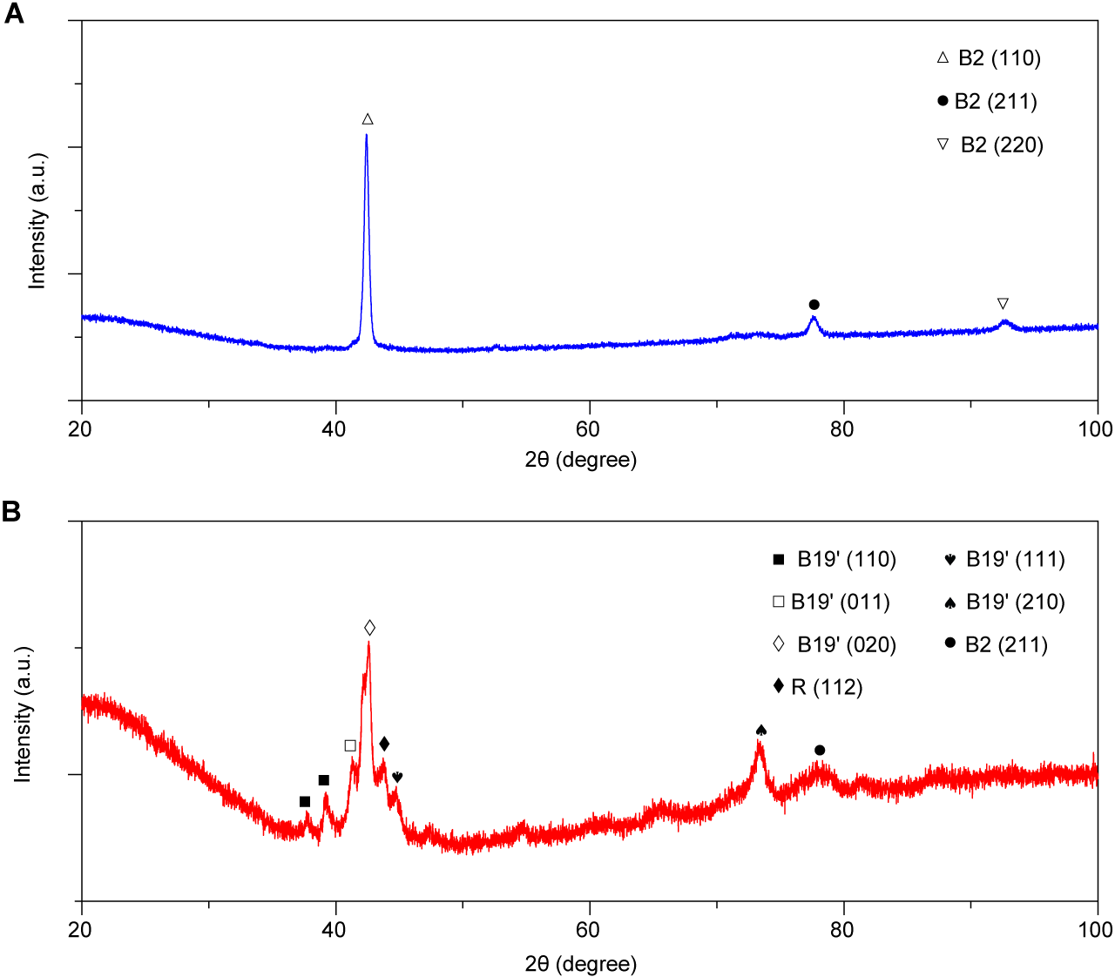
Fig. S5. X-ray diffraction (XRD) characterizations of original and thermally aged SMA. (A) XRD spectrum of the original SMA, showing dominant reflections of the B2 austenite phase, including a strong peak at 2θ ≈ 42.4° [B2 (110)] and weaker peaks at ~77.6° [B2 (211)] and ~92.7° [B2 (220)], indicating predominantly austenitic structure at room temperature. (B) XRD spectrum of the thermally aged SMA, showing a multiphase structure with residual B2 austenite together with peaks corresponding to monoclinic B19′ martensite and the R-phase, indicating phase transformation and microstructural evolution after aging.

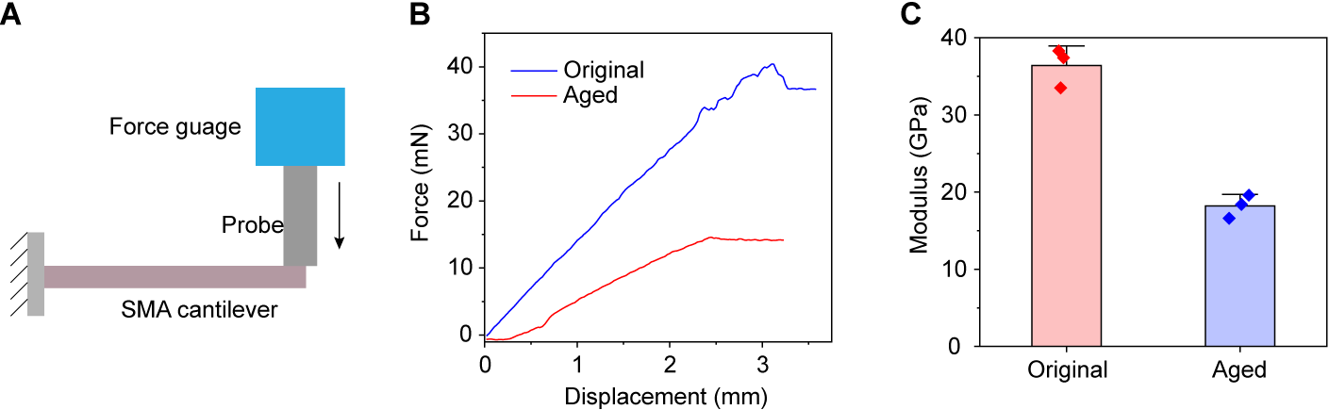
Fig. S6. Mechanical characterizations of original and thermally aged SMA. (A) Schematic of the the cantilever-based modulus measurement setup, where a calibrated force is applied at the free end of the SMA strip. (B) Representative force–displacement curves from bending tests of the original and thermally aged SMA. (C) Extracted Young’s modulus values, showing for the original and thermally aged SMA, showing a reduction after thermal aging from ~35–38 GPa to ~17–20 GPa. Error bars represent the s.d. of the mean from 3 samples.

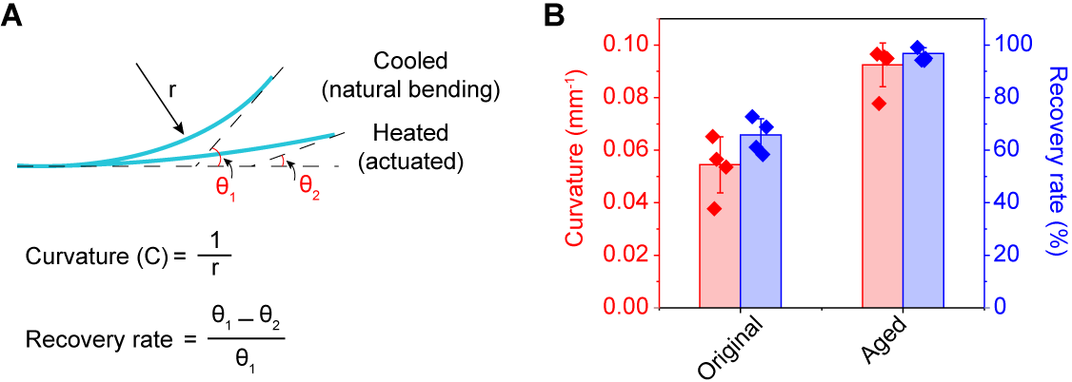
Fig. S7. Effect of thermal aging on actuator performance. (A) Definition of bending curvature and recovery rate. (B) Comparison of bending curvature and recovery rate of actuators with original and aged SMA. Error bars represent the s.d. of the mean from 4 samples.
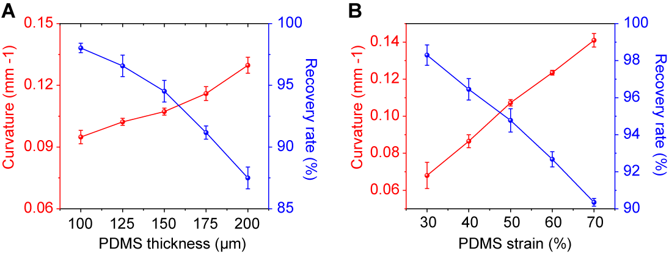
Fig. S8. Influence of PDMS thickness and pre-stretch on actuator performance. (A) Effect of PDMS thickness (100–200 μm). (B) Effect of PDMS prestretch (30–70%) at fixed thickness (150 μm). Error bars represent the s.d. of the mean from 4 samples.
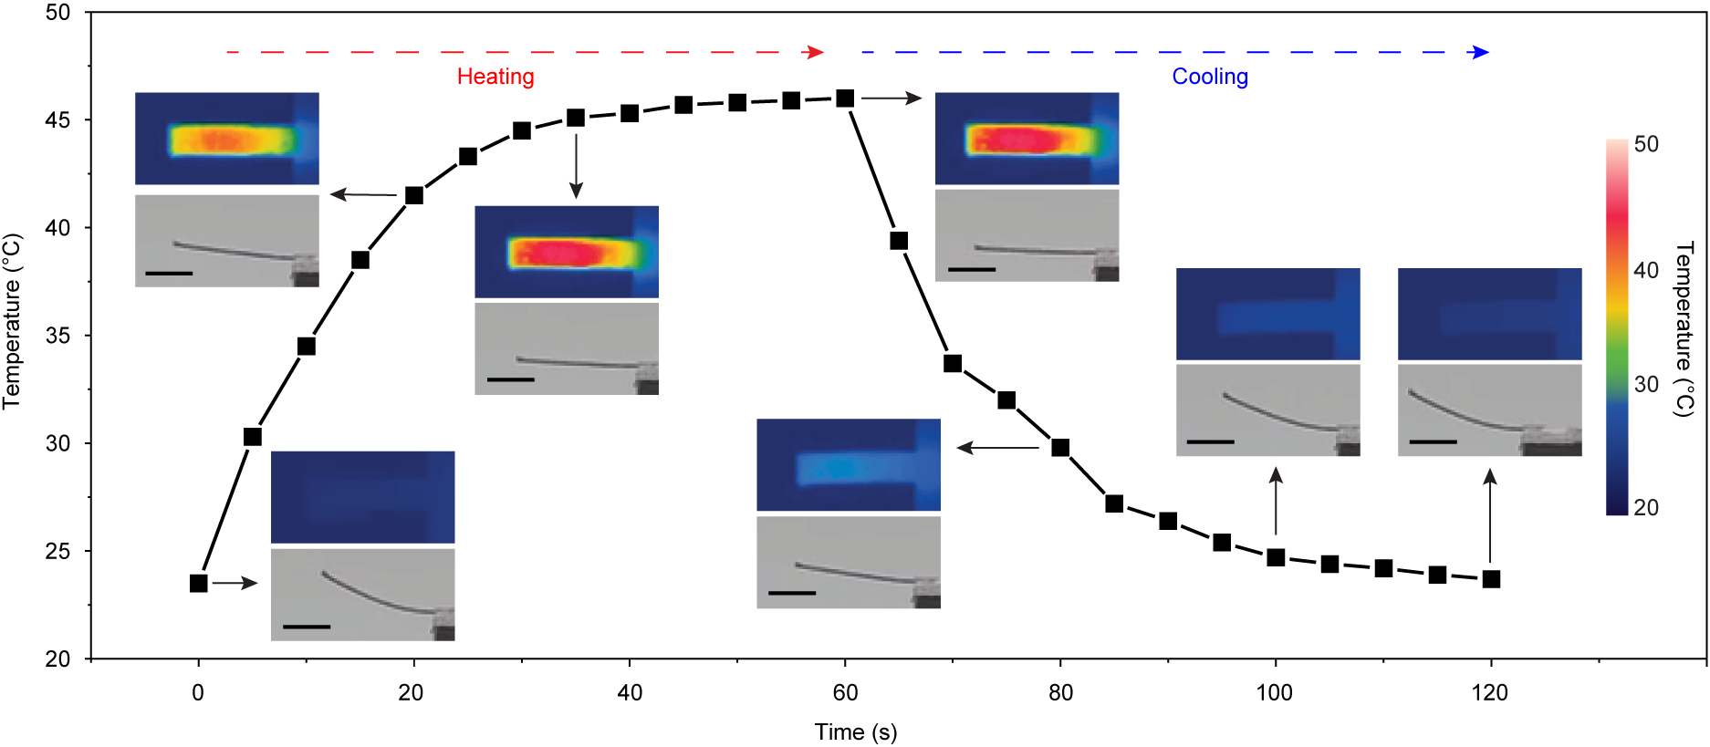
Fig. S9. Thermal response and actuation behavior of the actuator during a heating–cooling cycle. Infrared (IR) thermal images with overlaid optical photographs show the correlation between local temperature distribution and actuator deformation. A voltage of 2.5 V is applied to the thin-film heater. Scale bars, 5 mm.
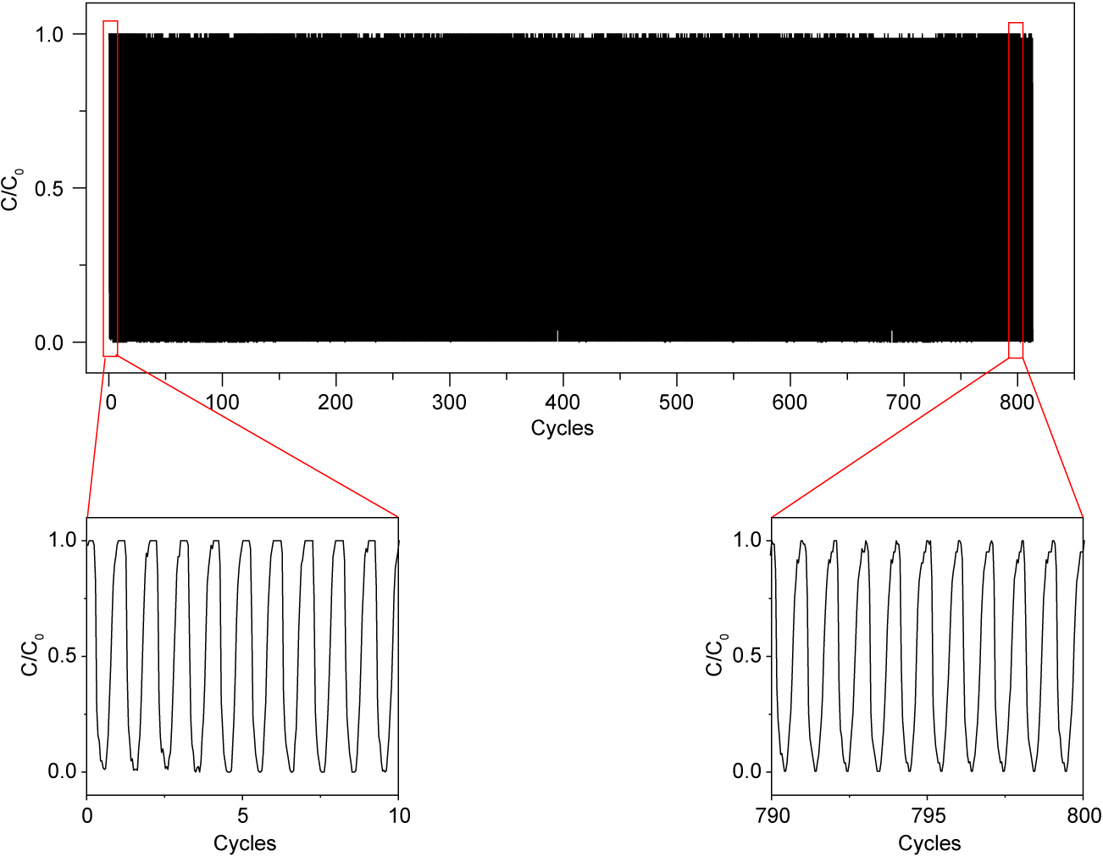
Fig. S10. Long-term actuation stability of the actuator. Curvature remains stable over 800 heating-cooling cycles. C₀ denotes the initial curvature, and C denotes the instantaneous curvature during cycling.

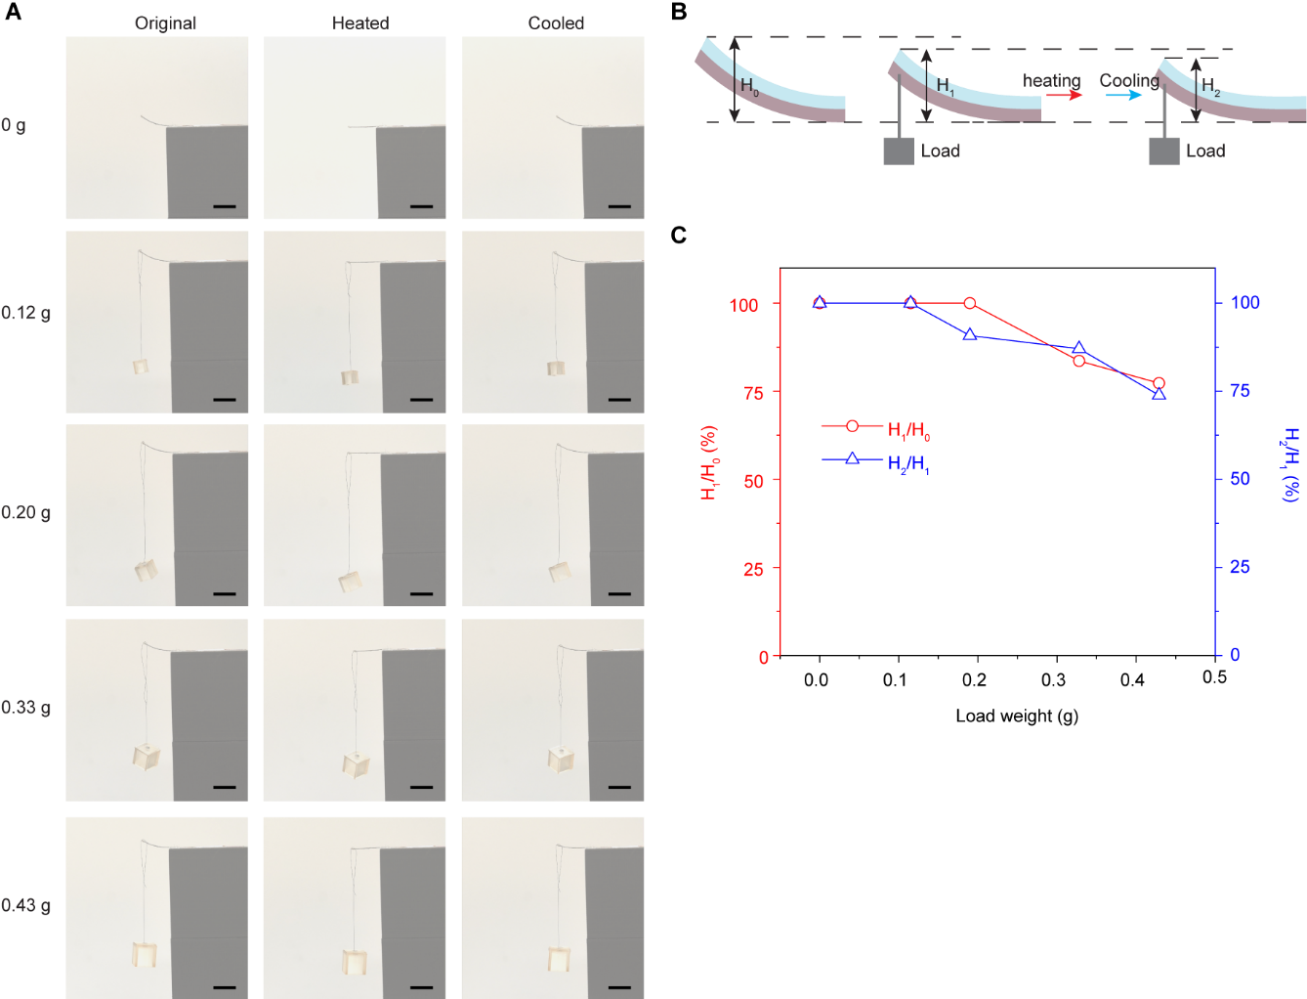
Fig. S11. Load-bearing actuation performance of the actuator. (A) Time-lapse images showing actuator deformation under loads ranging from 0 to 0.429 g in the initial, heated, and re-cooled states. (B) Schematic of recovery measurement under load. H₀ denotes the initial unloaded height, H₁ the loaded height before actuation, and H₂ the height after a heating–cooling cycle. (C) Normalized tip displacement as a function of applied load. Scale bars, 1 cm.

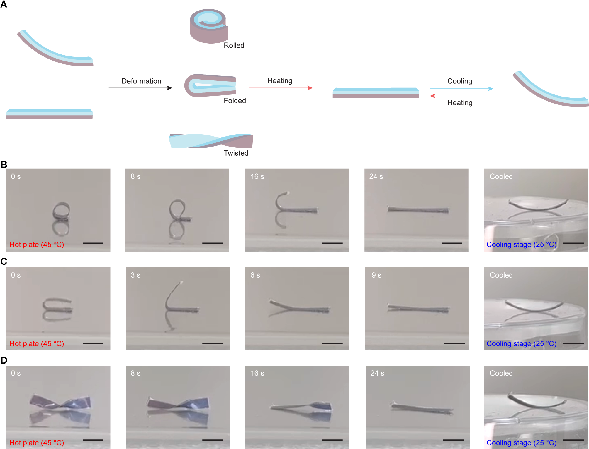
Fig. S12. Shape recovery of the PDMS–SMA actuator under extreme deformations. (A) Schematic of reversible actuation following extreme deformations (rolled, folded, and twisted). Heating restores the actuator to its straight configuration, and cooling returns it to the bent state. (B to D) Time-lapse images showing recovery from rolled (B), folded (C), and twisted (D) configurations. Scale bars, 5 mm.

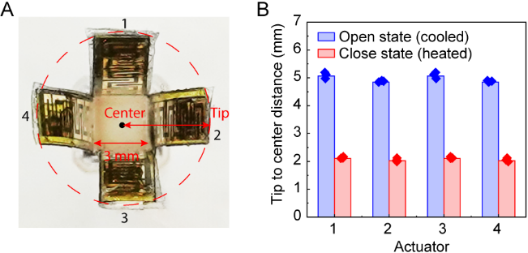
Fig. S13. Opening and closing geometry of the four-actuator array. (A) Photograph of the array in the open state, showing radially distributed actuators forming a cross-shaped configuration. (B) Tip-to-center distance (equivalent radius) of each actuator (1–4) in open and closed states. Error bars represent the s.d. of the mean from 3 tests.

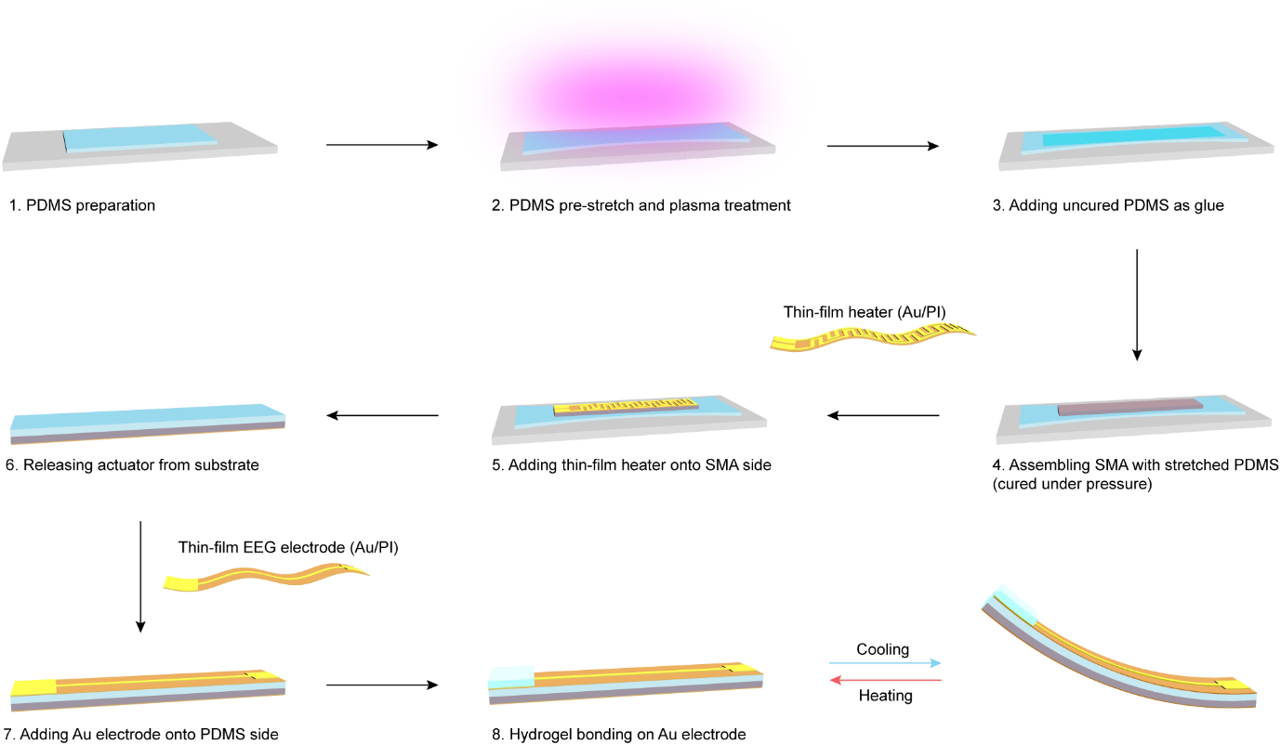
Fig. S14. Fabrication and assembly of the actuator–hydrogel interface. Process schematic showing PDMS–SMA bilayer formation and hydrogel electrode integration.

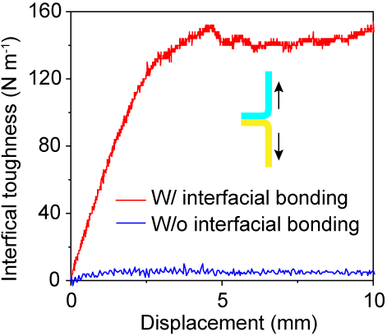
Fig. S15. Interfacial adhesion between Au substrate and WR-IC-PAAm hydrogel. Toughness increases with displacement and plateaus at ~140–150 N·m⁻¹, indicating robust interfacial bonding.

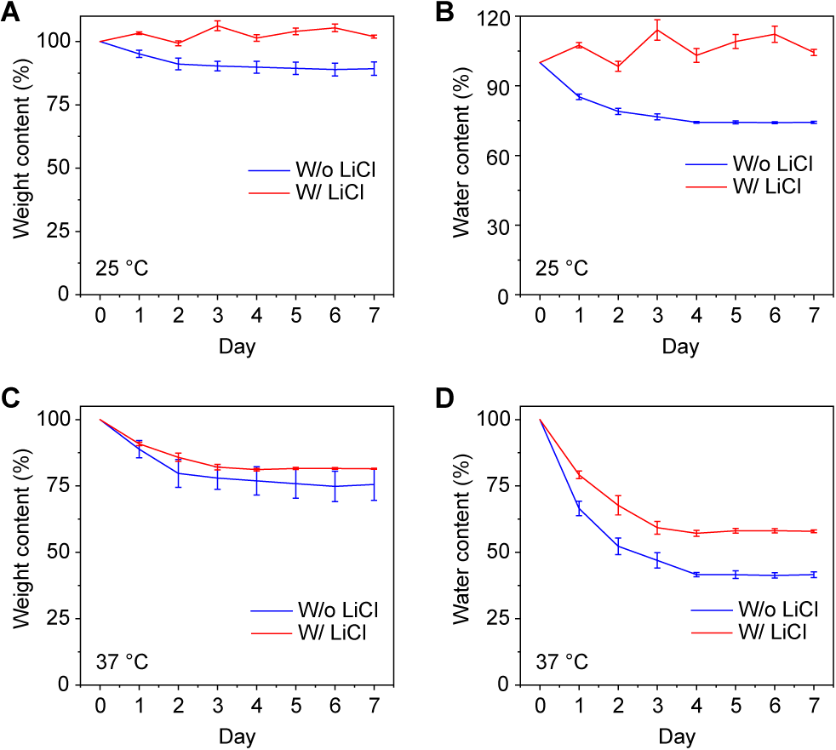
Fig. S16. Effect of LiCl on water retention of WR-IC-PAAm hydrogel. (A and B) Weight retention (A) and water content (B) of the hydrogels with and without LiCl during 7-day storage at 25 °C. (C and D) Weight retention (C) and water content (D) during 7-day storage at 37 °C. Error bars represent the s.d. of the mean from 4 samples.

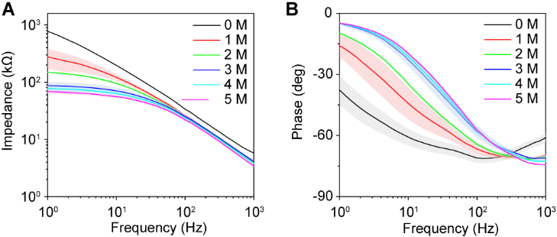
Fig. S17. Effect of LiCl concentration on electrode-skin impedance of WR-IC-PAAm hydrogel. (A and B) Electrode-skin impedance (A) and phase angle (B) as a function of frequency (1–1000 Hz) for hydrogels prepared with 0–5 M LiCl. Solid lines represent the mean and shaded areas indicate ± s.d. from 8 tests.
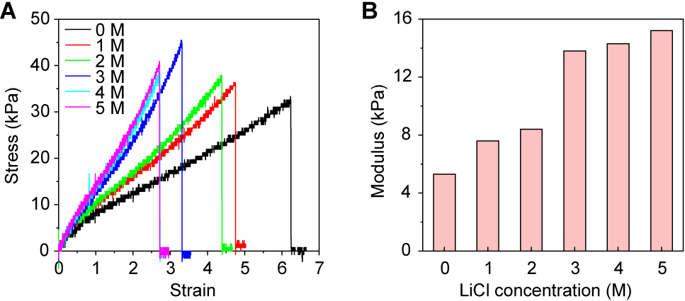
Fig. S18. Mechanical properties of WR-IC-PAAm hydrogels with varying LiCl concenterations. (A) Representative stress–strain curves for hydrogels prepared in 0–5 M LiCl. (B) Young’s modulus as a function of LiCl concentration, increasing from ~5 to ~15 kPa while remaining within a soft regime suitable for conformal skin contact.

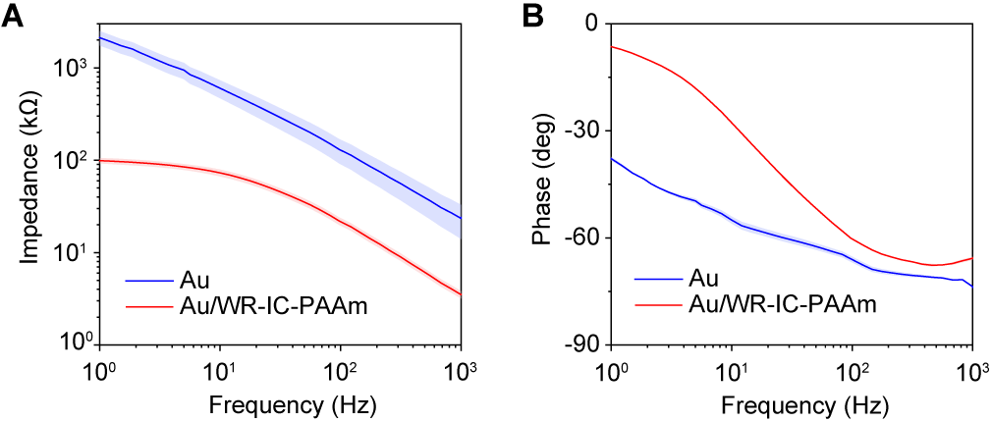
Fig. S19. Electrode-skin impedance of bare Au and Au/WR-IC-PAAm electrodes. (A and B) Impedance (A) and phase angle (B) as a function of frequency. Solid lines represent the mean and shaded areas indicate ± s.d. from 4 tests.

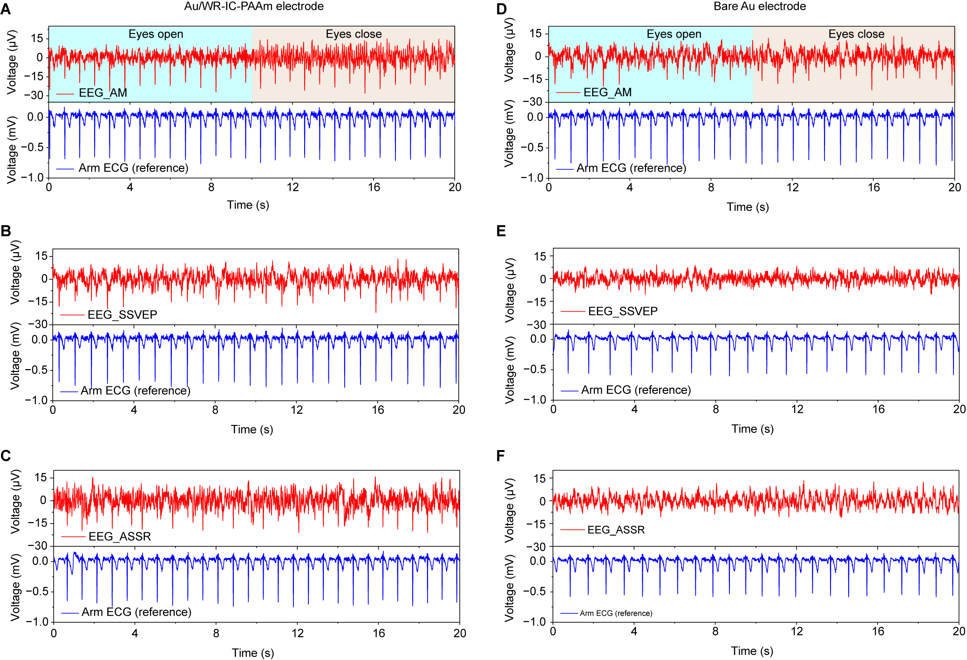
Fig. S20. Comparison of composite ear-canal biopotentials recorded with hydrogel-coated and bare Au electrodes. (A to C) Time-domain tential signals recorded using the Au/WR-IC-PAAm hydrogel electrode during alpha modulation (AM) (A), steady-state visual evoked potentials (SSVEP) (B), and auditory steady-state response (ASSR) (C), with corresponding reference arm ECG shown below. (D to F) Signals obtained using bare Au electrodes under identical experimental conditions: AM (D), SSVEP (E) and ASSR (F).

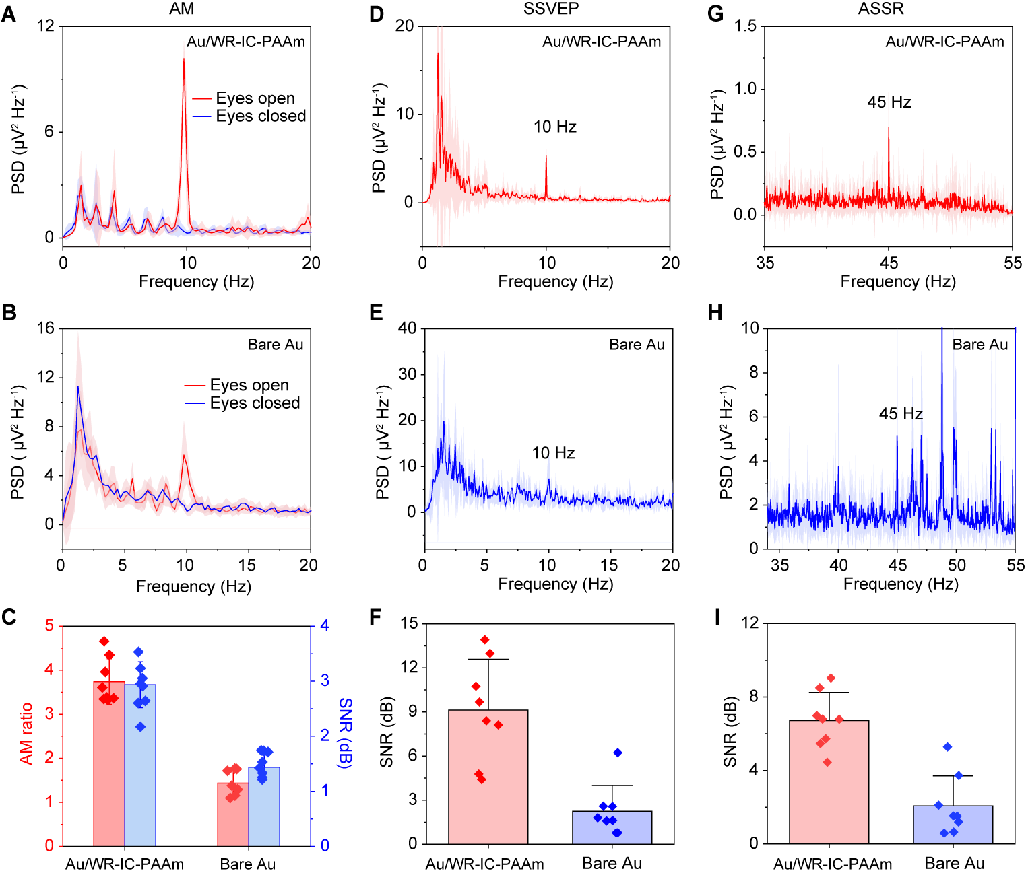
Fig. S21. Neural activity recording quality with hydrogel-coated versus bare Au electrodes. (A to C) AM: power spectral density (PSD) using Au/WR-IC-PAAm (A) and bare Au (B), and comparison of AM ratio and AM SNR (C). (D to F) SSVEP (10 Hz stimulation): PSD using Au/WR-IC-PAAm (D) and bare Au (E), and SNR comparison (F). (G to I) ASSR (45 Hz stimulation): PSD using the Au/WR-IC-PAAm (G) and bare Au (H), and SNR comparison (I). Solid lines represent mean values and shaded regions indicate ± s.d. from 8 tests.

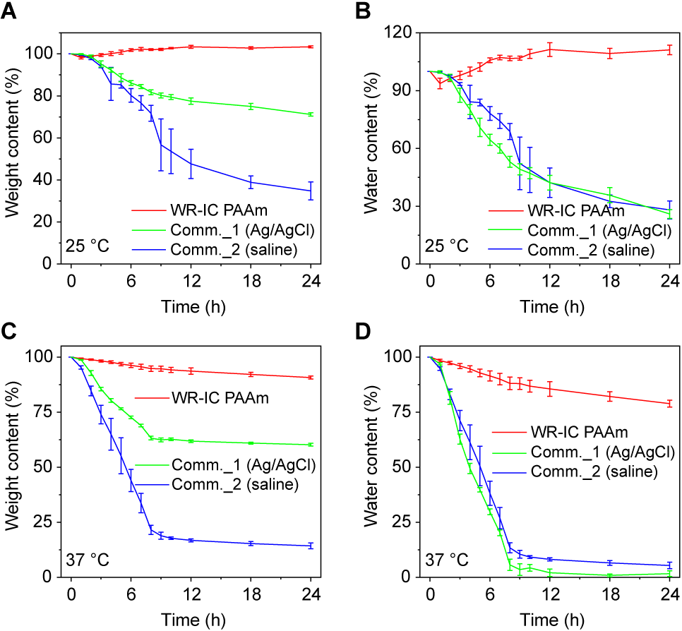
Fig. S22. Water-retention of WR-IC-PAAm hydrogel and commercial electrodes at different temperatures. (A and B) Weight retention (A) and water content (B) of three electrodes stored at 25 °C over 24 h. (C and D) Weight retention (C) and water content (D) of three electrodes stored at 37 °C over 24 h. Comm. 1, Ag/AgCl semi-dry electrode (3M Red Dot 2560); Comm. 2, saline-based wet gel (Parker Signa gel). Error bars represent the s.d. of the mean from 4 samples.

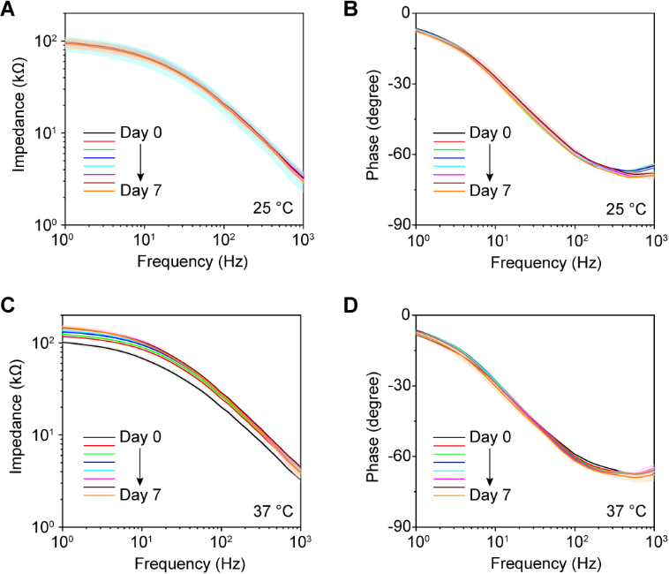
Fig. S23. One-week stability of electrode–skin impedance of WR-IC-PAAm hydrogel. (A and B) Impedance (A) and phase angle (B) measured from day 0 to day 7 during storage at 25 °C. (C and D) Impedance (C) and phase angle (D) measured from day 0 to day 7 during storage at 37 °C. Solid lines represent mean values and shaded regions indicate ± s.d. from 4 tests.

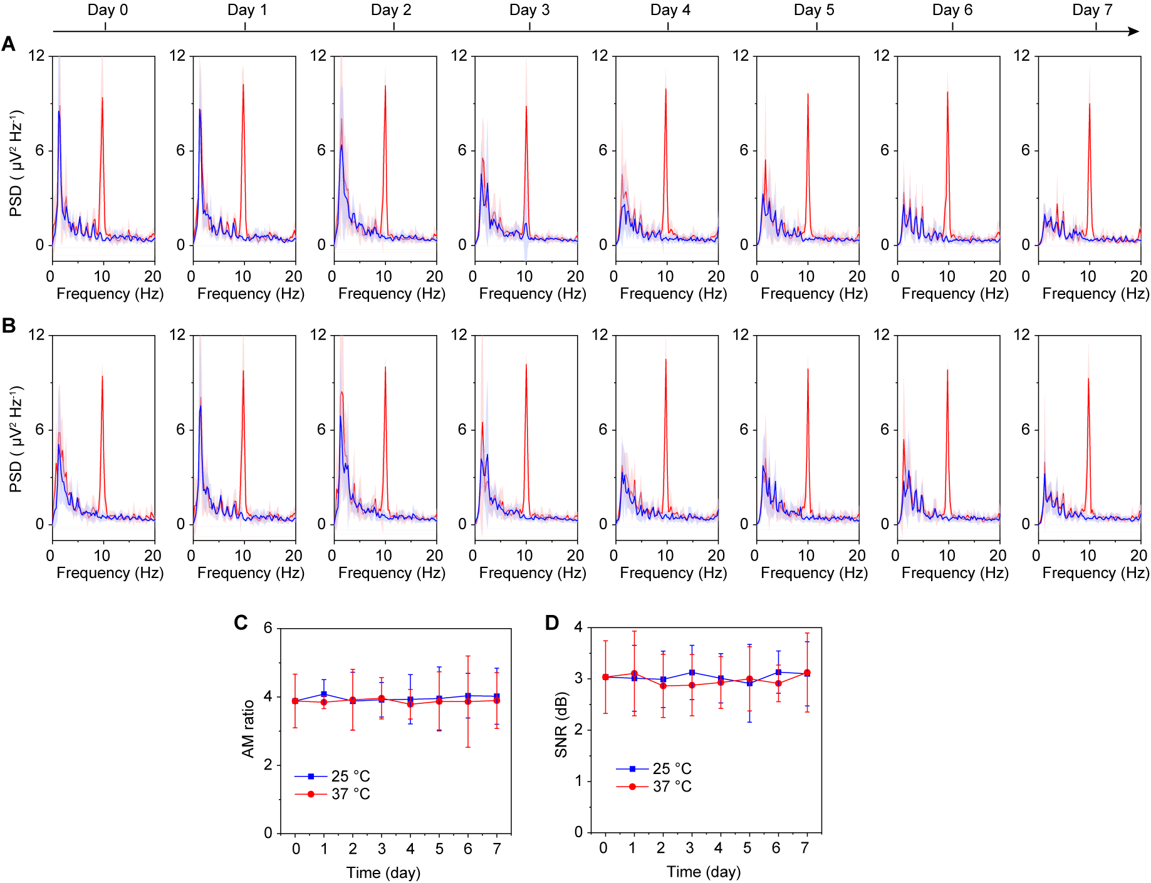
Fig. S24. One-week stability of neural responses in deep ear-canal biopotential recordings. (A and B) PSD of signals recorded during AM using the same WR-IC-PAAm electrodes after storage at 25 °C (A) and 37 °C (B) from day 0 to day 7. (C and D) AM ratio (C) and SNR (D) across the 7-day period. Solid lines represent the mean and shaded areas indicate ± s.d. from 8 tests.
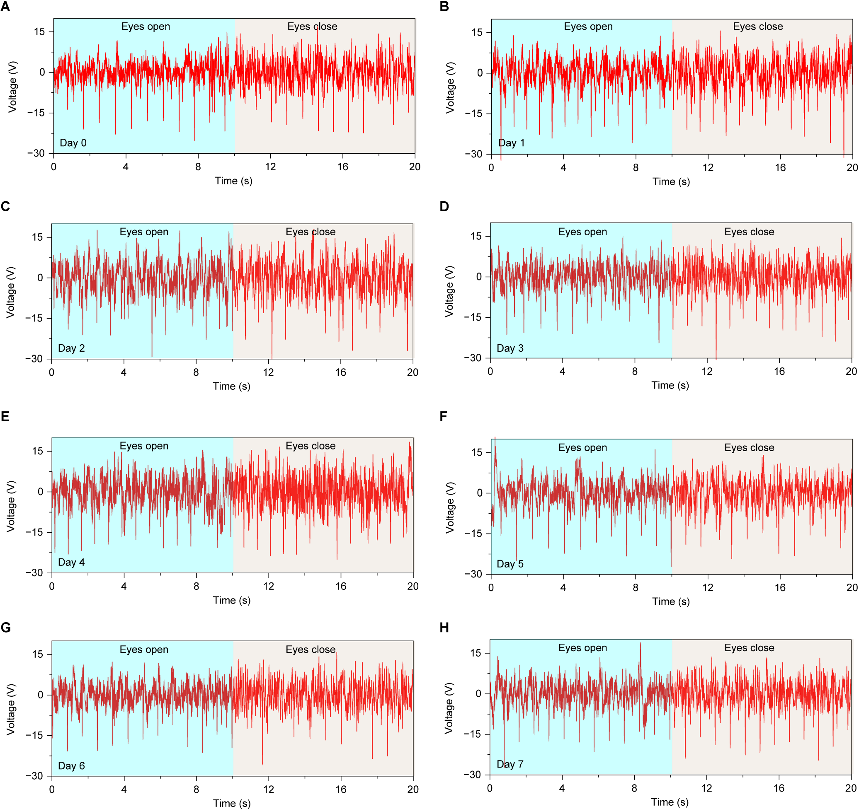
Fig. S25. One-week stability of cardiac features in deep ear-canal recordings. (A to H) Representative time-domain biopotential signals recorded during AM using the same WR-IC-PAAm electrodes after storage at 37 °C from day 0 to day 7.

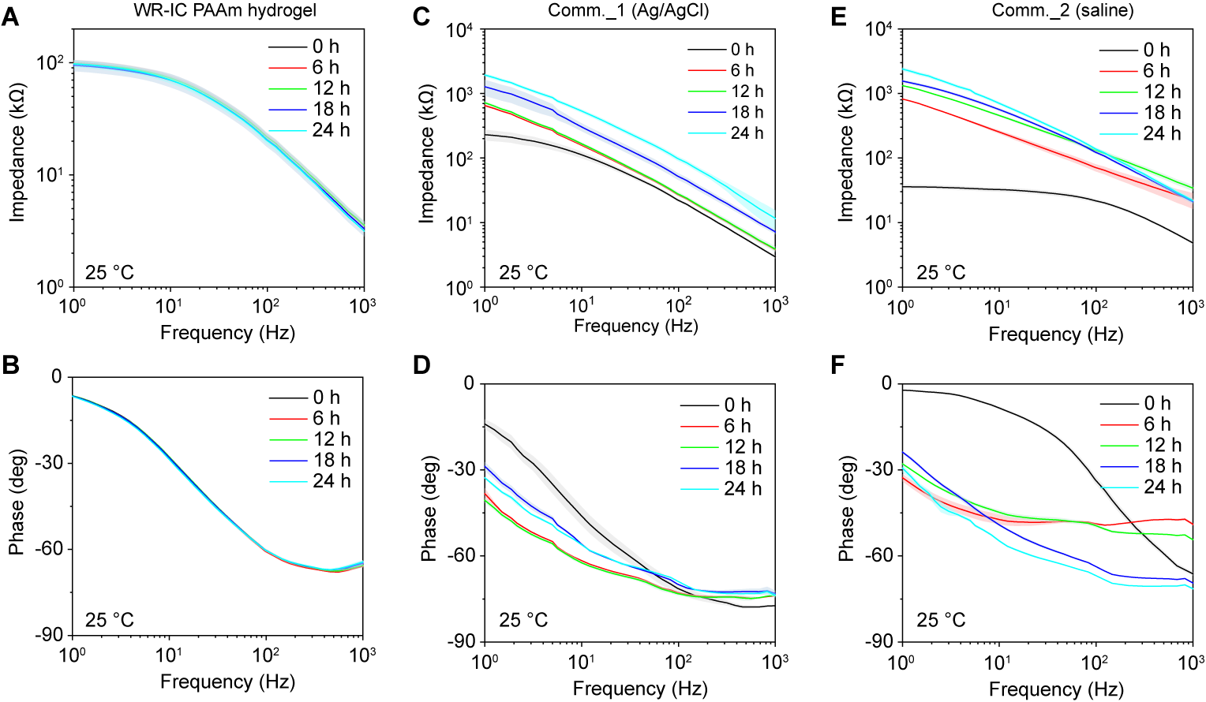
Fig. S26. Time-dependent electrode–skin impedance of WR-IC-PAAm electrodes versus commercial electrodes during storage at 25 °C over 24 h. (A and B) Contact impedance (A) and phase angle (A) of WR-IC-PAAm electrodes. (C and D) Contact impedance (C) and phase angle (D) of Comm._1 electrode. (E and F) Contact impedance (E) and phase angle (F) of Comm._2 electrode. Solid lines represent mean values and shaded regions indicate ± s.d. from 4 tests.

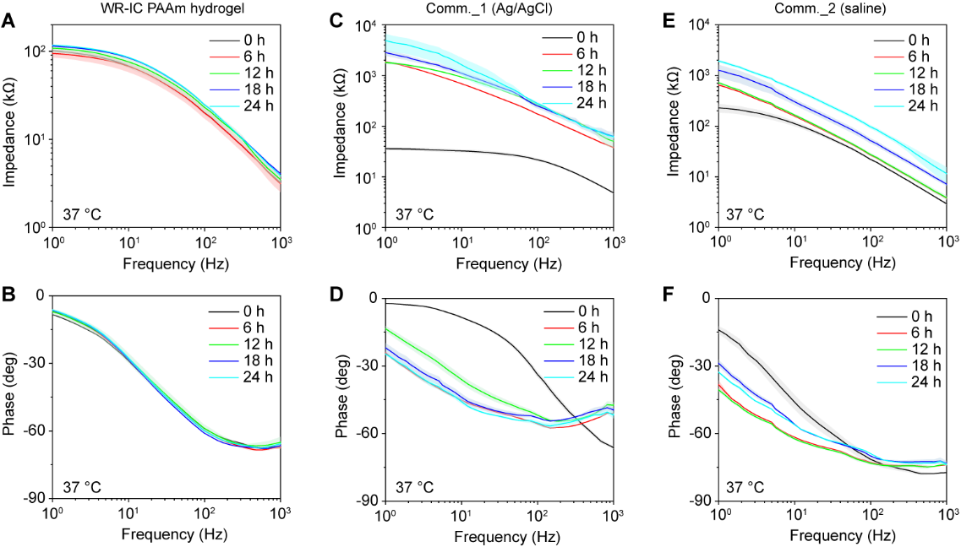
Fig. S27. Time-dependent electrode–skin impedance stability of WR-IC-PAAm electrodes versus commercial electrodes during storage at 37 °C in 24 h. (A and B) Contact impedance (A) and phase angle (B) of the WR-IC-PAAm, showing nearly unchanged contact impedance over 24 h. (C and D), Contact impedance (C) and phase angle (D) of Comm._1 electrode. (E and F) Contact impedance (E) and phase angle (F) of Comm._2 electrode. Solid lines represent the mean and shaded areas indicate ± s.d. from 4 tests.

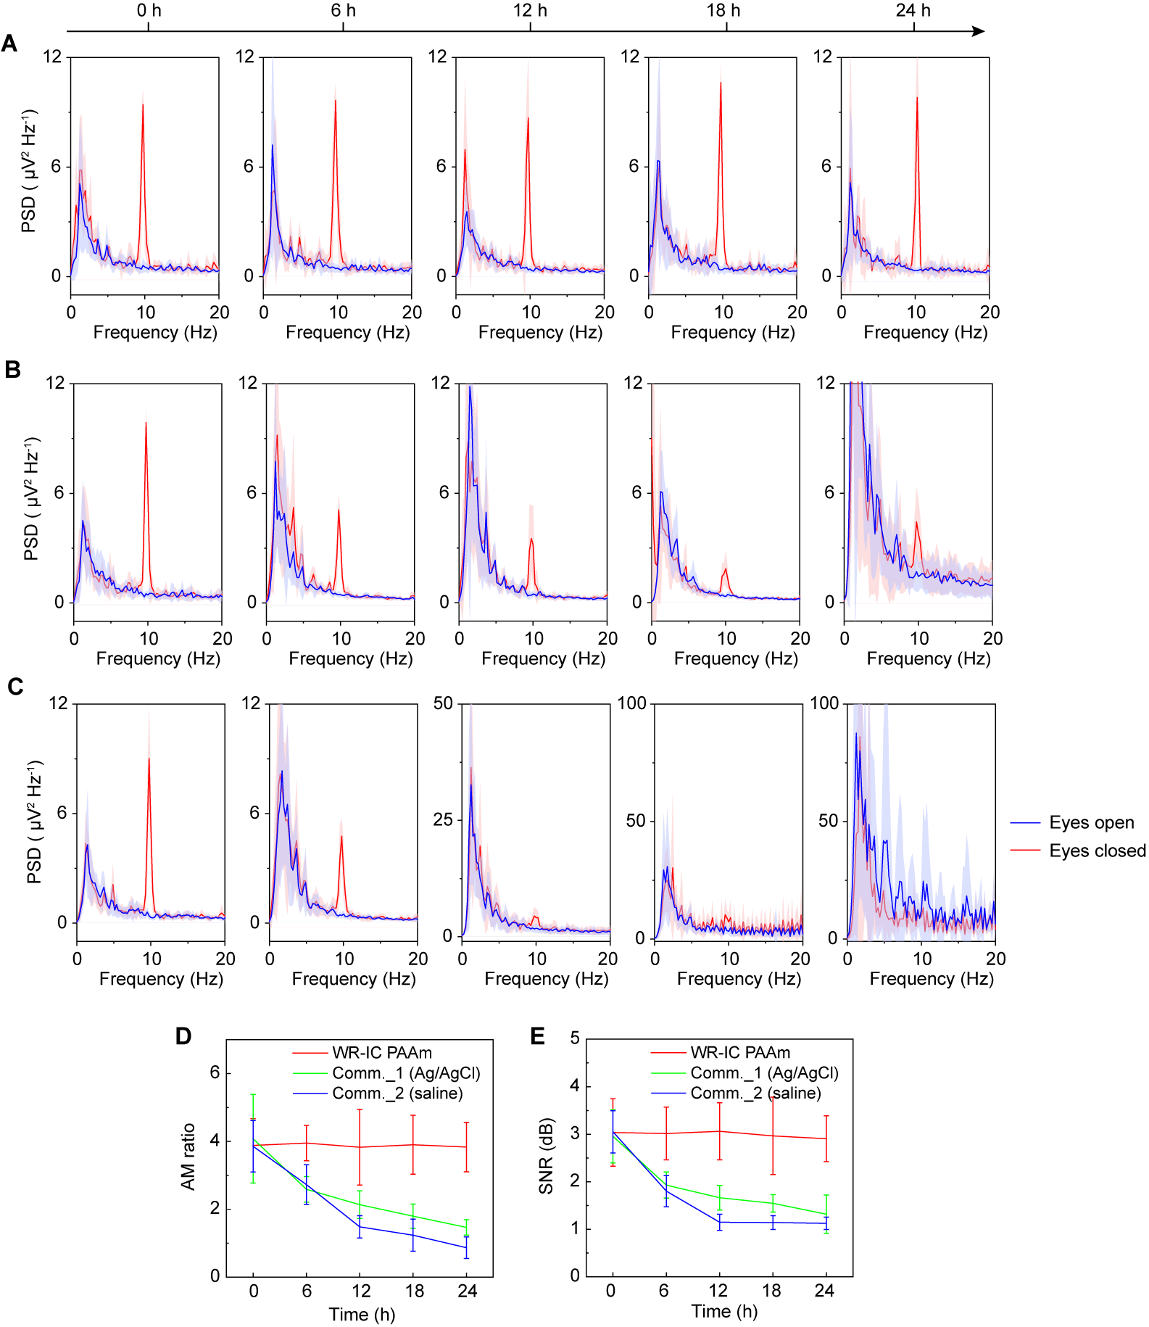
Fig. S28. Stability of EEG recordings with WR-IC-PAAm and commercial electrodes during storage at 25 °C. (A to C) PSD of EEG signals during AM recorded with WR-IC-PAAm (A) and Comm._1 (B) and Comm._2 (C) electrodes at 0, 6, 12, 18, and 24 h. Solid lines represent mean values and shaded regions indicate ± s.d. from 8 tests. (D and E) AM ratio (D) and SNR (E) as a function of time for the three electrode types. Error bars represent the s.d. of the mean from 8 tests.
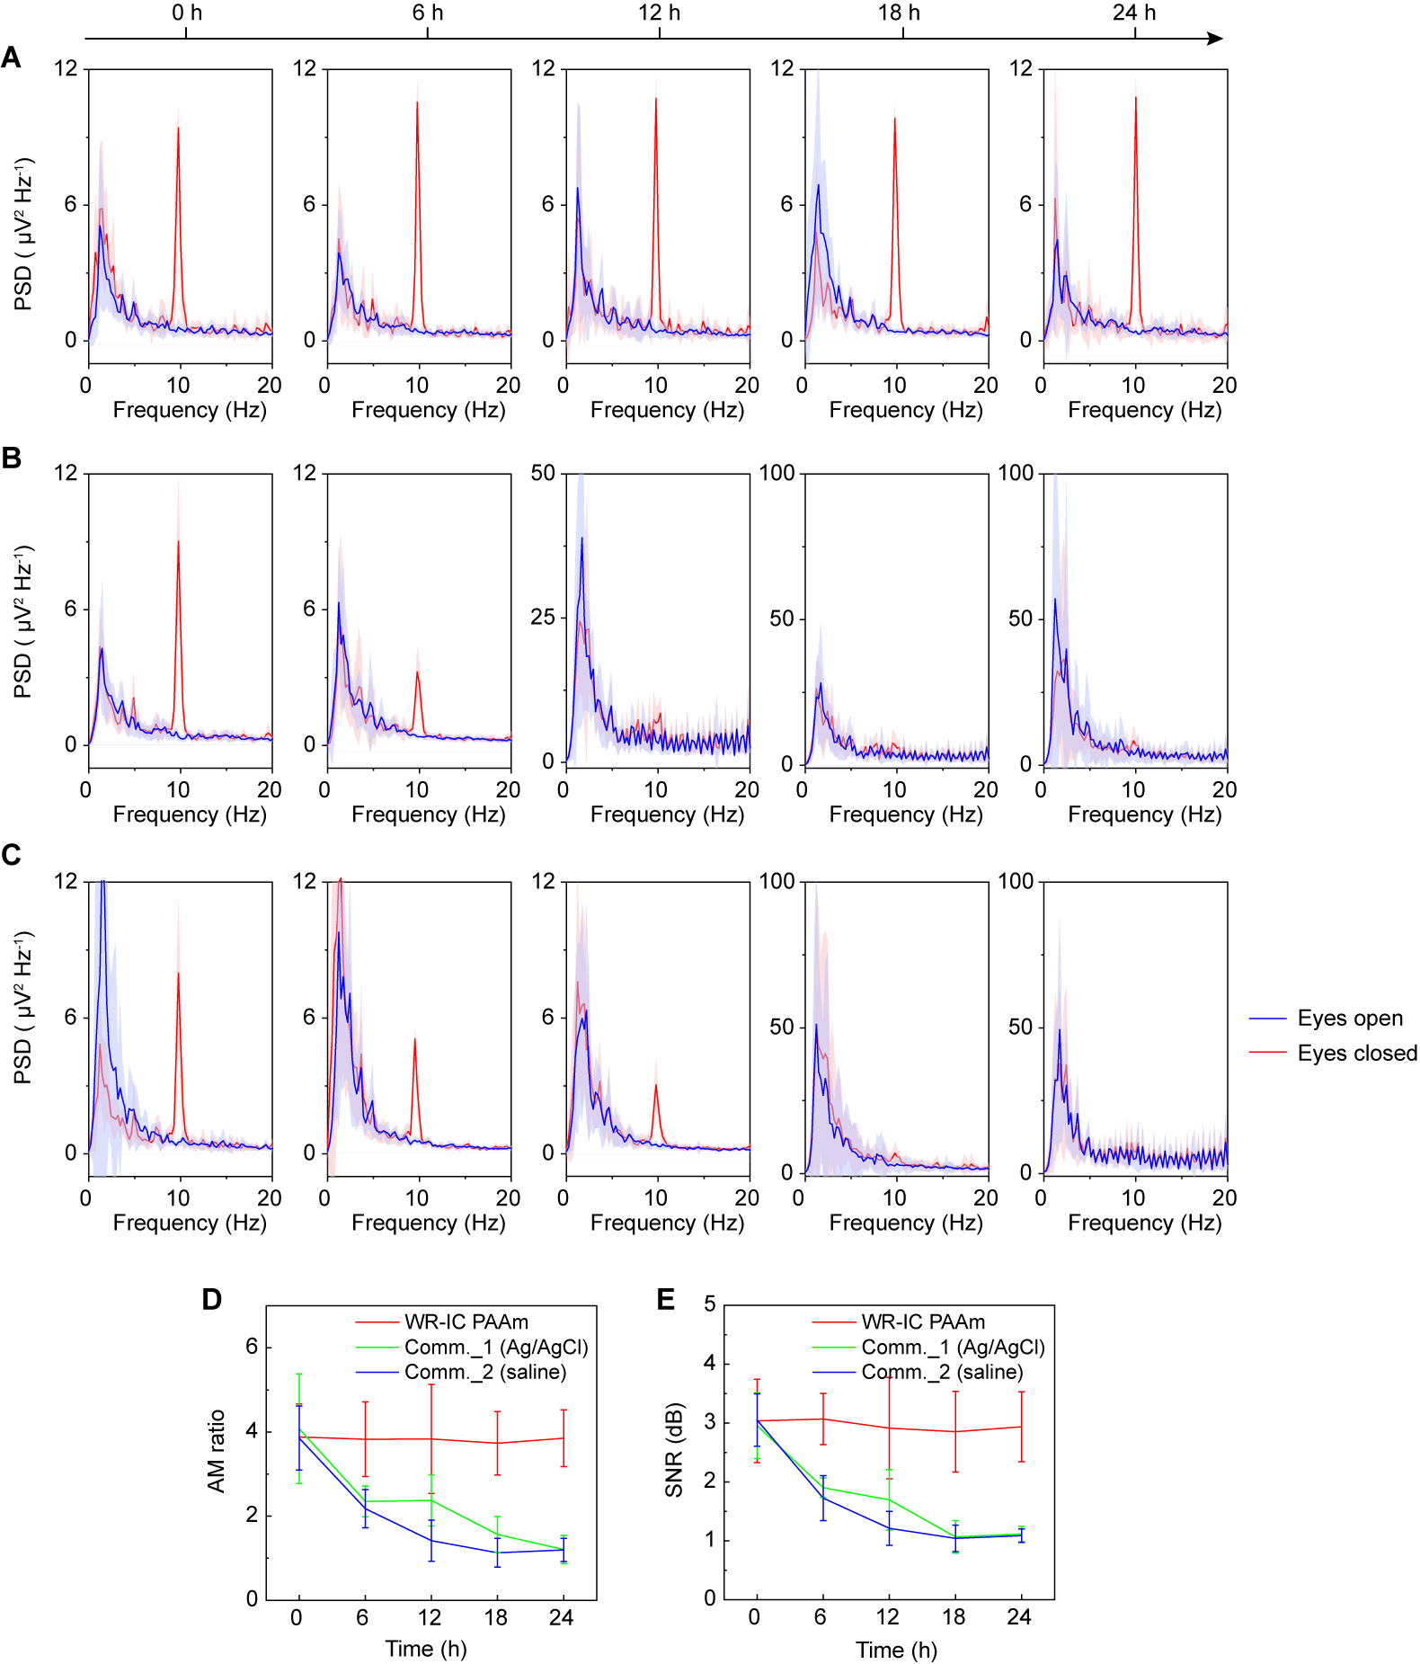
Fig. S29. Stability of EEG recording with WR-IC-PAAm and commercial electrodes during storage at 37 °C. (A to C) PSD of EEG signals during AM recorded by WR-IC-PAAm (A) and Comm._1 (B) and Comm._2 (C) electrodes at 0, 6, 12, 18, and 24 h. Solid lines represent mean values and shaded regions indicate ± s.d. from 8 tests. (D and E) AM ratio (D) and SNR (E) as a function of time for the three electrode types. Error bars represent the s.d. of the mean from 8 tests.

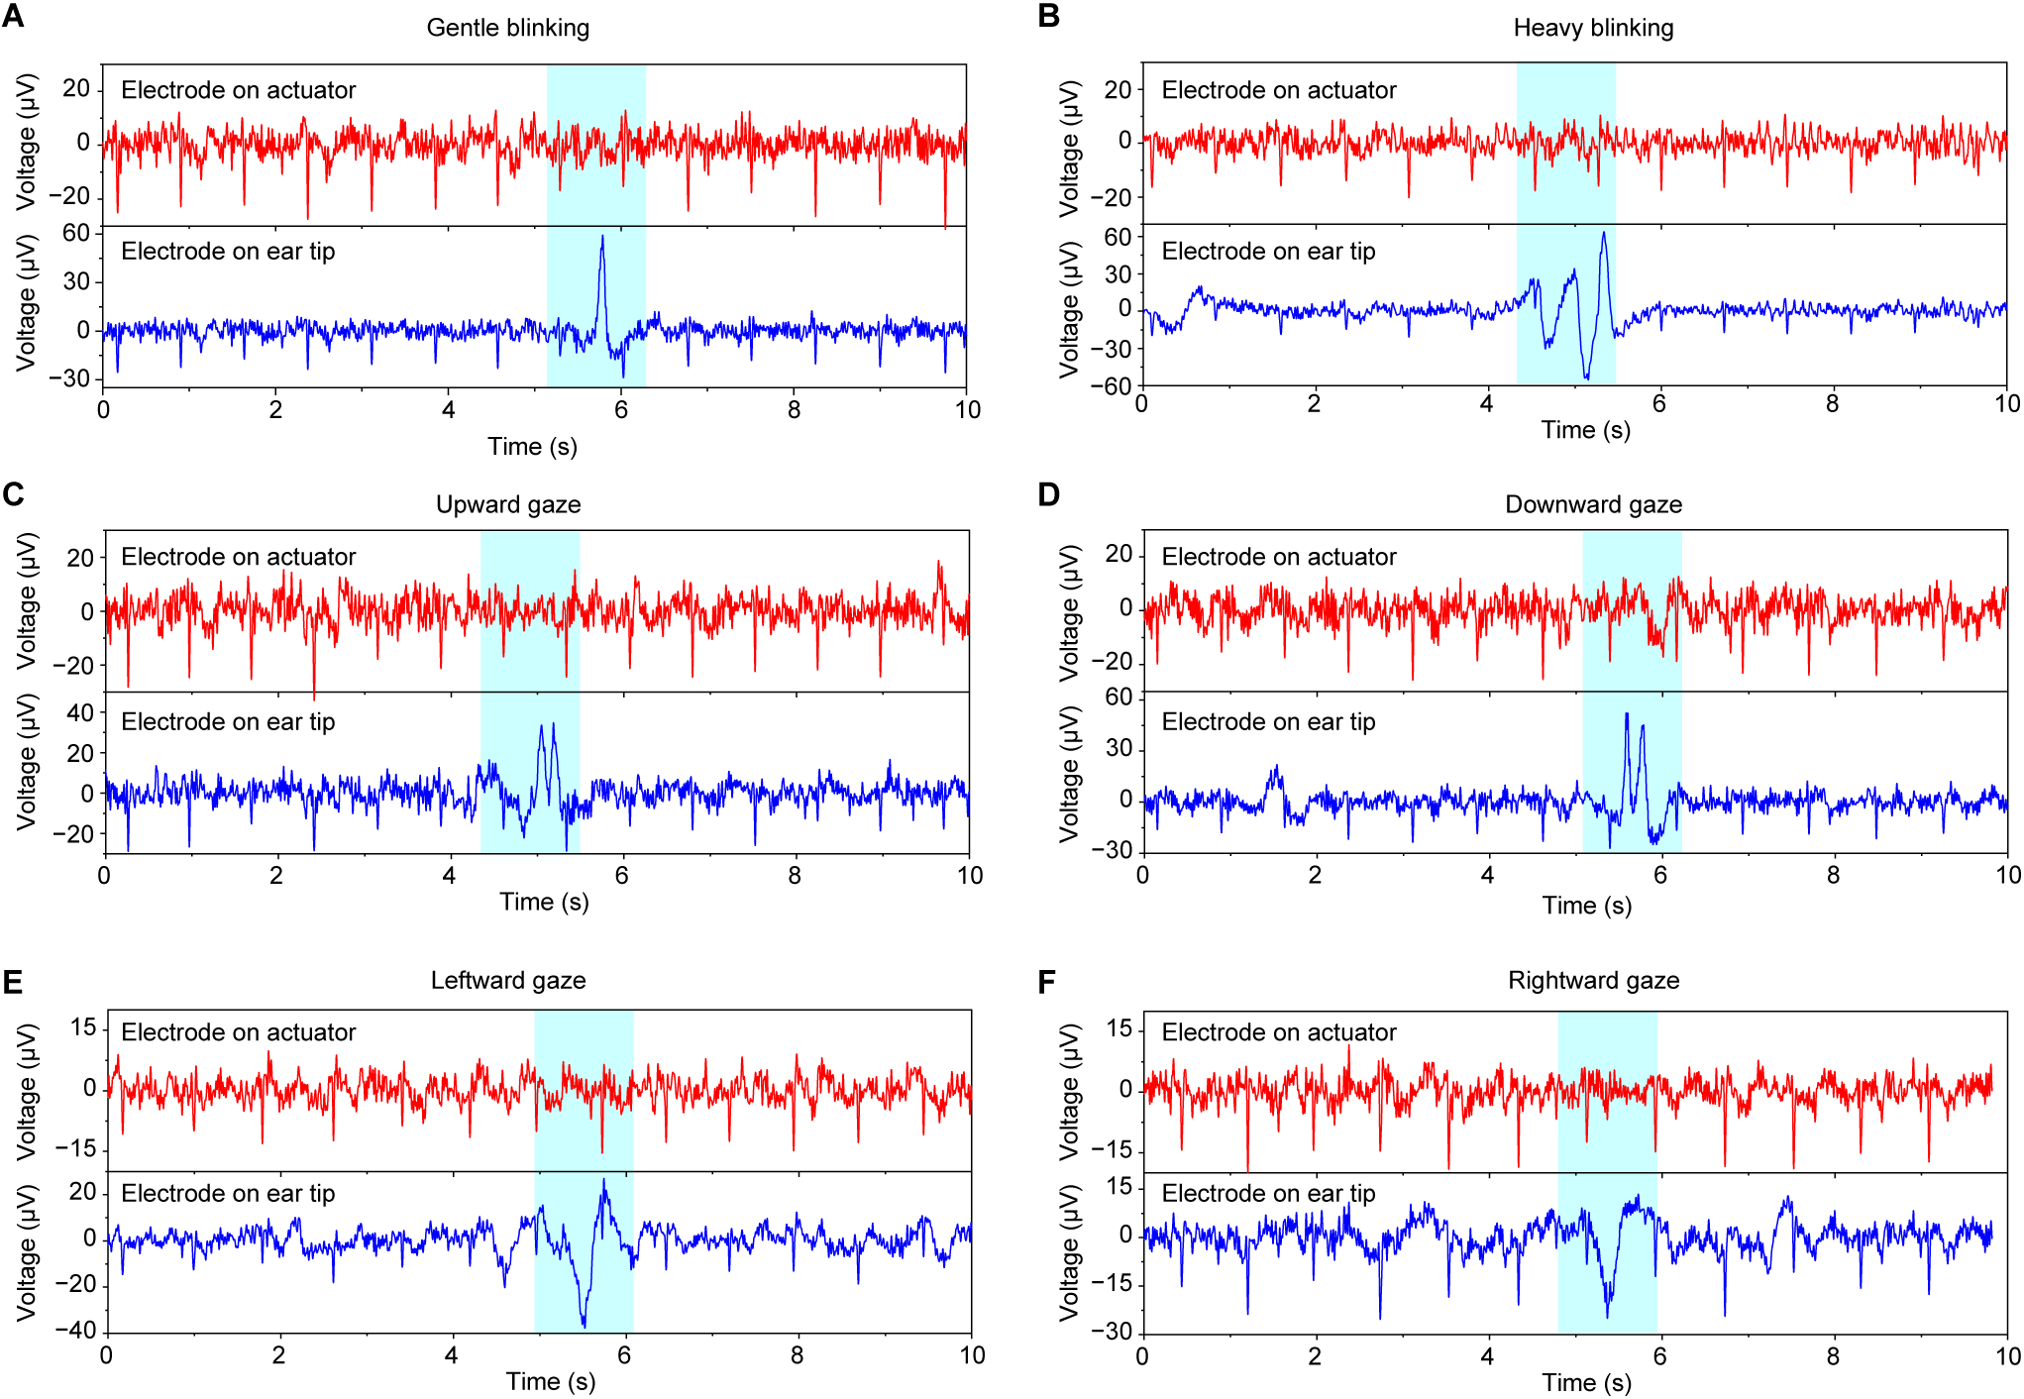
Fig. S30. Comparison of electrooculogram (EOG) tolerance in deep and shallow ear-canal recordings. (A to F) Time-domain biopotential signals recorded during gentle blinking (A), heavy blinking (B), upward gaze (C), downward gaze (D), leftward gaze (E), and rightward gaze (F), simultaneously measured using a deep ear-canal electrode and a shallow ear-tip electrode.

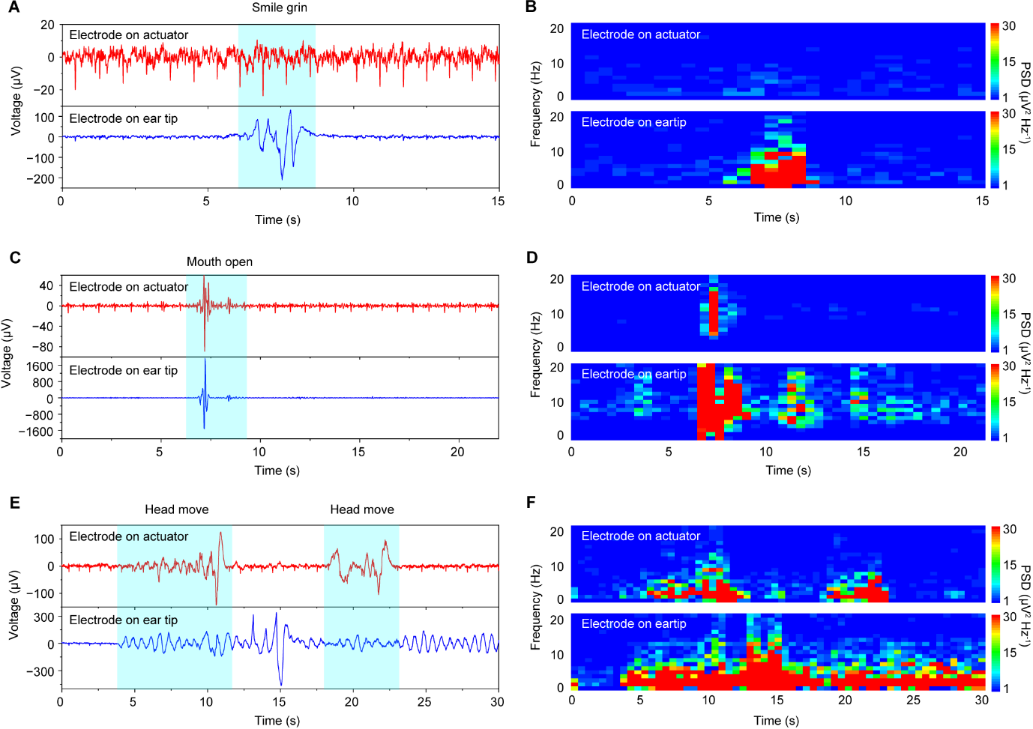
Fig. S31. Comparison of facial and motion artifacts in deep and shallow ear-canal recordings. (A and B) Time-domain biopotential signals (A) and corresponding PSD spectrograms (B) recorded during a smiling/grinning task, simultaneously measured using a deep ear-canal electrode and a shallow ear-tip electrode. (C and D) Time-domain signals (C) and PSD spectrograms (D) recorded during mouth opening. (E and F) Time-domain signals (E) and PSD spectrograms (F) recorded during head movements.

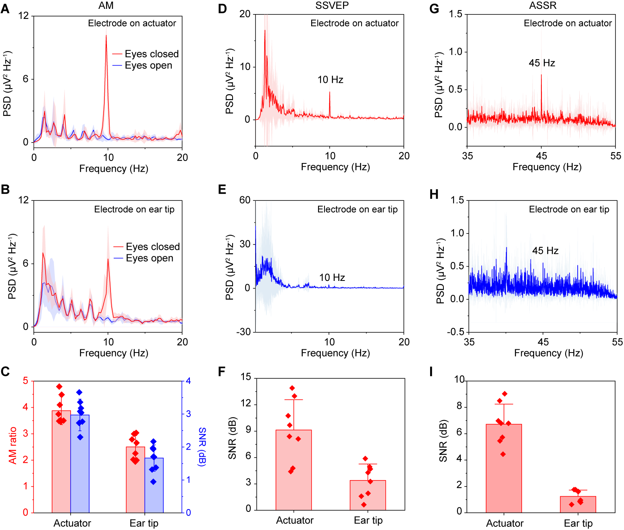
Fig. S32. Comparison of EEG recordings from deep ear-canal and shallow ear-tip electrodes. (A and B) PSD of AM signals recorded from a deep ear-canal electrode (A) and a shallow ear-tip electrode (B). (C) Comparison of AM ratio and SNR. (D and E) PSD of SSVEP EEG (10 Hz stimulation) recorded from a deep ear-canal electrode (D) and a shallow ear-tip electrode (E). (F) Comparison of SSVEP SNR. (G and H) PSD of ASSR EEG (45 Hz stimulation) recorded from a deep ear-canal electrode (G) and a shallow ear-tip electrode (H). (I) Comparison of ASSR SNR. Solid lines in PSD represent mean values and shaded regions indicate ± s.d. from 8 tests. Error bars represent the s.d. of the mean from 8 tests.

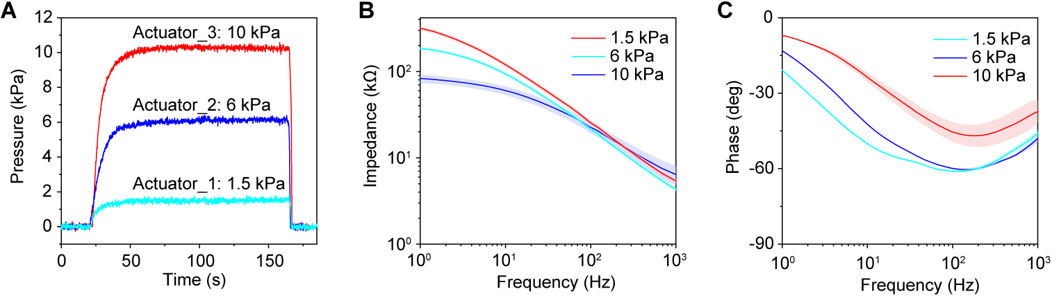
Fig. S33. Influence of actuator-induced contact pressure on electrode–skin impedance. (A) Contact pressure profiles for three actuators with different curvatures, corresponding to ~1.5 kPa (Actuator_1), ~6 kPa (Actuator_2), and ~10 kPa (Actuator_3). (B and C) Electrode-skin impedance (B) and phase angle (C) of WR-IC-PAAm electrodes uder the three contact pressures,. For impedance and phase spectra, solid lines represent mean values and shaded regions indicate ± s.d. from 4 tests.
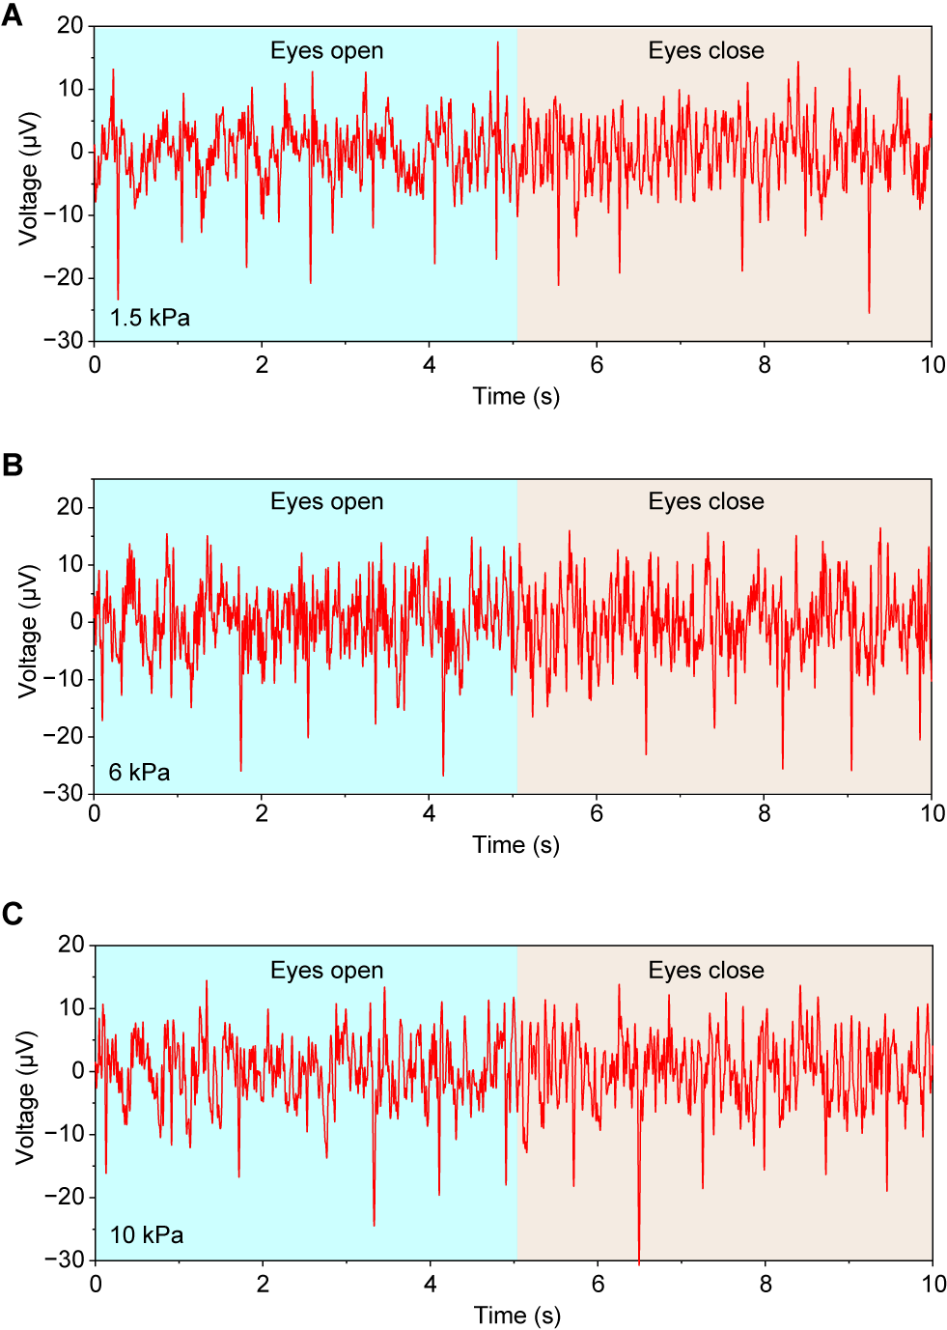
Fig. S34. Comparison of ear-canal biopotential recordings at different contact pressures. (A to C) Representative time-domain signals recorded during AM at contact pressures of 1.5 kPa (A), 6 kPa (B), and 10 kPa (C).

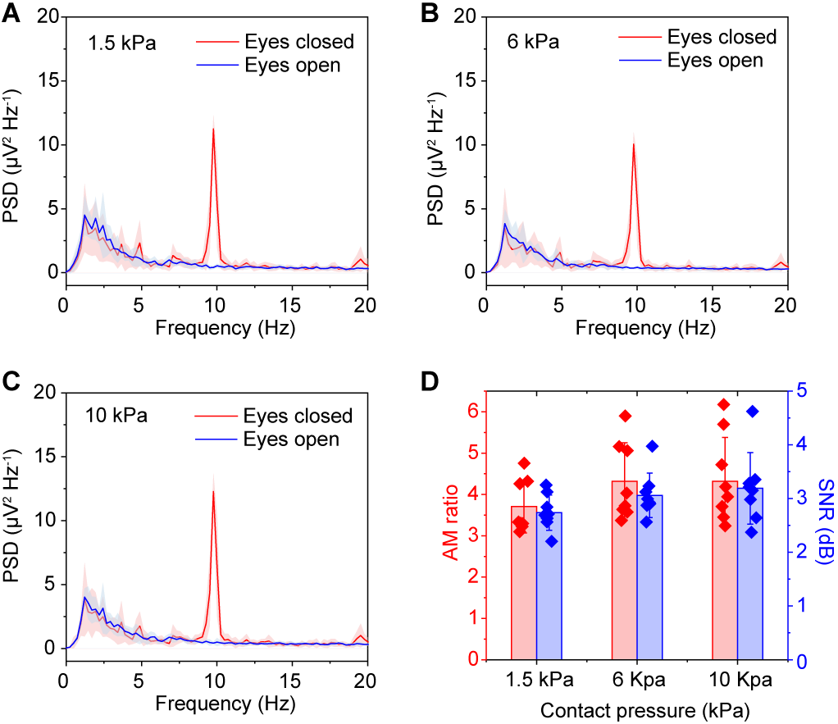
Fig. S35. EEG recordings at different actuator contact pressures. (A to C) PSD of AM signals recorded at contact pressures of 1.5 kPa (A), 6 kPa (B), and 10 kPa (C). Solid lines represent mean values and shaded regions indicate ± s.d. from 8 tests. (D) AM ratio and SNR as a function of contact pressure. Error bars represent the s.d. of the mean from 8 tests.

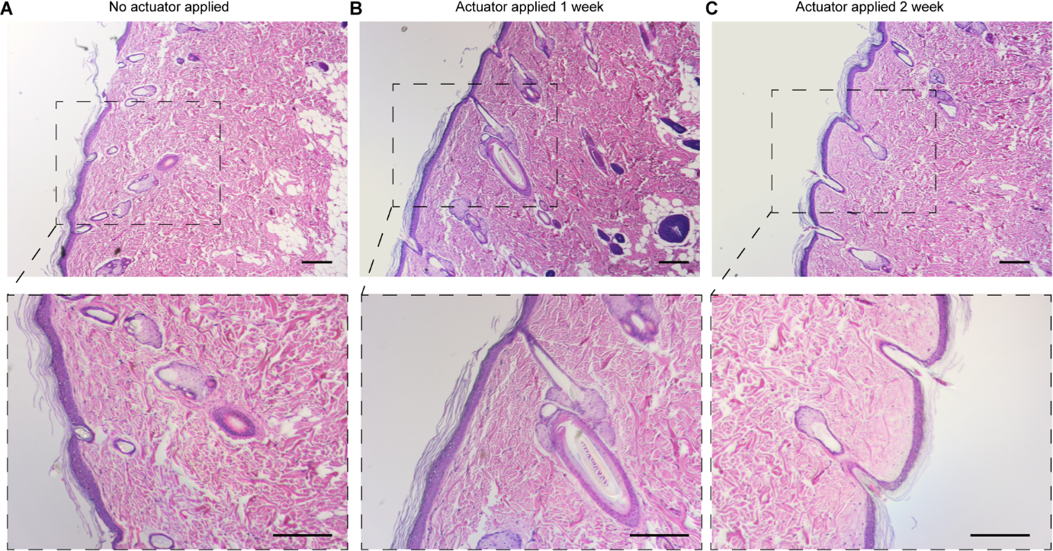
Fig. S36. Histological evaluation of tissue under sustained actuator pressure. (A to C) Hematoxylin and eosin (H&E) staining of skin tissue without actuator loading (A) and after application of ~10 kPa pressure for 1 week (B) and 2 weeks (C). Scale bars, 100 μm.
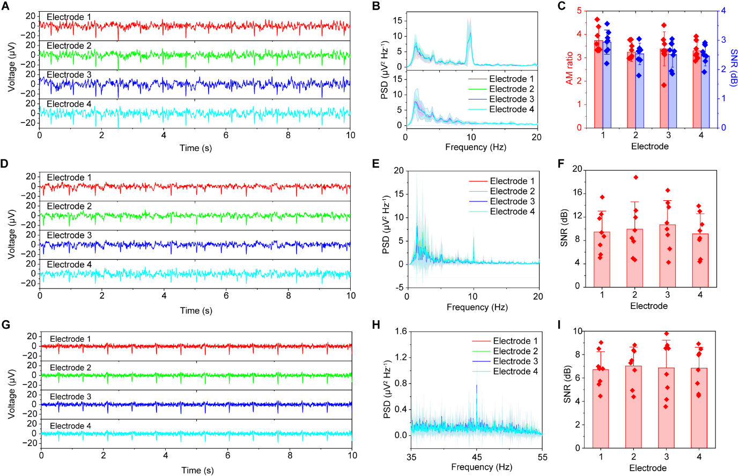
Fig. S37. Recording consistency across electrodes in a four-actuator array. (A and B) Time-domain signals (A) and corresponding PSD (B) during AM recorded simultaneously from four electrodes (Electrodes 1–4). (C) AM ratio and SNR for the four electrodes. (D and E) Time-domain signals (D) and corresponding PSD (E) during SSVEP recorded simultaneously from four electrodes (Electrodes 1–4). (F) SSVEP SNR across the four electrodes. (G and H) Time-domain signals (G) and PSD (H) during ASSR recorded from the four electrodes. (I) ASSR SNR across electrodes. Solid lines in PSD represent mean values and shaded regions indicate ± s.d. from 8 tests. Error bars represent the s.d. of the mean from 8 tests.

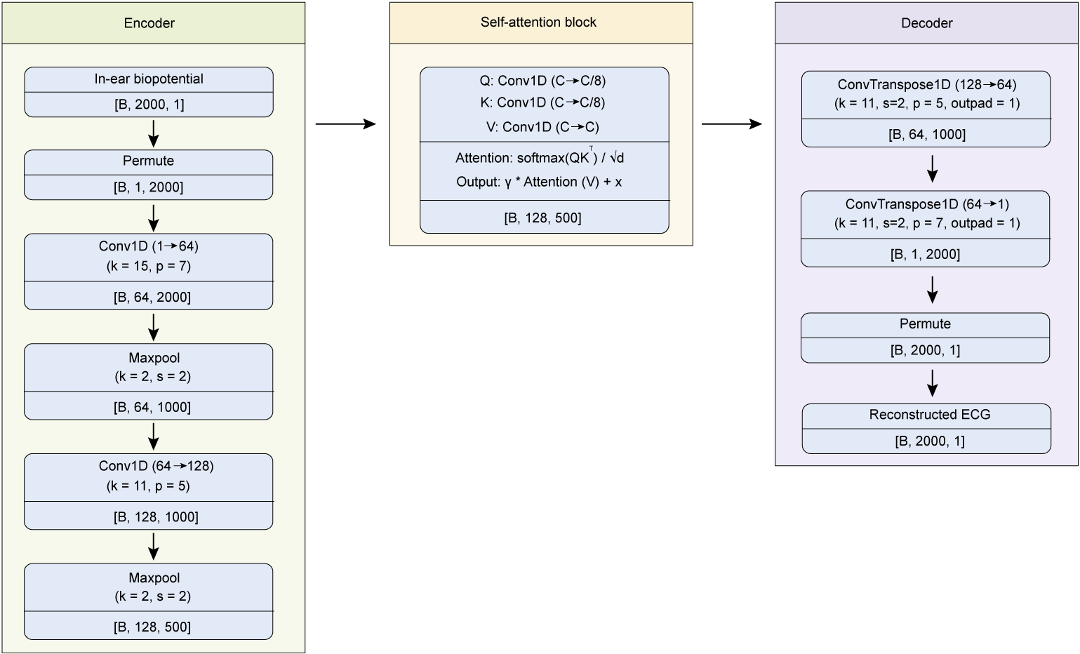
Fig. S38. Architecture of ECGNet for reconstructing ECG from the in-ear biopotential signals. ECGNet adopts an encoder–attention–decoder architecture to learn a physiology-aware mapping between in-ear electrophysiological signals and cardiac electrical activity. Q, query (features used to search for relevant temporal patterns); K, key (features used to compute similarity with the query); V, value (features aggregated by the attention mechanism); Conv1D, one-dimensional convolution; ConvTranspose1D, transposed convolution; k, kernel size; p, padding; s, stride; outpad, output padding; B, batch size; C, number of channels; T, temporal length.

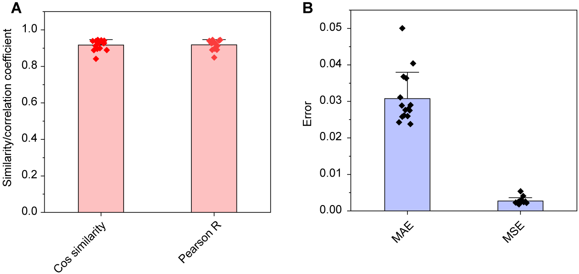
Figure S39. Similarity and error metrics for reconstructed and reference ECG signals. (A) Cosine similarity and Pearson correlation coefficient (r) between reconstructed ear ECG and referenced arm ECG. (B) Mean absolute error (MAE) and mean squared error (MSE) of reconstructed ECG relative to the reference. Error bars represent the s.d. of the mean of 15 cross-validated tests.
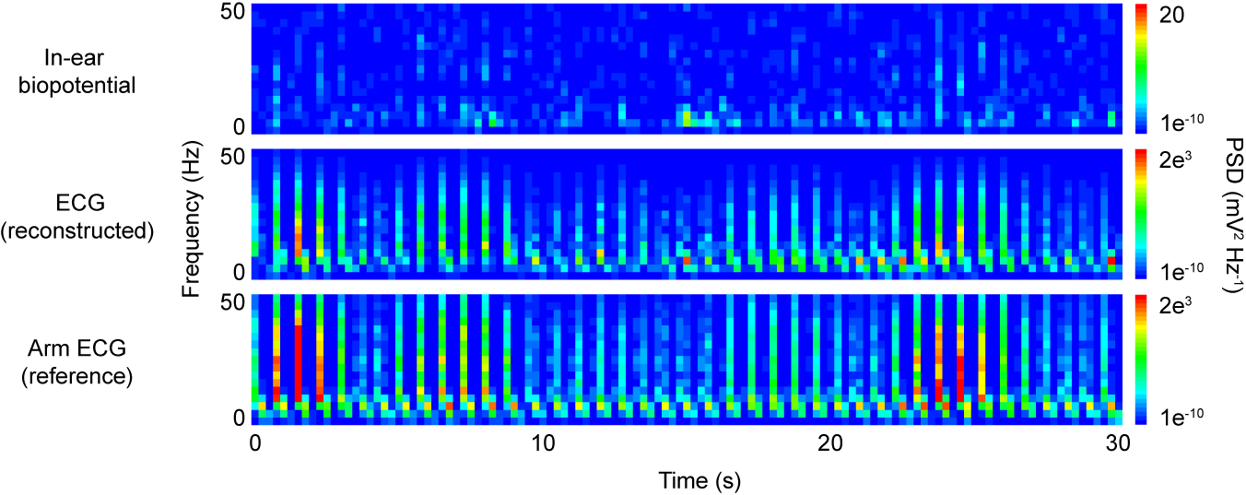
Fig. S40. PSD spectrograms of in-ear biopotential, reconstructed ECG, and reference arm ECG.

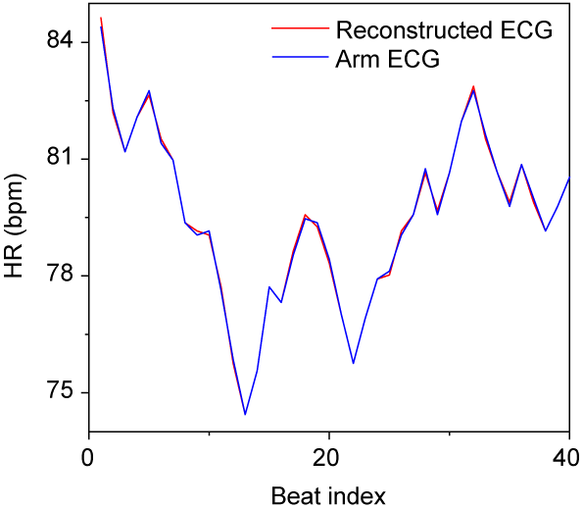
Fig. S41. Heart rate trajectories of reconstructed ECG and reference ECG signals.
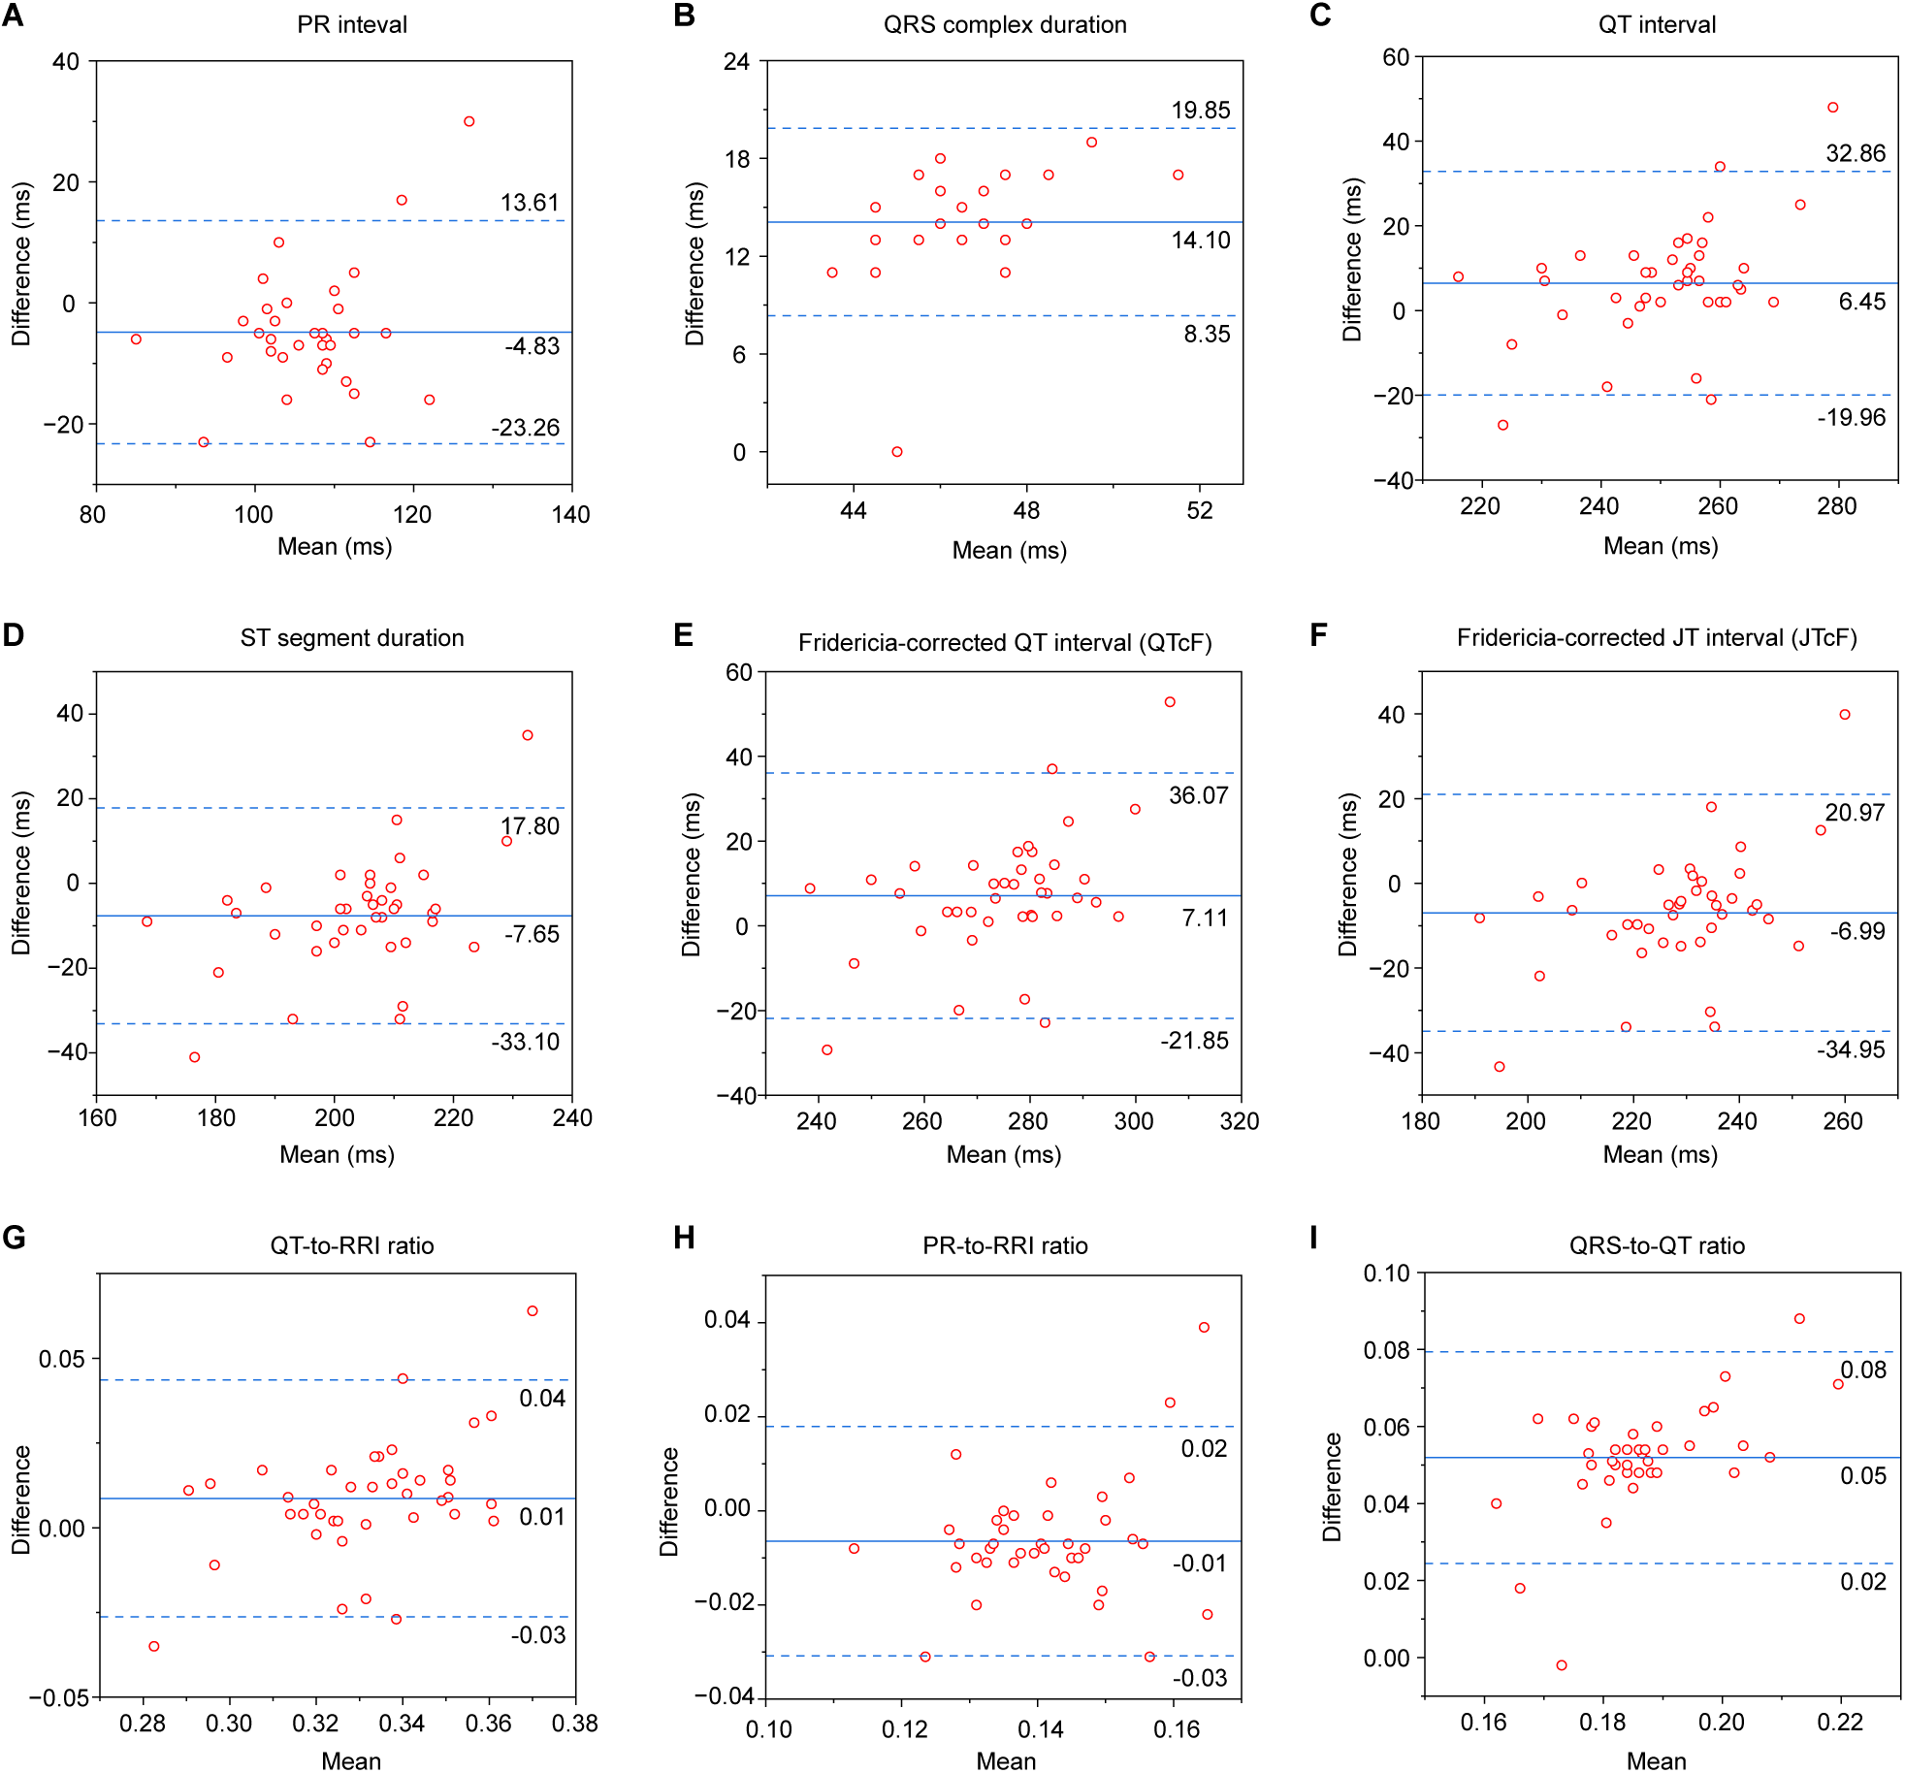
Fig. S42. Bland-Altman analysis of ECG metrics from reconstructed and reference ECG signals. (A to F) Absolute temporal intervals: PR interval (A), QRS duration (B), QT interval (C), ST segment duration (D), Fridericia-corrected QT interval (QTcF) (E), and Fridericia-corrected JT interval (JTcF) (F). (G to I) Ratio-based metrics: QT/RRI ratio (G), PR/RRI ratio (H), and QRS/QT (I). Solid lines indicate the mean bias; dashed lines denote limits of agreement (mean ± 1.96 s.d.).

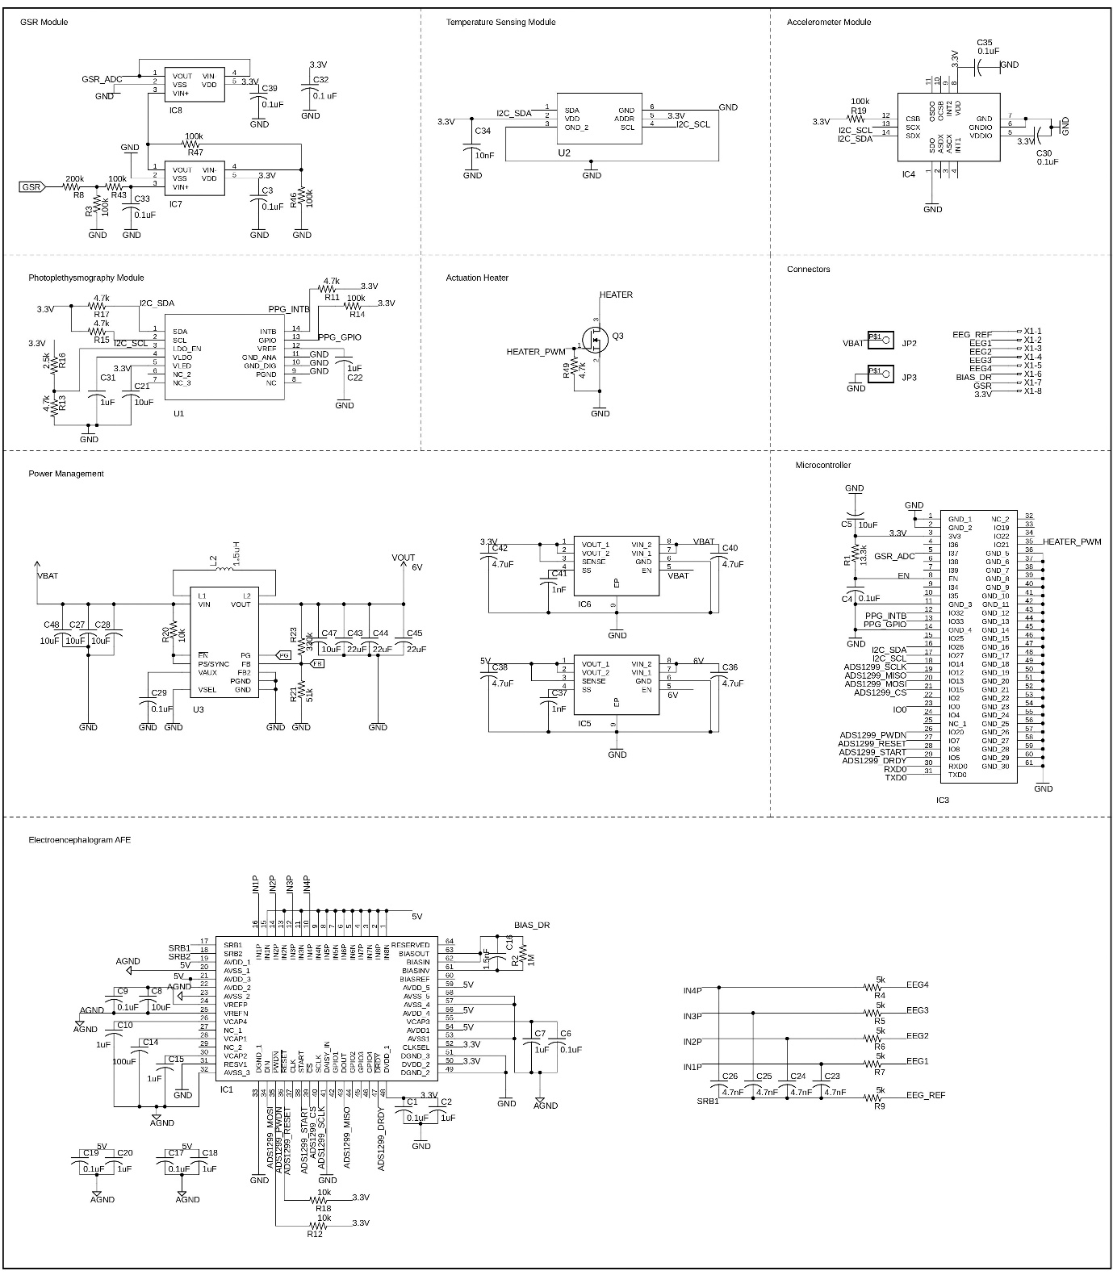
Fig. S43. Electronic circuit schematic of EarSense.

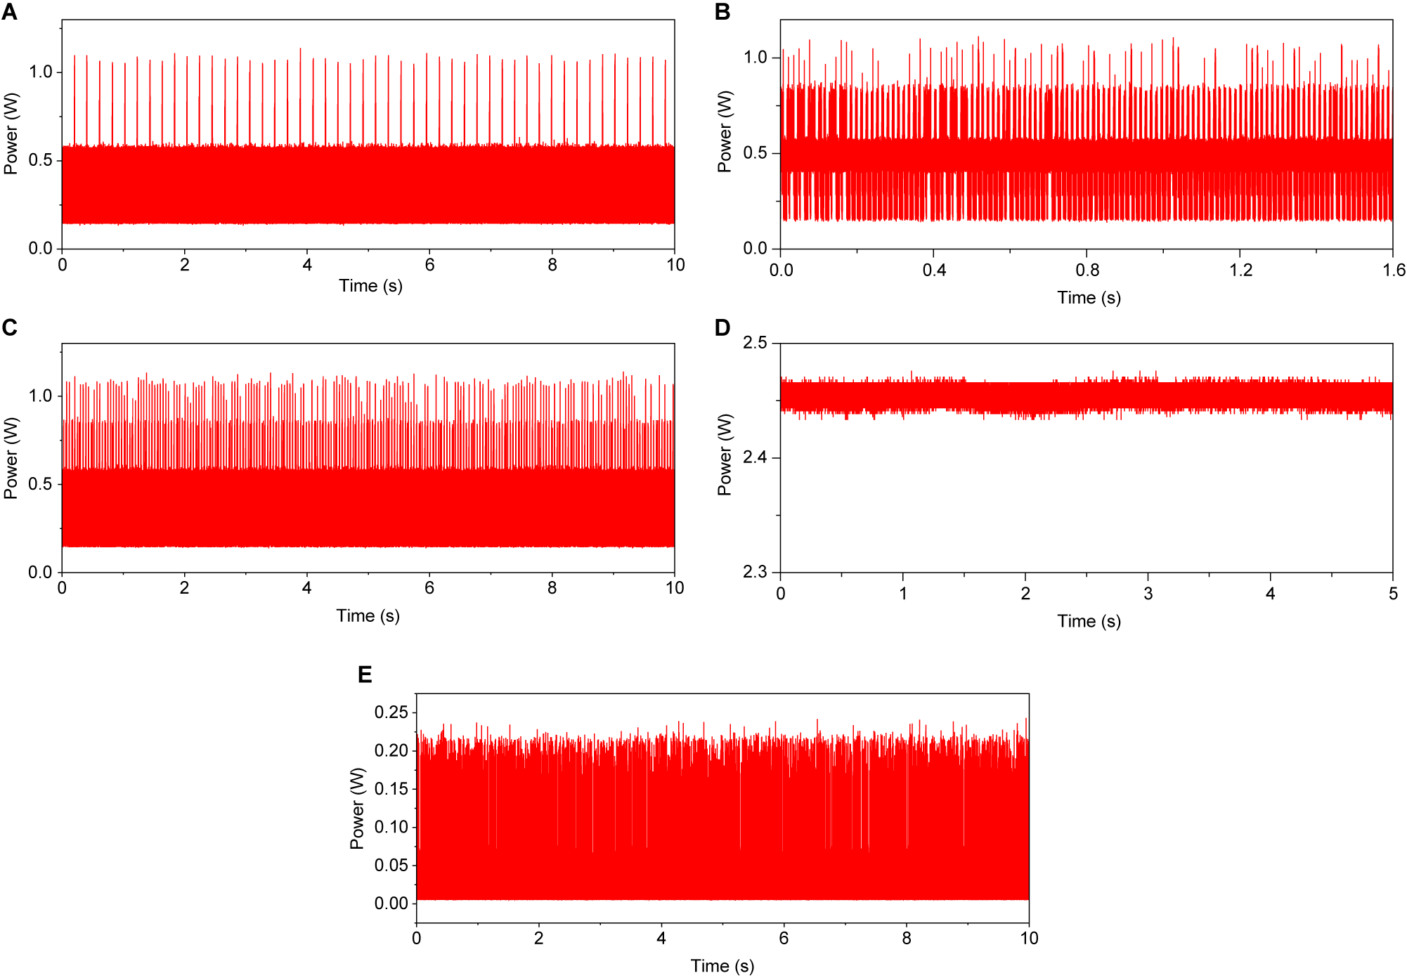
Fig. S44. Power consumption of the EarSense system under different operation modes. (A to E) Power profiles during advertisement (A), pairing (B), multimodal sensing with BLE transmission (C), actuator heating at 2.5 V (D), and deep sleep (E).

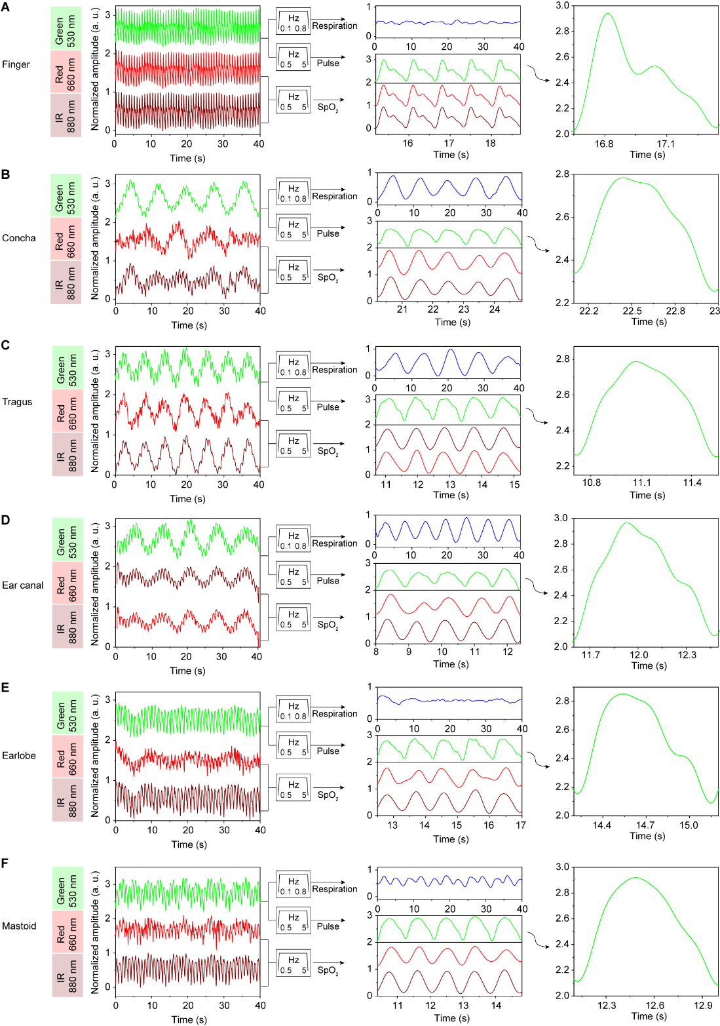
Fig. S45. PPG signals measured at different locations around the ear. (A to F) PPG signals recorded from the index finger (A), concha (B), tragus (C), ear canal (D), earlobe (E), and mastoid (F). The left column represents the raw PPG signal of green, IR and red LEDs plotted as normalized amplitude (a.u.). Left column: raw signals from green, infrared (IR), and red channels (normalized amplitude, a.u.). Middle column: filtered signals, including bandpass filtering at 0.1–0.8 Hz and 0.5–5 Hz for the green channel, and 0.5–5 Hz for the red and IR channels. Right column: representative single-beat pulse waveforms.
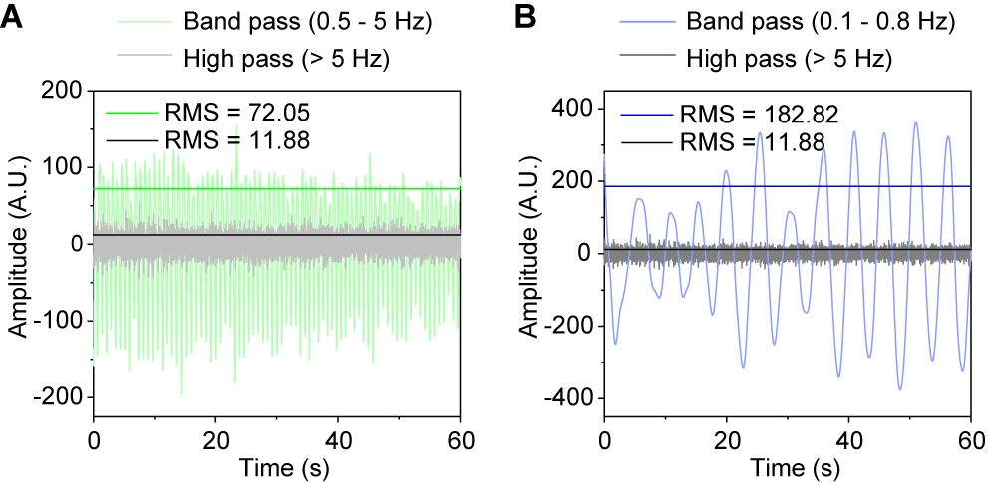
Fig. S46. SNRs of pulse and respiration signals derived from ear PPG. (A) Pulse wave (green) extracted sing a bandpass filter (0.5–5 Hz) and corresponding noise component (gray) obtained using a high-pass filter (>5 Hz). (B) Respiration signal (blue) extracted using a bandpass filter (0.1–0.8 Hz) and corresponding noise component (gray) obtained using a high-pass filter (>5 Hz).
Root-mean-square (RMS) amplitudes are used to calculate SNR.

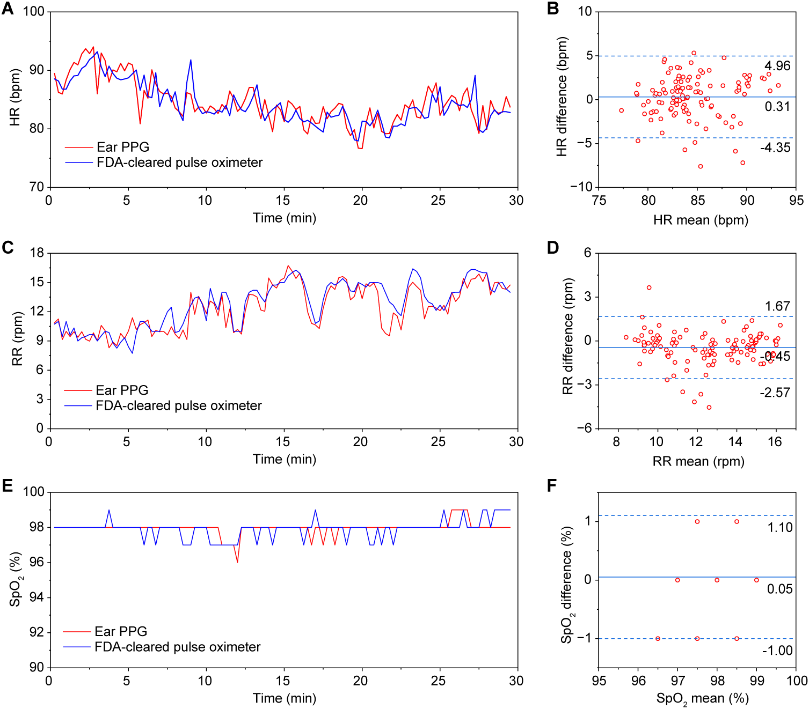
Fig. S47. Comparison of ear PPG-derived physiological parameters with a reference pulse oximeter at rest. (A) HR time series measured by ear PPG and the reference device. (B) Bland–Altman analysis of HR measurements versus their mean. Solid lines indicate mean bias; dashed lines denote limits of agreement (mean ±1.96 s.d.). (C) Respiration rate (RR) time series measured by ear PPG and the reference device. (D) Bland–Altman analysis of RR measurements versus their mean. Solid lines indicate mean bias; dashed lines denote limits of agreement (mean ±1.96 s.d.). (E) SpO₂ time series measured by ear PPG and the reference device. (F) Bland–Altman analysis of SpO₂ measurements versus their mean. Solid lines indicate mean bias; dashed lines denote limits of agreement (mean ±1.96 s.d.).
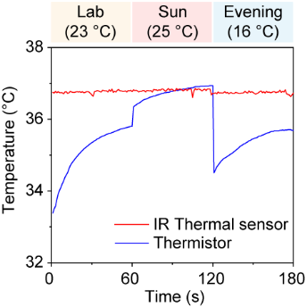
Fig. S48. Ear-canal temperature measured by non-contact IR sensor and contact thermistor under varying ambient conditions.

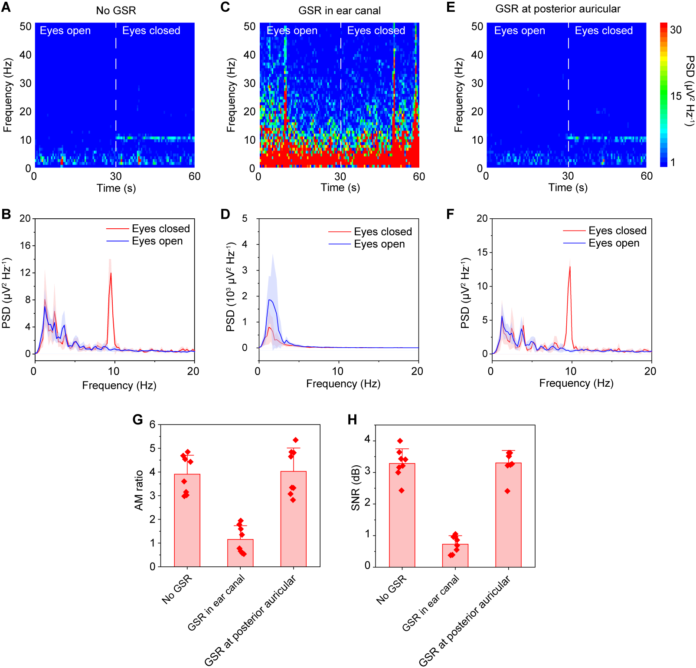
Fig. S49. EEG recordings under different GSR electrode placements. (A and B) AM spectrogram (A) and corresponding PSD (B) without GSR operation. (C and D) AM spectrogram (C) and corresponding PSD (D) with active GSR electrodes placed in the ear canal. (E and F) AM spectrogram (E) and corresponding PSD (F) with active GSR electrodes placed at posterior auricular region. (G and H) AM ratio (G) and SNR (H) for the three conditions: no GSR, GSR in the ear canal, and GSR at the posterior auricular region. Solid lines represent mean values and shaded regions indicate ± s.d. from 8 tests. Error bars represent the s.d. of the mean from 8 tests.

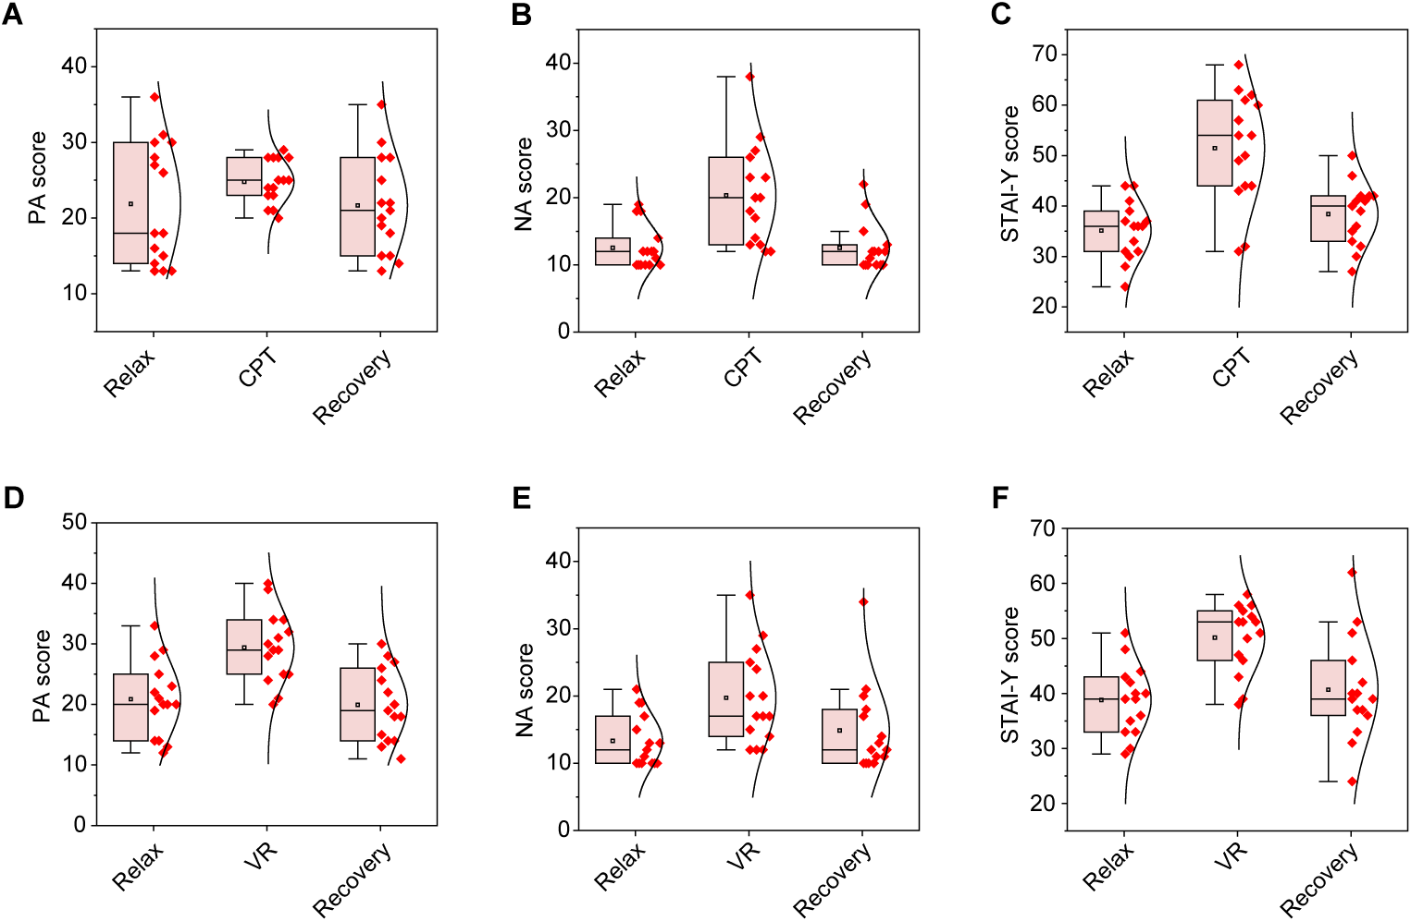
Fig. S50. Questionnaire-based affective scores during CPT and VR tasks. (A to C) Positive affect (PA) (A), negative affect (NA) (B), and state anxiety (STAI-Y1) (C) scores measured during baseline, task (CPT), and recovery. (D to F) PA (D), NA (E), and STAI-Y1 (F) measured during relaxed baseline , task (VR), and recovery. Error bars represent the s.d. of the mean from 15 participants.
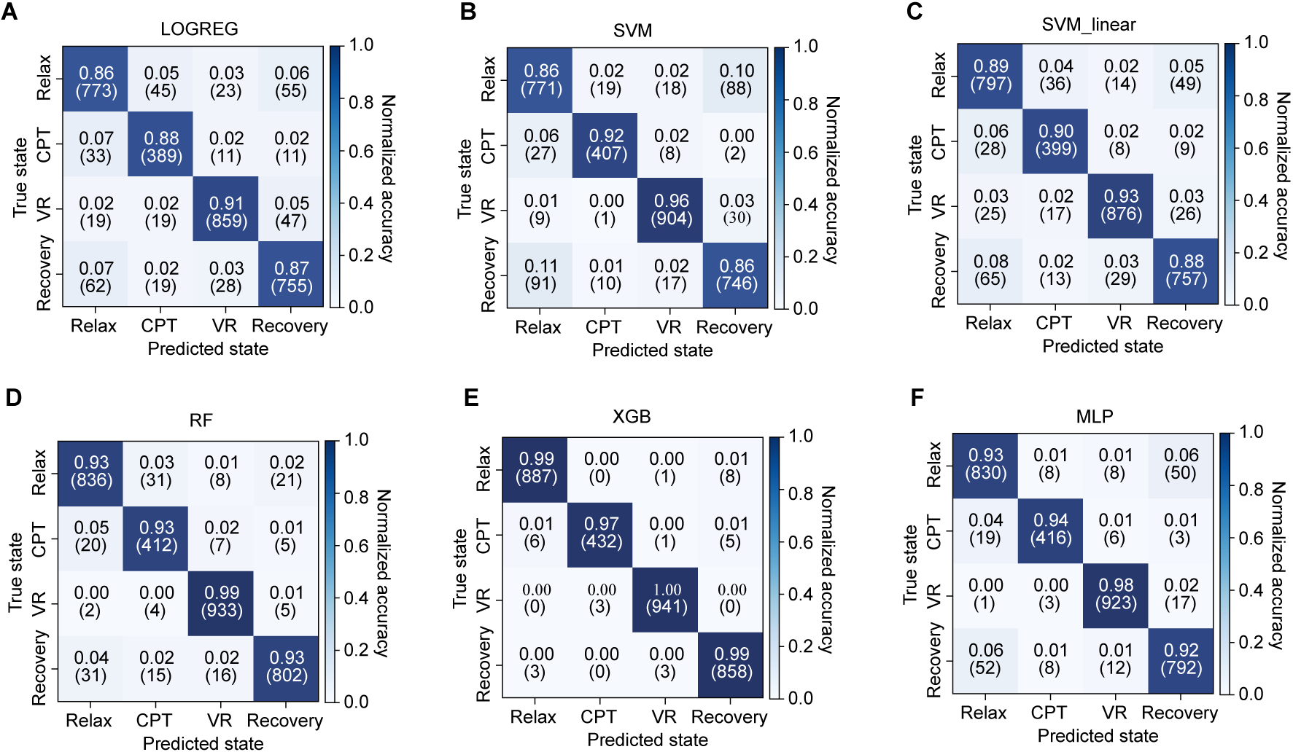
Fig. S51. Confusion matrices of ML models for affective state classification. (A to F) Normalized confusion matrices for four-class classification (Relax, CPT, VR and Recovery) using logistic regression (LOGREG) (A), support vector machine (SVM) with nonlinear kernel (B), linear support SVM (SVM_linear) (C), random forest (RF) (D), XGBoost (XGB) (E), and multilayer perceptron (MLP) (F).

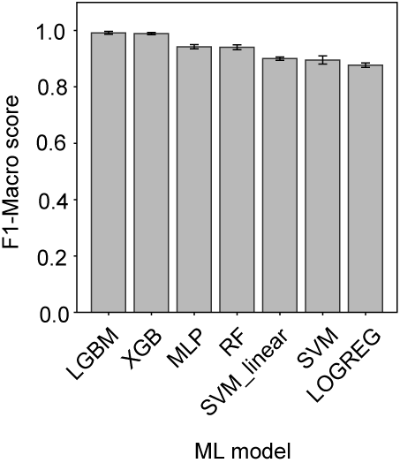
Fig. S52. Classification performance of machine-learning models for affective state prediction.

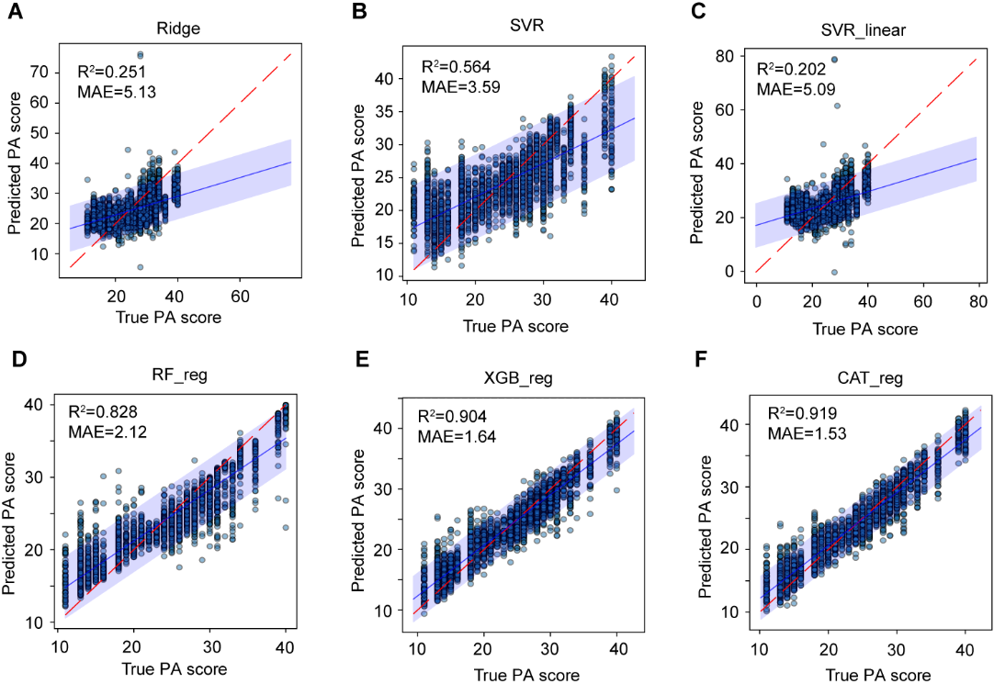
Fig. S53. Predicted versus true PA scores using different regression models. (A to F) Scatter plots for Ridge regression (A), support vector regression (SVR) with nonlinear kernel (B), linear SVR (C), random forest regression (RF_reg) (D), XGBoost regression (XGB_reg) (E), and CatBoost regression (CAT_reg) (F). The red dashed line denotes the ideal identity line (y = x); the blue solid line and shaded region represent the fitted regression and its 95% confidence interval.
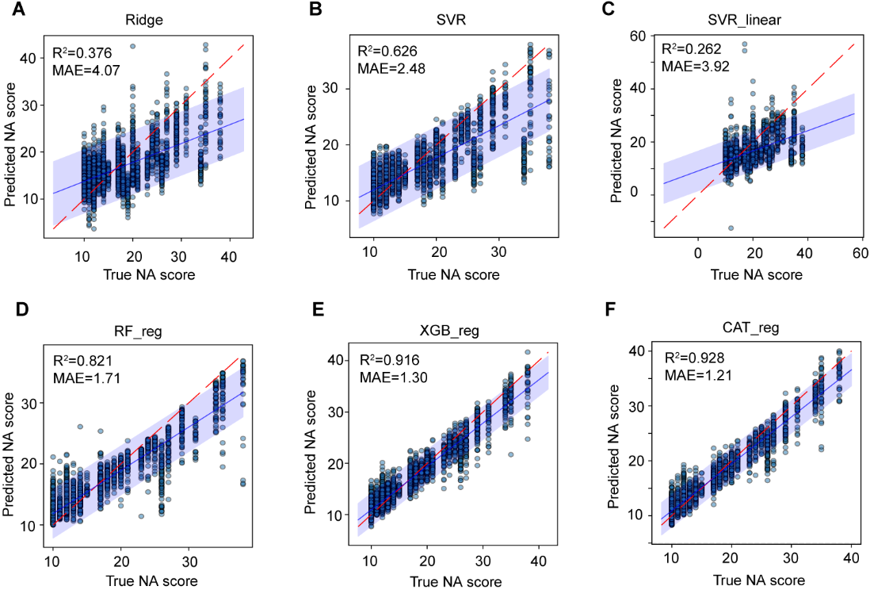
Fig. S54. Predicted versus true NA scores using different regression models. (A to F) Scatter plots for Ridge regression (A), support vector regression (SVR) with nonlinear kernel (B), linear SVR (C), random forest regression (RF_reg) (D), XGBoost regression (XGB_reg) (E), and CatBoost regression (CAT_reg) (F). The dashed red line denotes the ideal identity line (y = x); the solid blue line and shaded region represent the fitted regression and its 95% confidence interval.

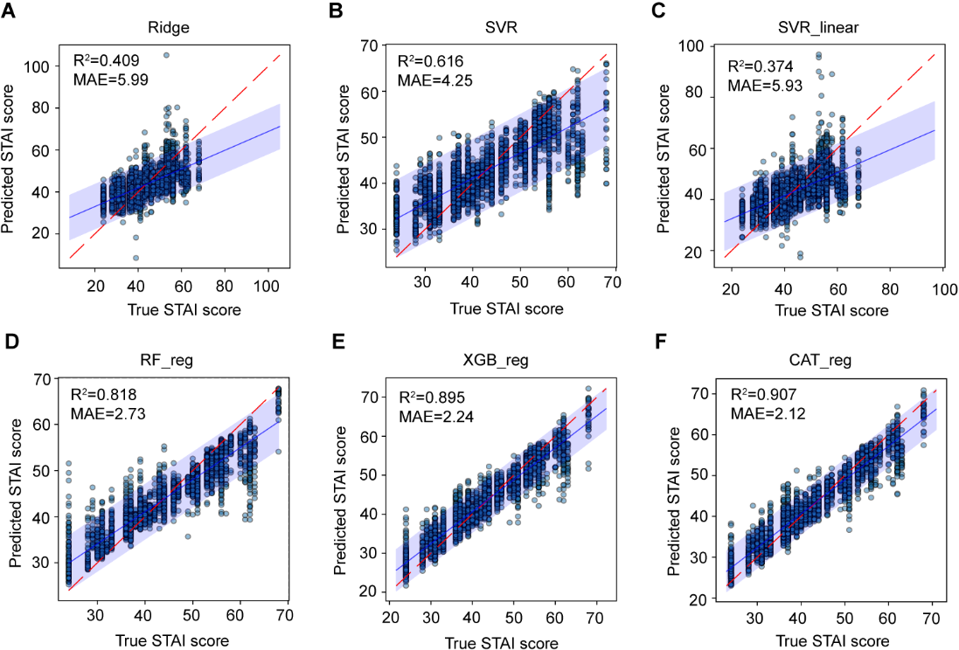
Fig. S55. Predicted versus true STAI scores using different regression models. (A to F) Scatter plots for Ridge regression (A), support vector regression (SVR) with nonlinear kernel (B), linear SVR (B), random forest regression (RF_reg) (B), XGBoost regression (XGB_reg) (B), and CatBoost regression (CAT_reg) (F). The dashed red line denotes the ideal identity line (y = x); the blue solid line and shaded region represent the fitted regression and its 95% confidence interval.

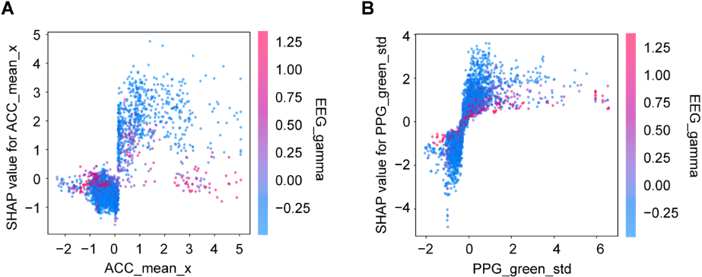
Fig. S56. SHAP dependence plots of features contributing to model predictions. (A) SHAP dependence plot for mean acceleration along the x-axis (ACC_mean_x). (B) SHAP dependence plot for the standard deviation of the green-channel PPG signal (PPG_green_std). Point colors indicate EEG_gamma power.
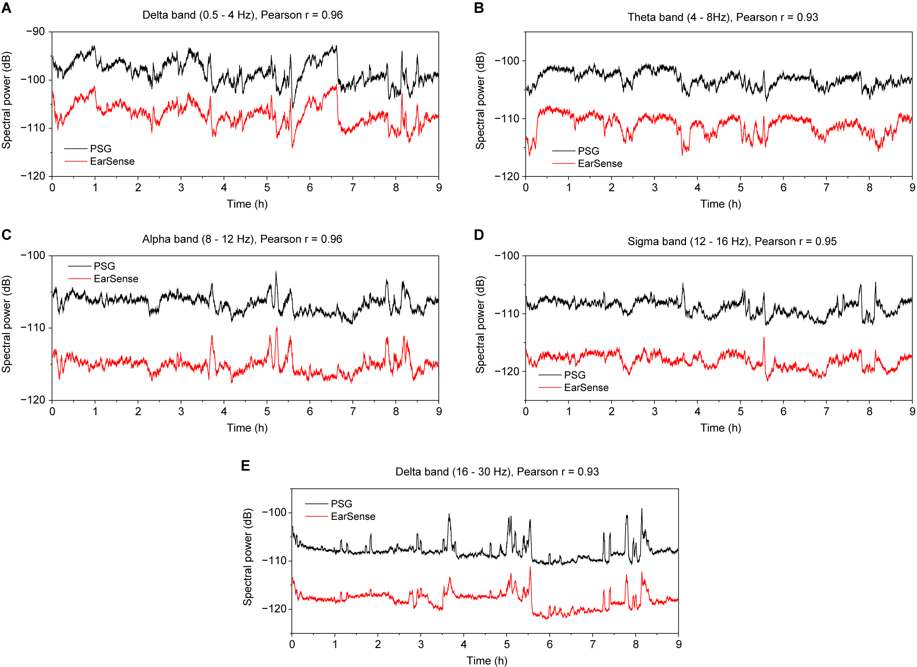
Fig. S57. Band-specific EEG spectral power recorded by EarSense and PSG during sleep. (A to E) Time-resolved spectral power in canonical EEG bands, including delta (0.5–4 Hz) (A), theta (4–8 Hz) (B), alpha (8–12 Hz) (C), sigma (12–16 Hz) (D), and beta (16–30 Hz) (E) bands, measured by EarSense and PSG.

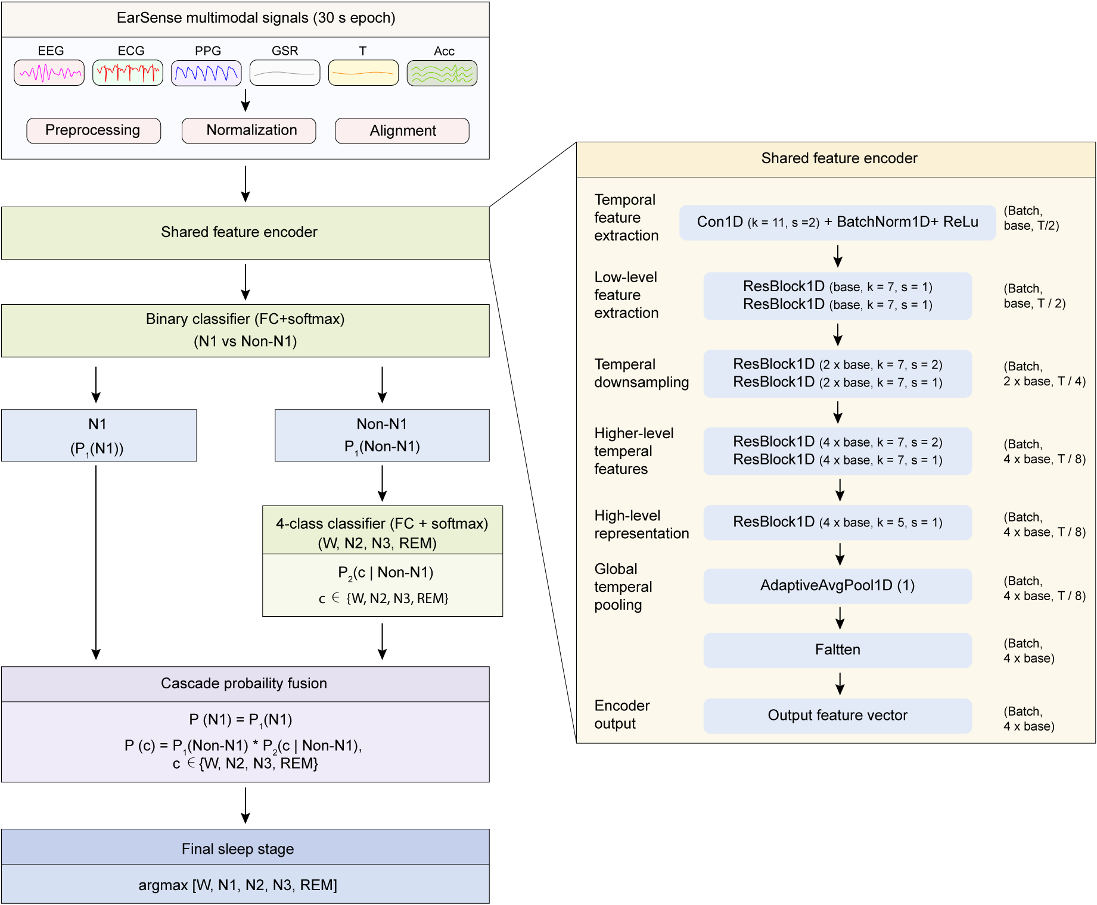
Fig. S58 | Hierarchical framework for sleep staging using EarSense. Schematic of the processing pipeline, including preprocessing, feature encoding, and classification. The model consists of a shared feature encoder and a cascade classification scheme for sleep stage prediction. Conv1D, one-dimensional convolution; BatchNorm1D, one-dimensional batch normalization; ResBlock1D, one-dimensional residual block; FC, fully connected layer; REM, rapid eye movement; W, wake; N1–N3, non–rapid eye movement sleep stages 1–3.

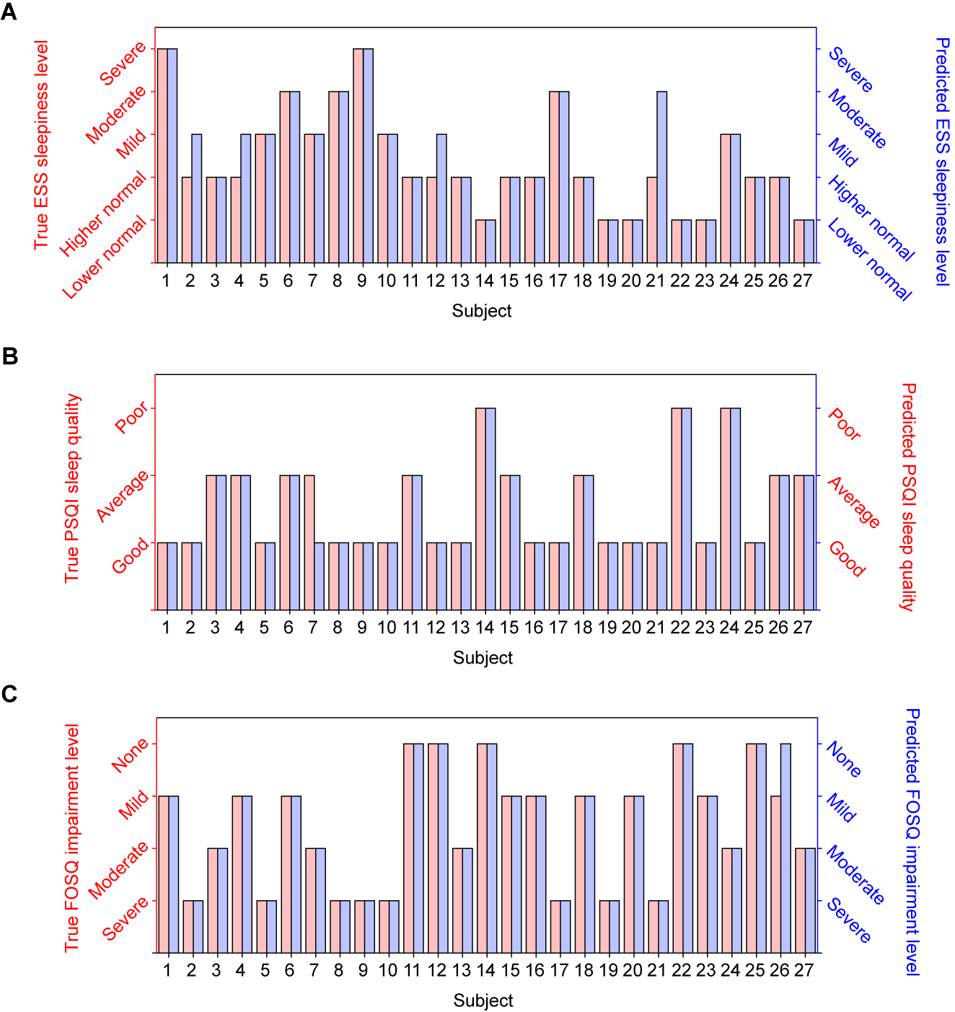
Figure S59. Leave-one-subject-out predictions of sleep-related outcome levels. (A to C) Comparison of true and predicted categorical levels across participants for daytime sleepiness based on ESS scores (A), sleep quality based on PSQI scores (B), and functional impairment based on FOSQ scores (C).

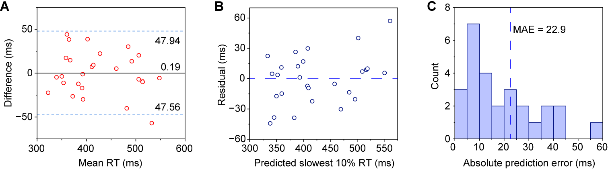
Fig. S60. Regression performance for predicting slowest 10% reaction time in the PVT. (A) Bland–Altman analysis comparing predicted and measured slowest 10% reaction times. Solid lines indicate mean bias; dashed lines indicate limits of agreement (mean ± 1.96 s.d.). (B) Residual plot against predicted values. (C) Distribution of absolute prediction errors. Each point represents one recording; evaluation is performed using leave-one-subject-out cross-validation.

Table S1. Reported approaches for ECG detection or reconstruction from ear-derived biopotential signals. Comparison of electrode locations, reference configurations, signal processing methods, and detected ECG components across prior studies.
Ear electrode location | Reference electrode location | Signal processing method | ECG component detected | Clinical metrics  validation | Reference
Postauricular region | Contralateral ear | Adaptive filtering  (EKRLS filter) | R peak | No | (64)
Postauricular region | Ipsilateral neck | Bandpass filter (0.5-100 Hz) | P–QRS–T complex | No | (65)
Ear canal | Contralateral ear | Deep learning | R peak | No | (66)
External car canal | Ipsilateral finger | / | P–QRS–T complex | No | (67)
Postauricular region | Contralateral ear | Bandpass filter (5-50 Hz) | R peak | No | (68)
Ear canal | Contralateral ear | Bandpass filter (10-20 Hz) | R peak | No | (69)
Postauricular region | Ipsilateral mastoid | Bandpass filter (0.16-5 Hz) | R peak | No | (70)
Ear canal | Ipsilateral mastoid | / | R peak | No | (71)
Ear canal | Contralateral ear | Deep learning | P–QRS–T complex | No | (72)
Postauricular region | Ipsilateral finger | Bandpass filter (0.5−45 Hz) | P–QRS–T complex | No | (73)
Ear canal | Ipsilateral mastoid | Bandpass filter (2-12 Hz); multi-channel MFHT | R peak | No | (74)
Ear canal | Contralateral ear | Bandpass filter (9-28 Hz); | R peak | No | (75)
Postauricular region | Contralateral ear | Machine learning | R peak | No | (76)
Ear canal | Ipsilateral mastoid | Deep learning | P–QRS–T complex | Yes | This work

Table S2. Demographic characteristics of affective state study participants.
Subject | Gender (M/F) | Age
1 | M | 30
2 | M | 26
3 | M | 26
4 | M | 30
5 | M | 30
6 | M | 30
7 | M | 26
8 | F | 30
9 | M | 28
10 | F | 32
11 | F | 38
12 | M | 25
13 | F | 32
14 | M | 26
15 | M | 28

Table S3. Questionnaire scores across participants for the affective state study. PANAS, Positive and Negative Affect Schedule (PANAS).
STAI score  (Relax-VR-recovery) | 43-56-40 | 39-53-40 | 42-53-39 | 33-47-37 | 40-43-37 | 30-55-51 | 33-58-42 | 35-56-36 | 39-50-46 | 44-38-31 | 36-54-39 | 48-53-53 | 51-46-62 | 29-51-24 | 40-39-33
NA score  (Relax-VR-recovery) | 10-12-10 | 10-12-10 | 10-12-10 | 11-20-12 | 15-14-10 | 12-25-17 | 13-27-20 | 10-24-11 | 19-29-21 | 19-15-13 | 10-20-14 | 21-35-34 | 17-17-18 | 10-17-11 | 13-17-12
PA score  (Relax-VR-recovery) | 14-28-13 | 14-29-15 | 12-24-14 | 22-40-19 | 13-29-14 | 28-20-26 | 21-25-24 | 20-21-22 | 25-25-18 | 33-30-28 | 19-34-18 | 29-31-27 | 20-34-11 | 23-39-30 | 20-32-20
STAI score  (Relax-CPT-recovery) | 44-54-40 | 37-49-41 | 39-50-46 | 36-63-33 | 36-38-42 | 24-31-30 | 31-61-41 | 30-43-35 | 33-44-42 | 28-32-32 | 36-54-36 | 41-44-50 | 31-62-27 | 44-60-42 | 37-57-39
NA score  (Relax-CPT-recovery) | 10-13-10 | 10-14-10 | 10-13-10 | 12-26-11 | 10-38-12 | 12-12-12 | 10-23-15 | 12-18-10 | 18-20-22 | 12-12-12 | 11-20-10 | 19-17-19 | 14-27-10 | 10-23-12 | 18-29-13
PA score  (Relax-CPT-recovery) | 18-24-15 | 13-24-13 | 13-25-15 | 18-25-22 | 14-23-14 | 28-28-28 | 15-28-25 | 30-23-20 | 31-21-22 | 27-28-28 | 13-29-19 | 30-28-30 | 36-21-35 | 16-20-18 | 26-25-21
Subject | 1 | 2 | 3 | 4 | 5 | 6 | 7 | 8 | 9 | 10 | 11 | 12 | 13 | 14 | 15

Table S4. Demographic characteristics of sleep study participants.
Subject | Gender (M/F) | Age
Healthy_1 | M | 31
Healthy_2 | M | 27
Healthy_3 | M | 30
Healthy_4 | M | 27
Healthy_5 | M | 26
Healthy_6 | M | 30
Healthy_7 | M | 24
Healthy_8 | M | 25
Healthy_9 | M | 26
Healthy_10 | F | 27
Healthy_11 | M | 25
Healthy_12 | M | 34
Healthy_13 | F | 32
Healthy_14 | M | 28
Healthy_15 | M | 23
Healthy_16 | F | 29
Healthy_17 | F | 31
Healthy_18 | M | 25
Healthy_19 | M | 31
Healthy_20 | F | 19
Patient_1 | M | 47
Patient_2 | F | 37
Patient_3 | M | 46
Patient_4 | F | 34
Patient_5 | M | 35
Patient_6 | F | 30
Patient_7 | M | 47

Table S5. Questionnaire scores and PVT metrics in the sleep study. SSS, Stanford Sleepiness Scale; ESS, Epworth Sleepiness Scale.
Subject | SSS score |  | ESS score |  | PSQI  score | FPSQ  score | PVT
Subject | Before sleep | Wake up | Before sleep | Wake up | PSQI  score | FPSQ  score | Lapse rate (%) | Slow_10% mean RT (ms) | Mean RT  (ms)
Healthy_1 | 5 | 6 | 7 | 17 | 5 | 16.6 | 1.52% | 421.6 | 297.8
Healthy_2 | 5 | 5 | 12 | 9 | 3 | 11 | 2.92% | 499.8 | 301.2
Healthy_3 | 5 | 1 | 8 | 7 | 6 | 13.7 | 0.43% | 358.9 | 263.9
Healthy_4 | 5 | 2 | 14 | 6 | 9 | 17 | 0.79% | 382.6 | 276.9
Healthy_5 | 6 | 3 | 8 | 11 | 5 | 12.7 | 4.74% | 508 | 287.6
Healthy_6 | 4 | 5 | 10 | 14 | 6 | 16.8 | 4.53% | 516 | 307.2
Healthy_7 | 3 | 2 | 10 | 11 | 7 | 13.4 | 0.00% | 348.31 | 269.6
Healthy_8 | 3 | 2 | 13 | 13 | 4 | 8.7 | 3.36% | 545.1 | 347.8
Healthy_9 | 4 | 5 | 14 | 17 | 5 | 9.3 | 2.76% | 498.6 | 321.2
Healthy_10 | 6 | 1 | 11 | 11 | 4 | 12.3 | 1.21% | 378 | 278.6
Healthy_11 | 5 | 2 | 8 | 6 | 9 | 18.1 | 0.76% | 392 | 277.8
Healthy_12 | 6 | 3 | 18 | 7 | 2 | 18.2 | 1.99% | 509 | 297.6
Healthy_13 | 6 | 4 | 8 | 7 | 4 | 15.2 | 1.50% | 414.6 | 299.1
Healthy_14 | 4 | 4 | 3 | 2 | 11 | 18 | 0.38% | 367.3 | 280.3
Healthy_15 | 6 | 3 | 7 | 7 | 9 | 17. | 0.38% | 348.1 | 282
Healthy_16 | 4 | 4 | 4 | 9 | 5 | 17.9 | 2.39% | 438.7 | 291.3
Healthy_17 | 5 | 1 | 13 | 13 | 3 | 8.1 | 1.51% | 377.5 | 284.9
Healthy_18 | 6 | 2 | 9 | 8 | 8 | 17.5 | 0.00% | 337 | 272
Healthy_19 | 5 | 2 | 10 | 1 | 5 | 12.5 | 1.28% | 418.6 | 292.1
Healthy_20 | 5 | 3 | 5 | 3 | 4 | 16.2 | 1.08% | 384 | 269
Patient_1 | 5 | 4 | 10 | 10 | 4 | 12.8 | 2.46% | 463.2 | 279.7
Patient_2 | 2 | 4 | 2 | 1 | 12 | 18 | 1.56% | 461.6 | 303
Patient_3 | 2 | 2 | 5 | 5 | 4 | 16.6 | 0.00% | 311.2 | 264
Patient_4 | 4 | 2 | 12 | 11 | 8 | 13.1 | 3.05% | 503.9 | 267.6
Patient_5 | 3 | 4 | 5 | 7 | 3 | 18.3 | 3.38% | 502.4 | 307
Patient_6 | 3 | 1 | 7 | 6 | 10 | 17.11 | 0.40% | 374.4 | 279.1
Patient_7 | 2 | 4 | 4 | 5 | 7 | 14.11 | 1.53% | 382.5 | 287.7

Table S6. Spindle detection agreement between PSG (C4-M1) and EarSense (left ear canal-M1) during N2 sleep. Precision, proportion of ear-detected spindles corresponding to PSG spindles; recall, proportion of PSG spindles detected in ear EEG; F1 score, harmonic mean of precision and recall; intersection-over-union (IoU), fraction of spindle time shared between PSG and ear EEG.
Band (Hz) | PSG spindle density  (min⁻¹) | EarSense spindle density  (min⁻¹) | Precision | Recall | F1 | LoU_global
Slow (11-13.5) | 2.52 | 1.62 | 0.29 | 0.19 | 0.23 | 0.10
Fast (13.5-16) | 3.14 | 4.03 | 0.48 | 0.61 | 0.54 | 0.30

Table S7. Sleep stage accuracy of wearable devices and research systems compared with PSG.
Reference | (77) | (78) | (79) | (80) | (81) | (82) | (83) | (84) | (85) | (86)
Manual /automatic (M/A) | M | A | M | M | M | A | A | A | A | A
Stage scoring  Accuracy/kappa value | 76.0%/-  (4 class) | 71.6% /0.56  (4 class) | 72.2% /0.43  (4 class) | 63.6%/0.41  (4 class) | 75%/0.61(4 class) | 72%/0.72  (4 class) | 66.6%/64  (5 class) | 75.3%/~0.6-0.7  (3 class) | 65.11%/0.53  (5 class) | 82.34%/0.74  (5 class)
Nights used | 9 | 1430 | 98 | 30 | 35 | 808  (MrOS Dataset) | 39 | 43 | 357 | 32
Signals monitored | HR, HRV; respiration; movement | HR, HRV; respiration; movement | HR, HRV; respiration; movement | HR, HRV; respiration; movement | HR, HRV, respiration | Movement | HR, movement | Respiration, HR, skin temperature, movement | HR, HRV, SpO2, skin temperature, movement | EEG, EOG, EMG
Sensors applied | PPG, IMU | PPG, IMU | PPG, IMU | PPG, IMU | PPG | IMU | IMU | IMU, thermistor | ECG, PPG, IMU, thermistor | Electrophysiology
Form factor | Smartwatch  (Fitbit Inspire 2) | Smartwatch (Samsung Galaxy Watch 2-5) | Smartwatch  (Huawei Watch GT2) | Smartwatch  ( Google Pixel Watch) | Smart ring  (Oura Ring 3) | Wrist actigraphy  （Sleepwatch-O） | Wrist actigraphy | Wireless Chest patch | Chest patch,  Finger oximeter  (ANNE One) | Head-Face patch

Reference | (87) | (88) | (89) | (90) | (91) | (92) | (93) | (94) | This work
Manual /automatic (M/A) | A | A | A | A | A |  | A | A | A
Stage scoring  Accuracy/kappa value | 83.5%/0.75  (5 class) | 74%/-  (4 class) | 71.3%/0.63  (5 class) | 5 class79.9%/0.73  (5 class) | 85.2%/0.77  (5 class) | - | 80.5%/0.73  (5 class) | 74.1%/0.61 | 89.8%/0.85
Nights used | 25 | - | 47 | 40 | 200 | 9 | 80 | 22 | 6
Signals monitored | EEG, movement, respiration, HR | EEG, EOG, EMG | EEG, EOG, EMG, HR, movement, snoring | EEG | EEG | EEG, EOG, EMG | EEG | EEG | EEG, ECG, HR, HRV, respiration, core body temperature, galvanic skin response, movement
Sensors applied | Electrophysiology, IMU, PPG | Electrophysiology | Electrophysiology, PPG, IMU, microphone | Electrophysiology | Electrophysiology | Electrophysiology | Electrophysiology | EEG | Electrophysiology, PPG, IR thermometer, Skin conductance, IMU
Form factor | Headband  (Dreem headband) | Wired headband | Headband  (Sleep Profiler) | Headband | Headband  (Muse S) | Head-face patch | Wired Earpiece | Electrophysiology | EarSense

Table S8. User-reported wearability of the EarSense device during overnight use. Participants reported side effects, wearing comfort (0–10), and willingness to replace PSG with EarSense (0–10) after overnight use. Scores are self-reported, with higher values indicate greater comfort or preference. For participants without concurrent PSG monitoring, representative images of PSG equipment were shown during survey administration.
Subject | Any side effect? | Wearing Comfort  (score from 0 -10) | Replace over PSG  (score from 0-10)
Healthy_1 | No | 10 | 10
Healthy_2 | No | 8 | 10
Healthy_3 | No | 10 | 9
Healthy_4 | Need to hold posture to avoid device falling off | 8 | 10
Healthy_5 | No | 9 | 10
Healthy_6 | No | 5 | 7
Healthy_7 | No | 7 | 9
Healthy_8 | No | 9 | 10
Healthy_9 | No | 10 | 10
Healthy_10 | No | 8 | 8
Healthy_11 | No | 8 | 8
Healthy_12 | No | 8 | 8
Healthy_13 | No | 8 | 10
Healthy_14 | No | 6 | 7
Healthy_15 | No | 10 | 10
Healthy_16 | No | 8 | 8
Healthy_17 | No | 8 | 8
Healthy_18 | No | 10 | 10
Healthy_19 | No | 6 | 10
Healthy_20 | No
Patient_1 | A little pain (this subject has same problem for commercial earphones) | 6 | 8
Patient_2 | No | 7 | 10
Patient_3 | No | 9 | 10
Patient_4 | No | 9 | 10
Patient_5 | No | 8 | 9
Patient_6 | No | 4 | 10
Patient_7 | No | 6 | 10
Average |  | 7.93 | 9.18

Movie captions
Movie S1. Thermal response and actuation behavior of the actuator during a heating–cooling cycle.
Movie S2. Load-bearing actuation performance of the actuator.
Movie S3. Shape recovery of the actuator under extreme deformations.
Movie S4. Synchronized actuation of an assembled four-actuator array.
Movie S5. Opening and closing of an assembled four-actuator in a simulated ear canal.

